**ESCUELA NORMAL DE EDUCACIÓN PREESCOLAR**

**ENGLISH B1.2 BECOMING INDEPENDENT COMMUNICATORS**

**UNIT 1 – THAT’S MY KIND OF FRIEND**

**LISTENING – 2ND PART**

**Go to** [**https://www.youtube.com/watch?v=RYxDONGyL_8**](https://www.youtube.com/watch?v=RYxDONGyL_8)**, watch the video and complete the following exercises.**

1. What words describe Elizabeth and the bachelors? Write the correct word under each picture.

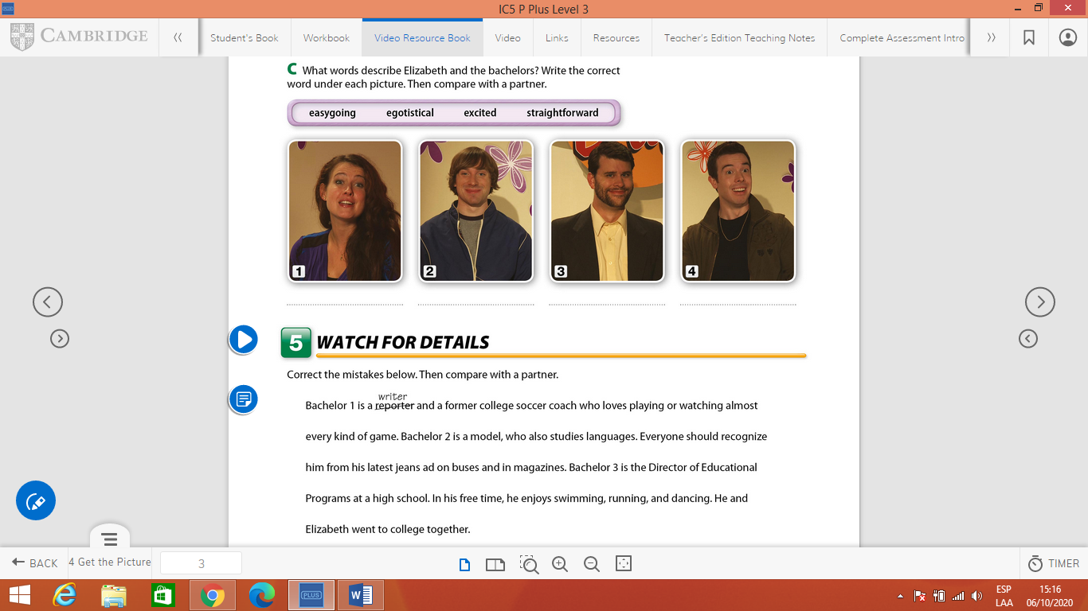

1. Watch the video again if necessary and corect the mistakes below.



