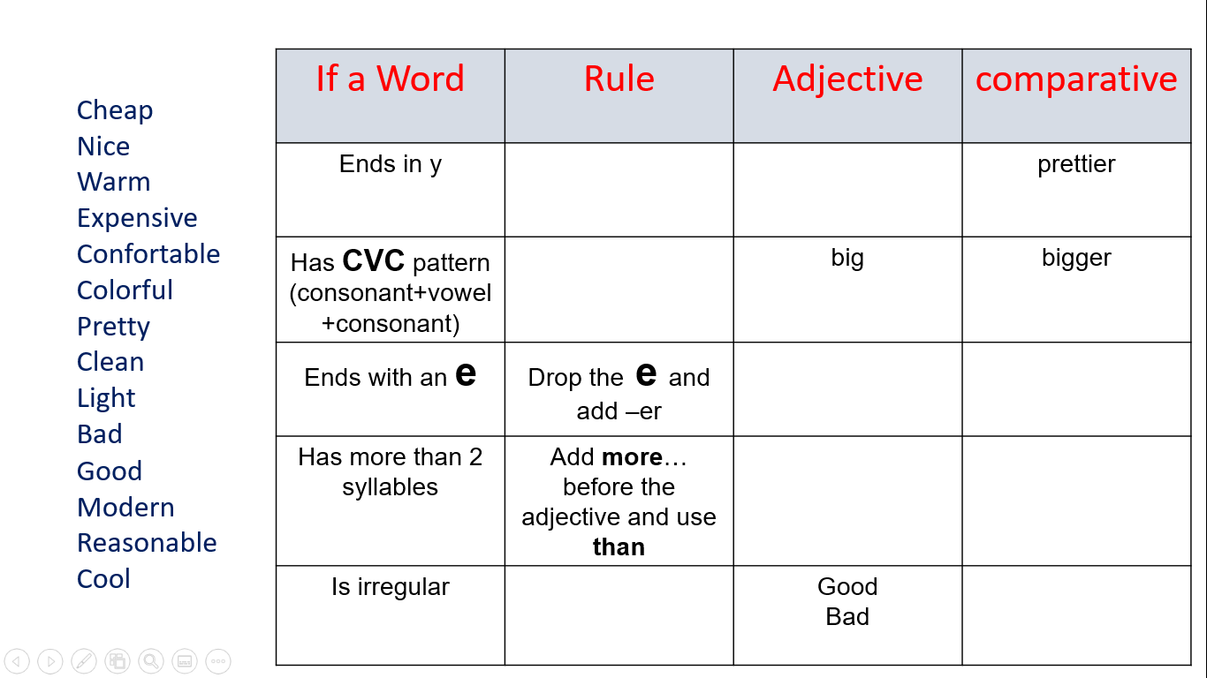

**Dear all, in this activity you will work with your team to complete this chart with the rules for COMPARATIVES**

**These are your teams. Organize a videocall in TEAMS or ZOOM to share your screen and complete the chart together. Remember to take a screenshot for evidence**

**Be successful!**

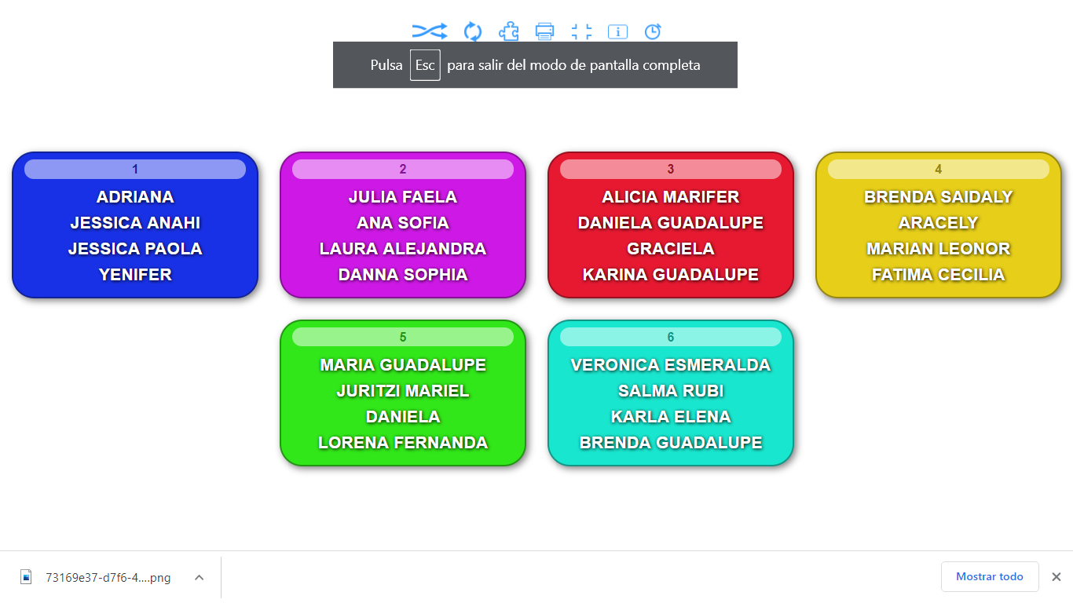

**Your screenshot here**

**Your team names here**

