**How are the two pictures different? Write ten sentences.**

Find the differences

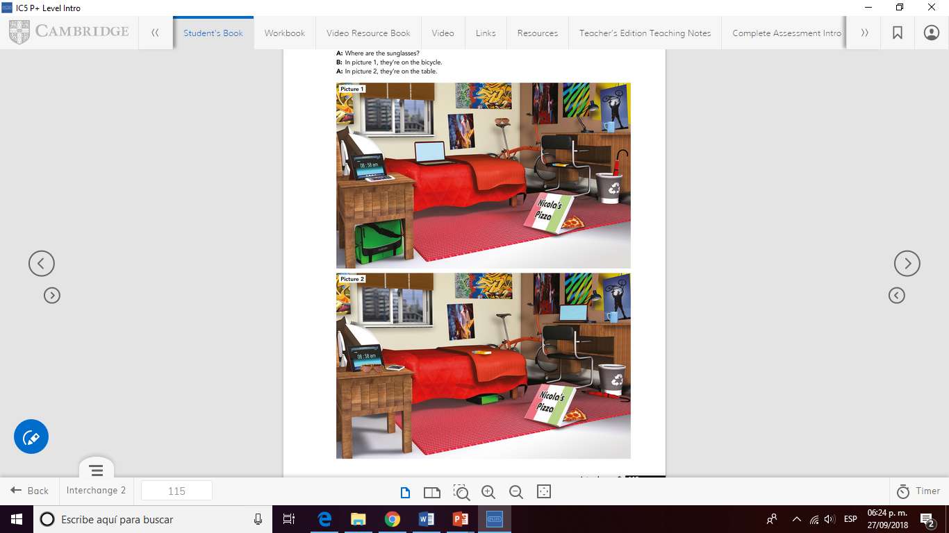**Example: “In picture 1 the laptop is on the bed. In picture 2 the laptop is on the desk.”**

**ESCUELA NORMAL DE EDUCACIÓN PREESCOLAR**

**ENGLISH A1.1 STARTING BASIC COMMUNICATION**

**ENGLISH PROJECT**

**UNIT 2: Where are my keys?**

**Aim:** To describe the location of personal items.

**Instructions:** Write ten sentences about the differences in the two pictures above in a word document. Upload your document in Escuela en red.

Write your name and the name of the Unit.

**Evaluation:** Use of correct structure and vocabulary from the unit.

**Due date:** October. Monday 1st,2018.