ESCUELA NORMAL DE EDUCACIÒN PREESCOLAR  
  
Licenciatura en educaciòn preescolar  
Curso: Ingles  
Maestra: Brenda Bollain Y Goytia  
Alumna: Montserrat Rodriguez Rivera #18  
Evidencia unidad 1

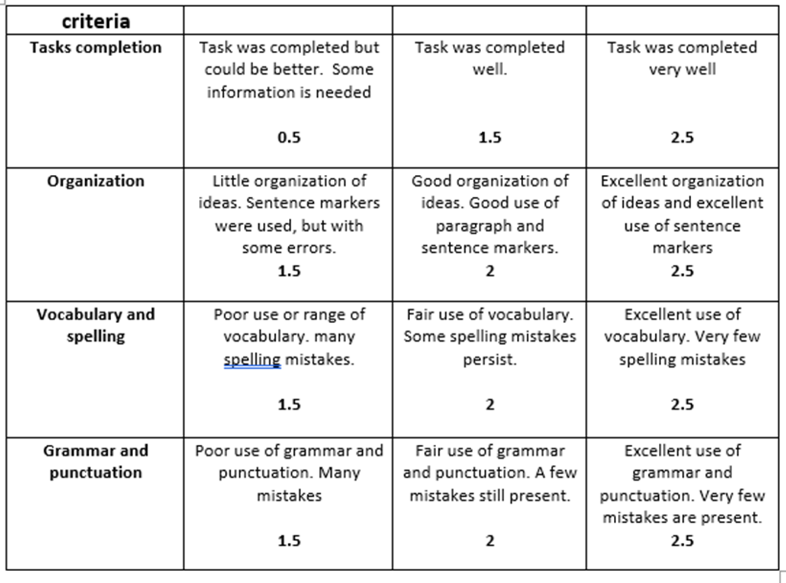

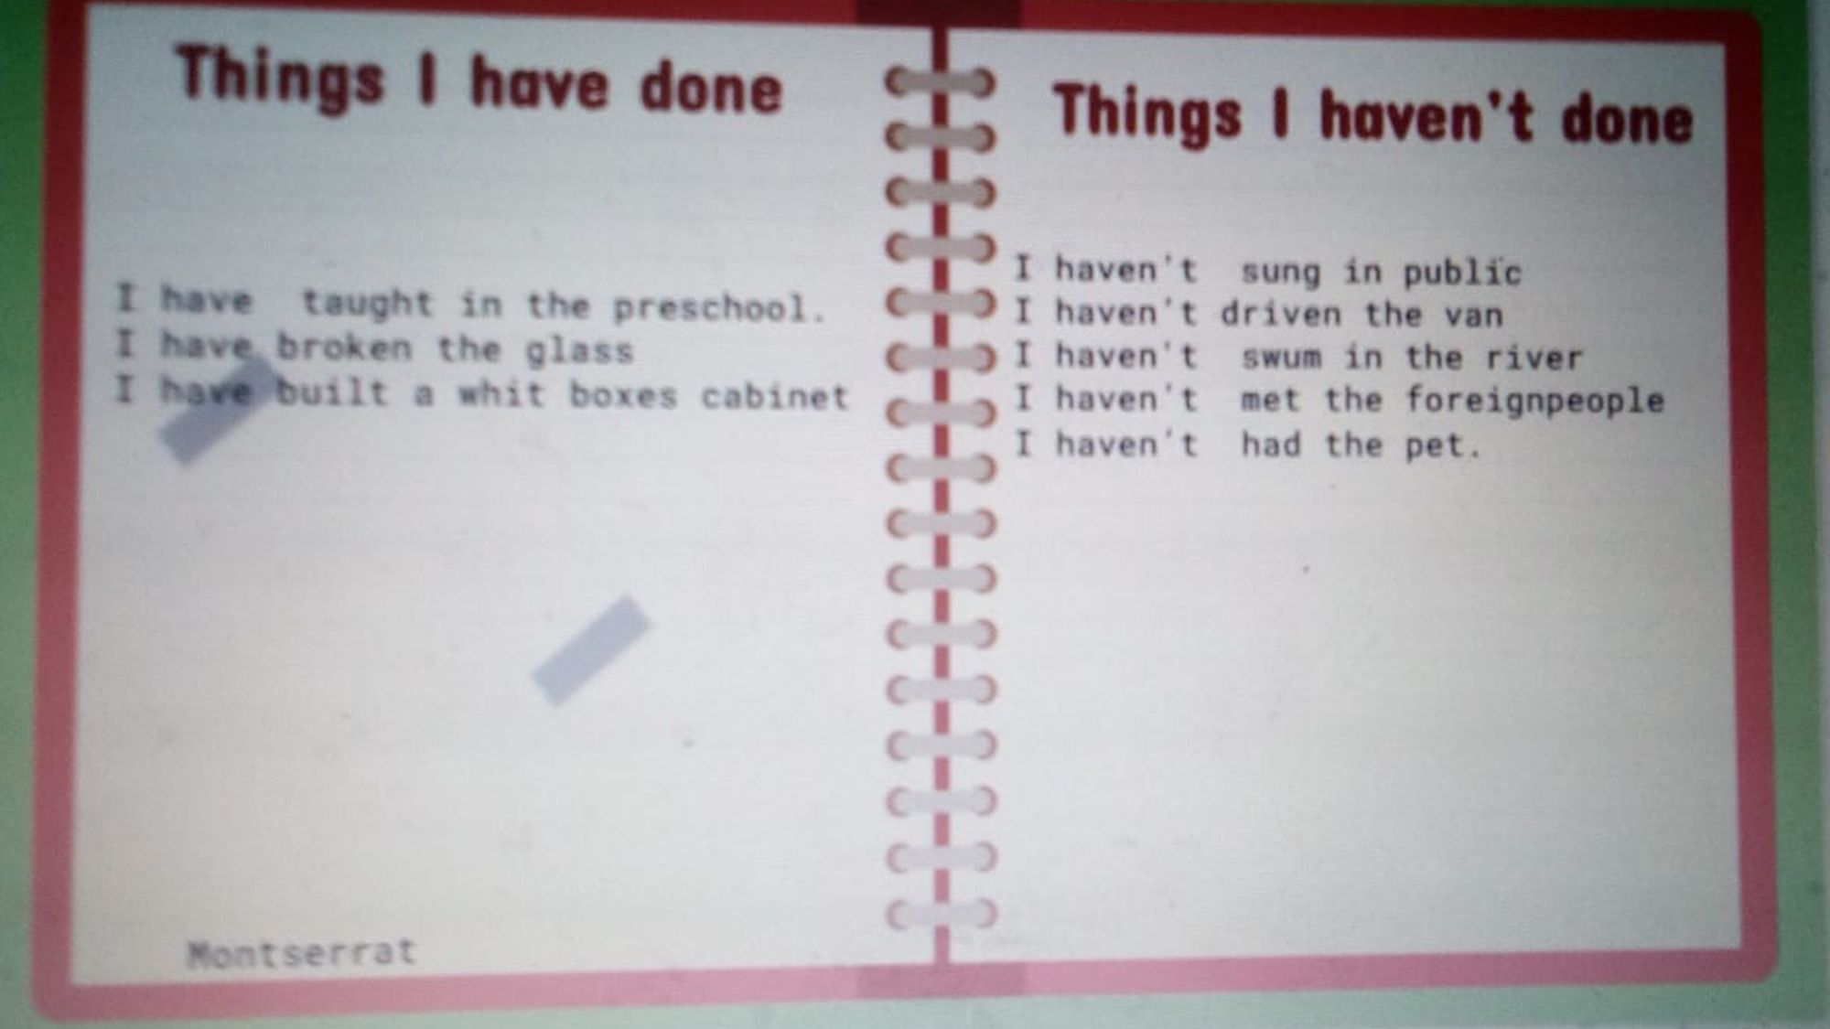

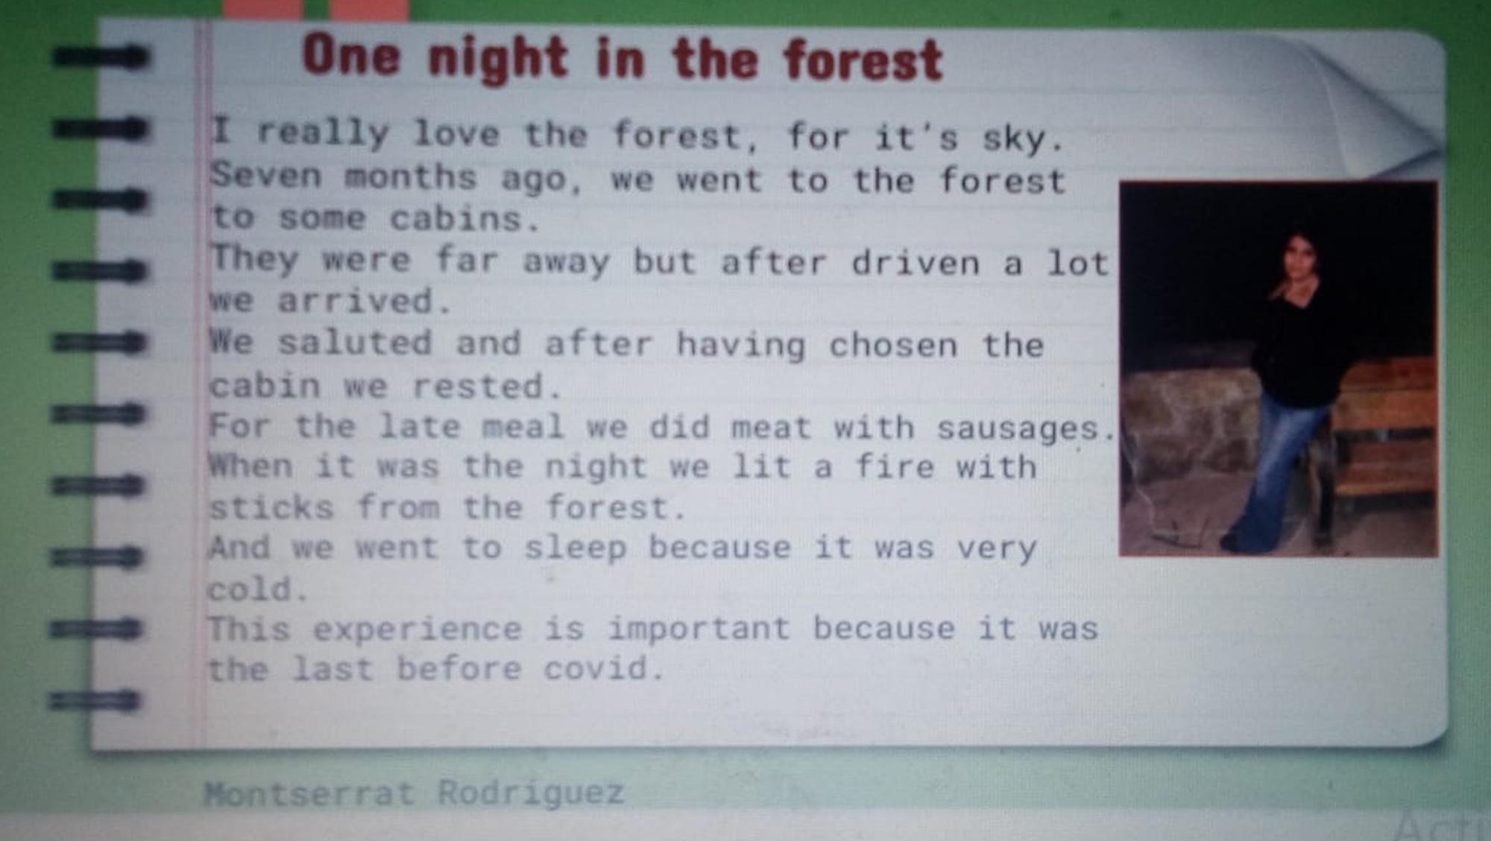

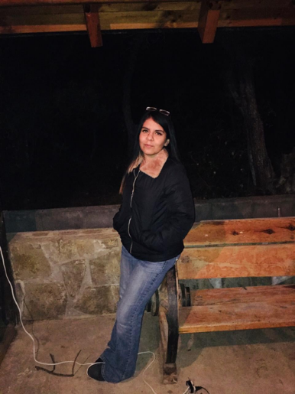One night in the forest

I really love the forest, for it’s sky.  
Seven months ago, we went to the forest to some cabins.  
They were far away but after driven a lot we arrived.   
We saluted and after having chosen the cabin we rested.   
For the late meal we did meat with sausages.  
When it was the night we lit a fire with sticks from the forest.   
And we went to sleep because it was very cold.  
This experience is important because it was the last before covid.