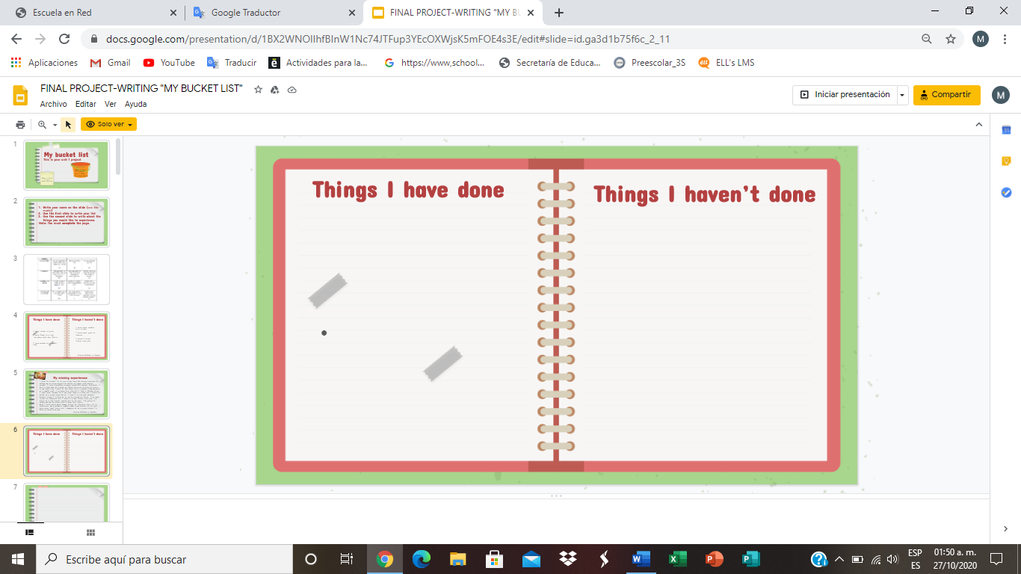

I have never known the city of Paris

I`ve never jumped from the parachute but I will

I have never swam whit the sharks. It is one of my dreams.

I have known Disneyland in Orlando Florida

I have been able to drive a motorcycle

I have taken a makeup course and still do not know how to apply makeup

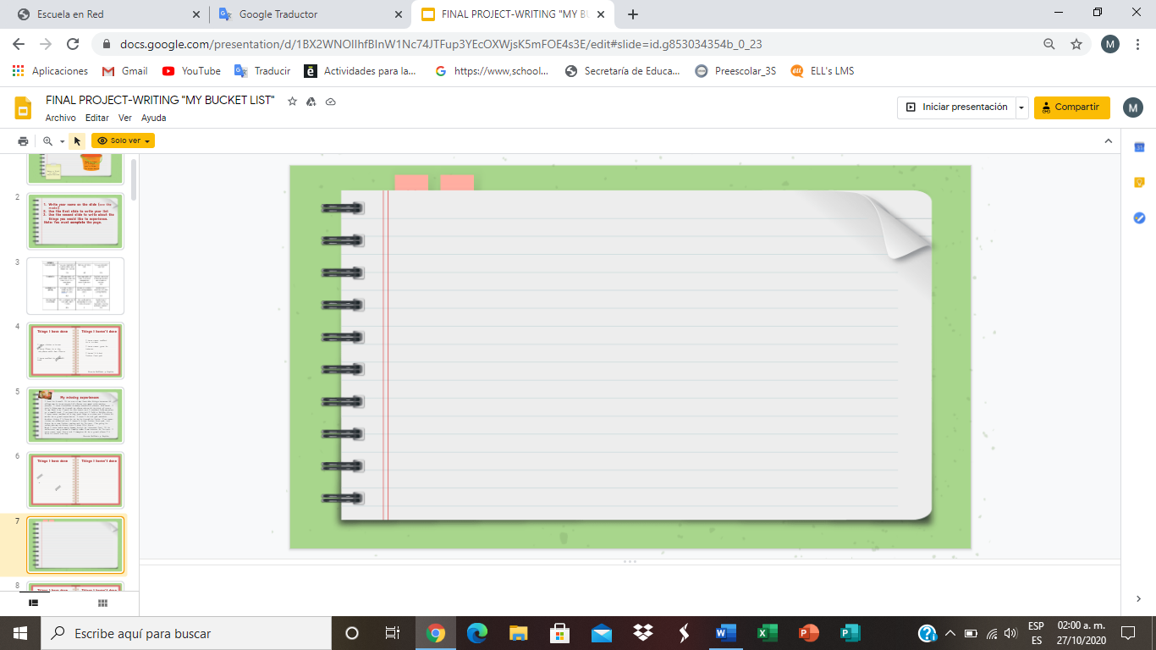

**My missing experiences**

I have always liked traveling to places around the world, I have the experience of knowing some places in my country, but I think I know more about the United States.

I have always wanted to know San Miguel de Allende, they say that it is a super beautiful place, with many places to go sightseeing and learn more about the culture of that place.

Food is an important aspect for me, because a woman is conquered by her appetite from time to time.

I would like to travel more with my family, visit places together to live the same experience and never forget Spending time with the family is my best hobby.

I would like to know more places here in Mexico because it begins with our place of origin. Mexico has a lot to offer its own inhabitants.

**Mariana Quezada Villagomez**