**Escuela Normal De Educación Preescolar**

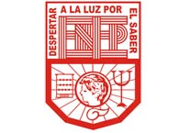

**Licenciatura en educación preescolar**

**Subject: English**

**Teacher: Brenda Bollain Goytia De La Peña**

**Unit 1**

## Final project unit 1

**Student:** Griselda Estefania García Barrera **N.L. 6**

**Fifth semester Section B**

Saltillo, Coahuila

October 29, 2020

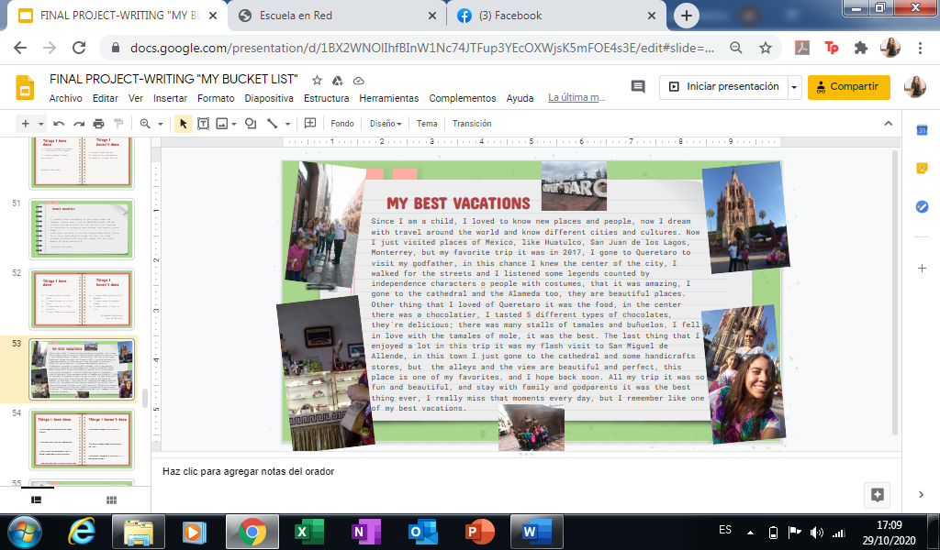

Since I am a child, I loved to know new places and people, now I dream with travel around the world and know different cities and cultures. Now I just visited places of Mexico, like Huatulco, San Juan de los Lagos, Monterrey, but my favorite trip it was in 2017, I gone to Queretaro to visit my godfather, in this chance I knew the center of the city, I walked for the streets and I listened some legends counted by independence characters o people with costumes, that it was amazing, I gone to the cathedral and the Alameda too, they are beautiful places. Other thing that I loved of Queretaro it was the food, in the center there was a chocolatier, I tasted 5 different types of chocolates, they´re delicious; there was many stalls of tamales and buñuelos, I fell in love with the tamales of mole, it was the best. The last thing that I enjoyed a lot in this trip it was my flash visit to San Miguel de Allende, in this town I just gone to the cathedral and some handicrafts stores, but the alleys and the view are beautiful and perfect, this place is one of my favorites, and I hope back soon. All my trip it was so fun and beautiful and stay with family and godparents it was the best thing ever, I really miss that moments every day, but I remember like one of my best vacations.