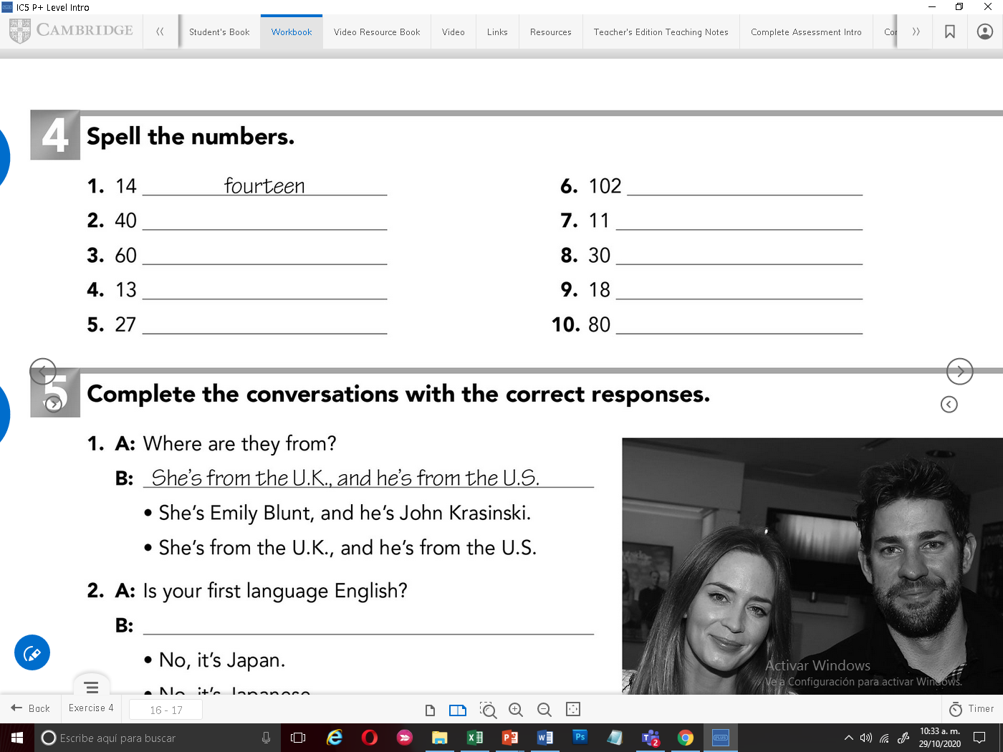

One hundred-two

Eleven

Thirty

Eighteen

eighty

Fourty

Sixty

Thirteen

Twenty seven

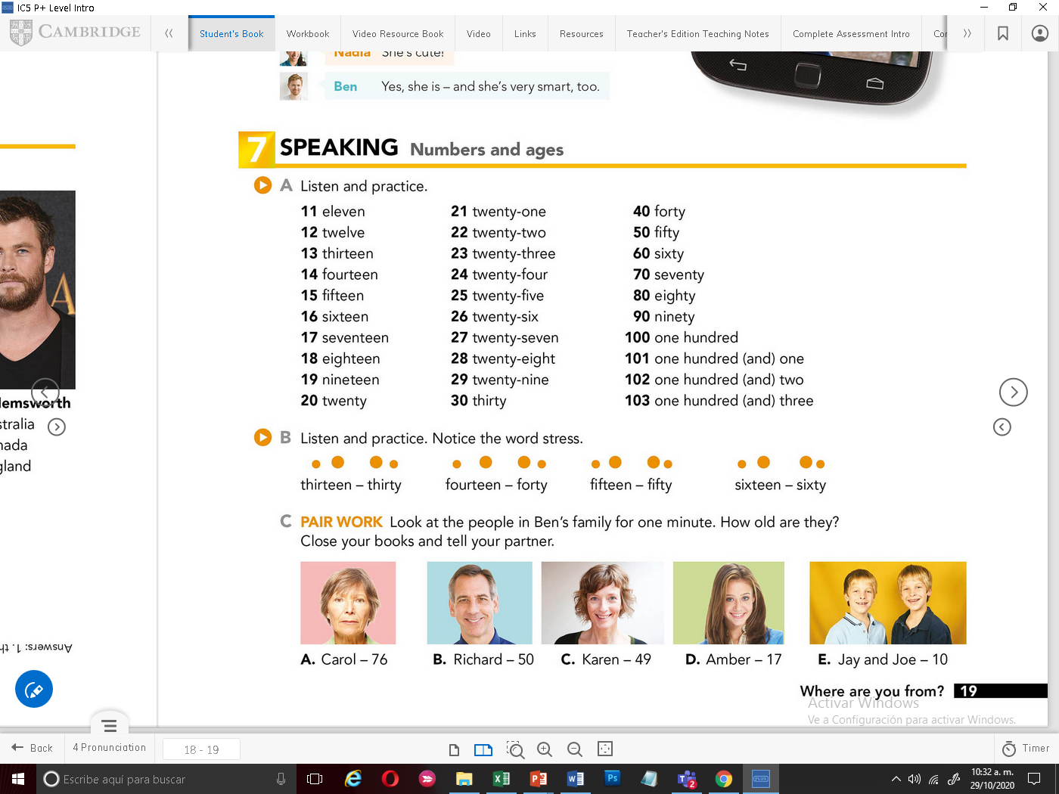



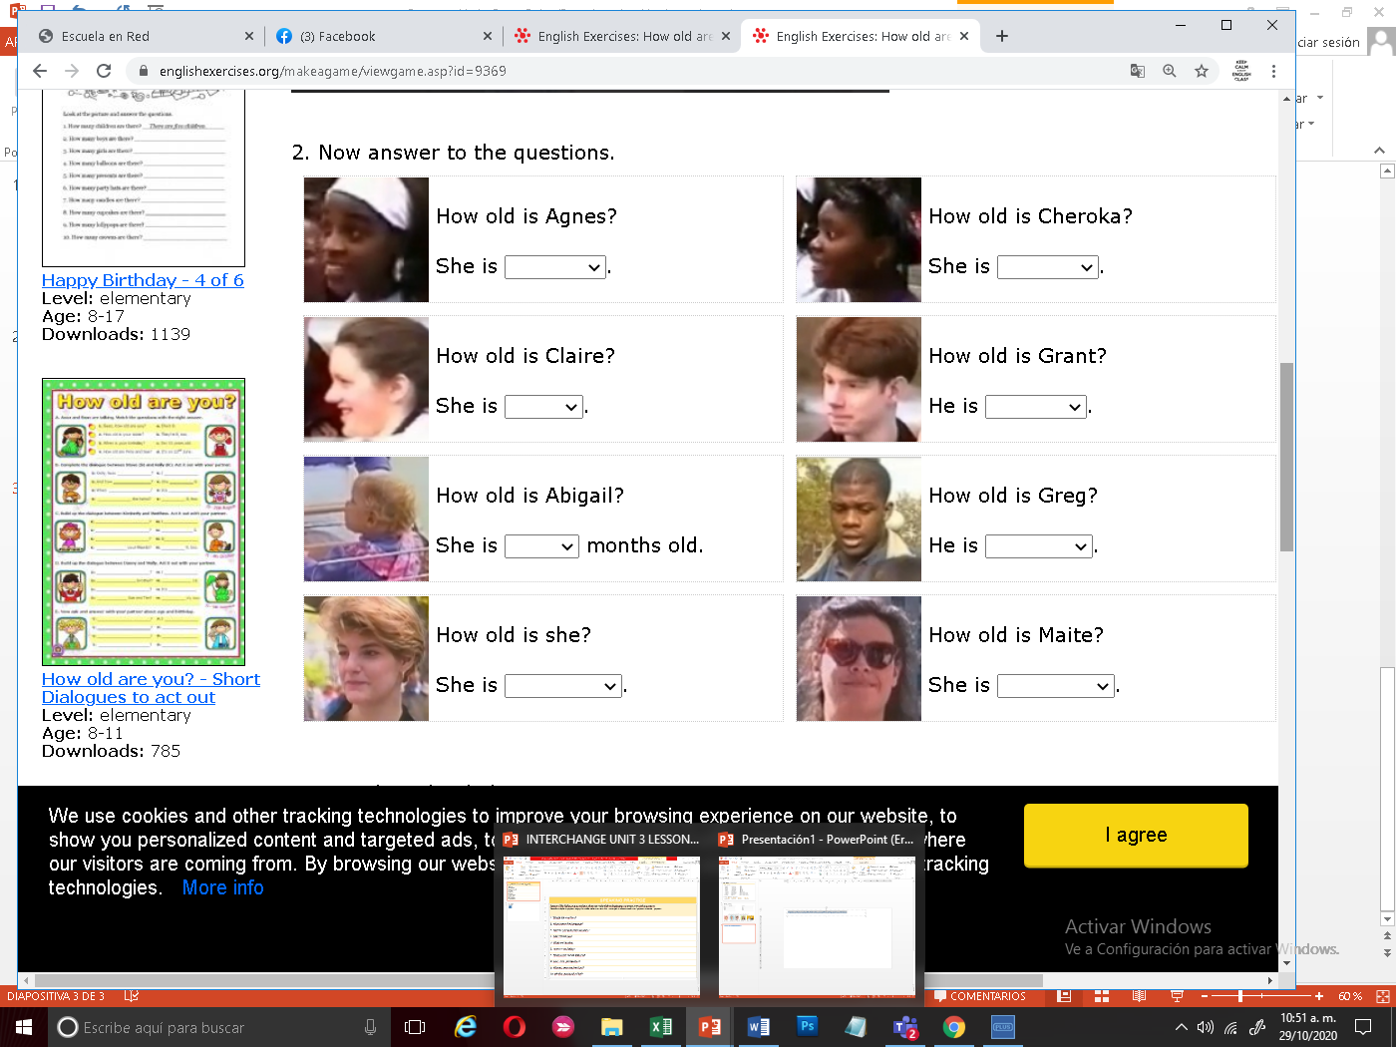

Fifteen years old

Eleven

Seventeen years old



Twenty two years old



Twenty one years old

Seventeen years old

Twenty years old

Eighteen years old