***UNIT 2***

***“HOW MUCH ARE THESE?”***

***AT THE DEPARTMENT STORE***

Look at the picture. Complete the conversations with *this*, *that*, *these*,   
*those*, *one*, or *ones*.

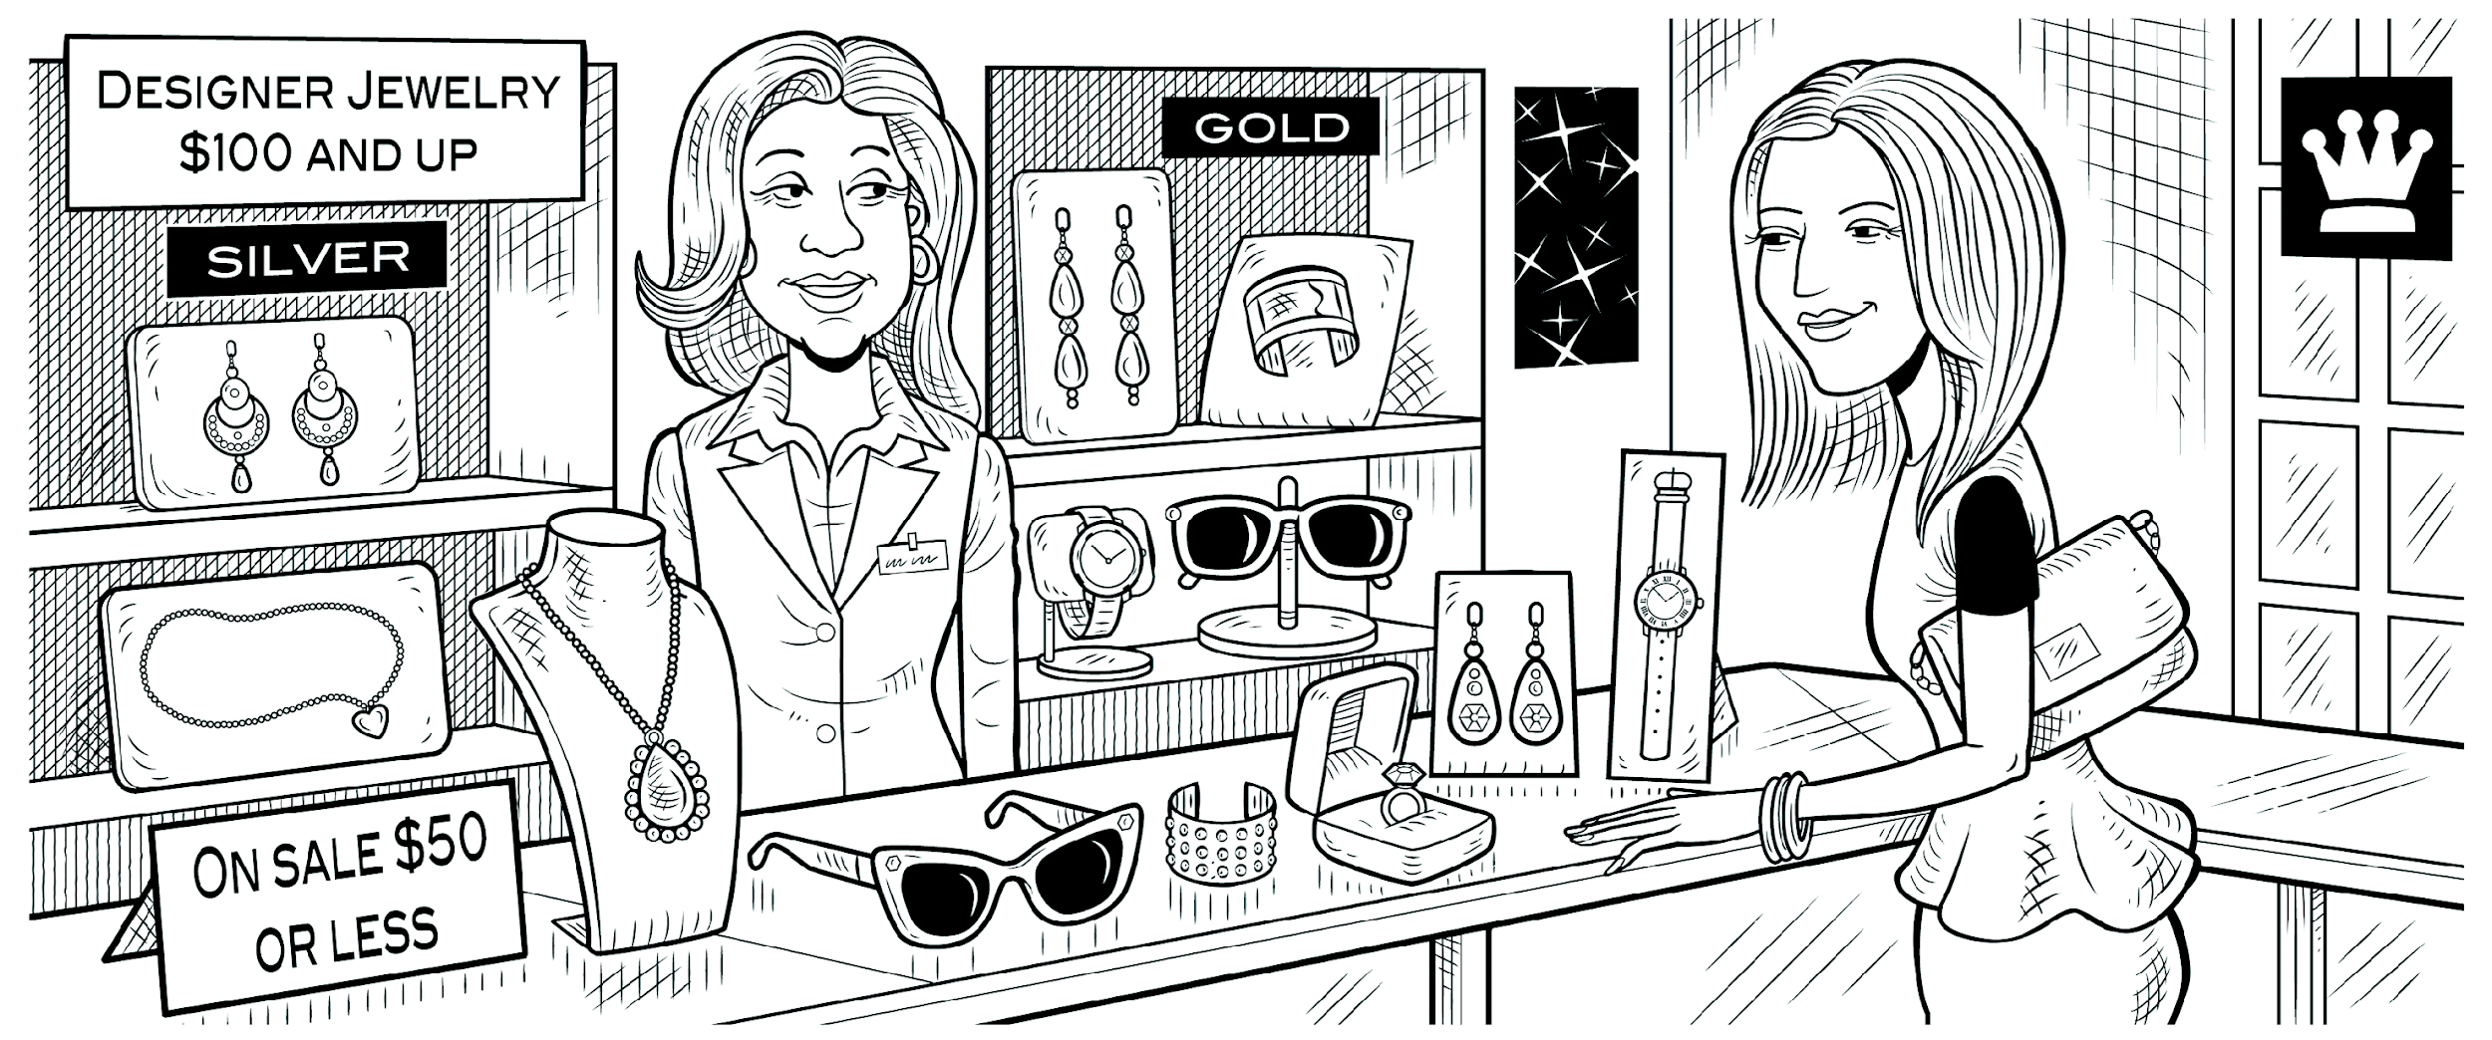

Lynn: Excuse me. How much is       that       necklace?

Clerk: Which THIS _________? They have different prices.

Lynn: The long THOSE__T_______ over there.

Clerk: It’s $119.

Lynn: How about THOSE _________ earrings over there?

Clerk: Do you mean the gold THIS _________?

Lynn: No, the silver _________.

Clerk: They’re $149.99.

Lynn: $150 for a pair of earrings! Wow! How much are THESE _________ earrings?

Clerk: They’re only $39.99.

Lynn: Hmm. Well, how much is THAT________ ring over here?

Clerk: It’s $29.50.

Lynn: Oh, that’s not bad.