AT THE DEPARTMENT STORE
Look at the picture. Complete the conversations with this, that, these,
those, one, or ones.
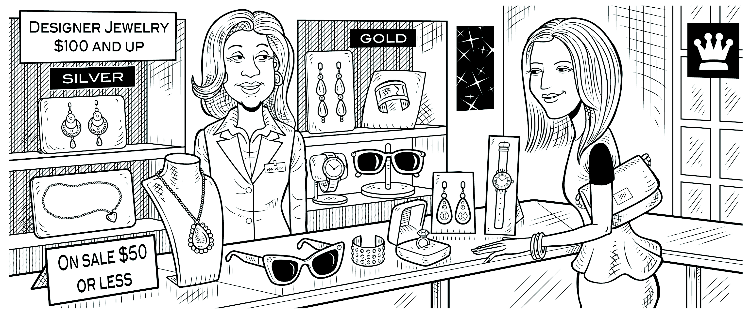
Lynn: Excuse me. How much is that necklace?
Clerk: Which one? They have different prices.
Lynn: The long that over there.
Clerk: It’s $119.
Lynn: How about those earrings over there?
Clerk: Do you mean the gold ones?
Lynn: No, the silver one.
Clerk: They’re $149.99.
Lynn: $150 for a pair of earrings! Wow! How much are these earrings?
Clerk: They’re only $39.99.
Lynn: Hmm. Well, how much is this ring over here?
Clerk: It’s $29.50.
Lynn: Oh, that’s not bad.

