ESCUELA NORMAL DE EDUCACIÓN PREESCOLAR


Materia: Inglés
Docente: Brenda Bollain y Goytia de la Peña
Alumna: Graciela de la Garza Barboza
3° semestre, sección “A”

4 de noviembre de 2020

AT THE DEPARTMENT STORE

Look at the picture. Complete the conversations with this, that, these,
those, one, or ones.
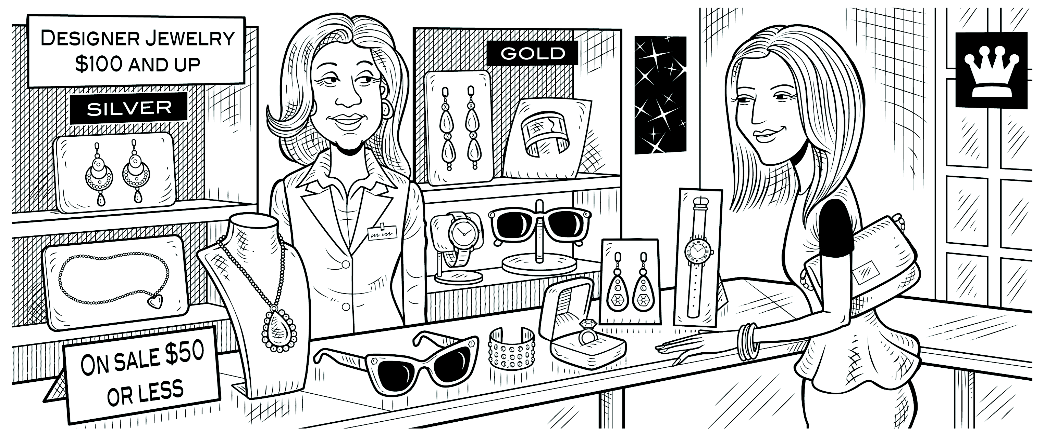
Lynn: Excuse me. How much is that necklace?
Clerk: Which ____these____? They have different prices.
Lynn: The long _____one____ over there.
Clerk: It’s $119.
Lynn: How about ___those______ earrings over there?
Clerk: Do you mean the gold _____ones____?
Lynn: No, the silver _____ones____.
Clerk: They’re $149.99.
Lynn: $150 for a pair of earrings! Wow! How much are ___these______ earrings?
Clerk: They’re only $39.99.
Lynn: Hmm. Well, how much is ____this _____ ring over here?
Clerk: It’s $29.50.
Lynn: Oh, that’s not bad.

