AT THE DEPARTMENT STORE

Look at the picture. Complete the conversations with this, that, these,   
those, one, or ones.

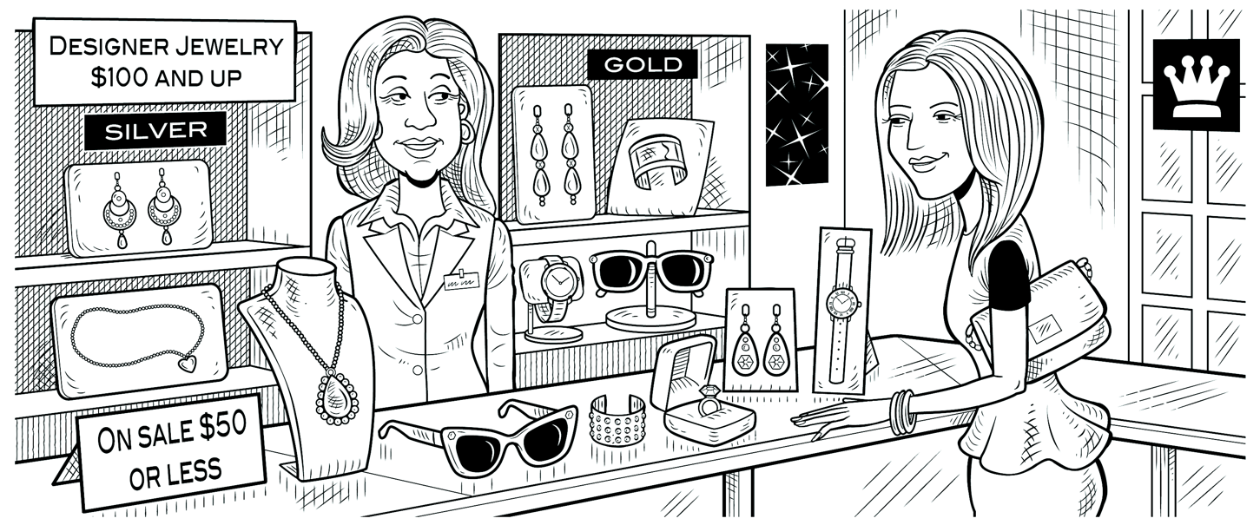

Lynn: Excuse me. How much is       that       necklace?

Clerk: Which one? They have different prices.

Lynn: The long one over there.

Clerk: It’s $119.

Lynn: How about those earrings over there?

Clerk: Do you mean the gold ones?

Lynn: No, the Silver ones.

Clerk: They’re $149.99.

Lynn: $150 for a pair of earrings! Wow! How much are ones earrings?

Clerk: They’re only $39.99.

Lynn: Hmm. Well, how much is this ring over here?

Clerk: It’s $29.50.

Lynn: Oh, that’s not bad.