AT THE DEPARTMENT STORE
Look at the picture. Complete the conversations with this, that, these,
those, one, or ones.
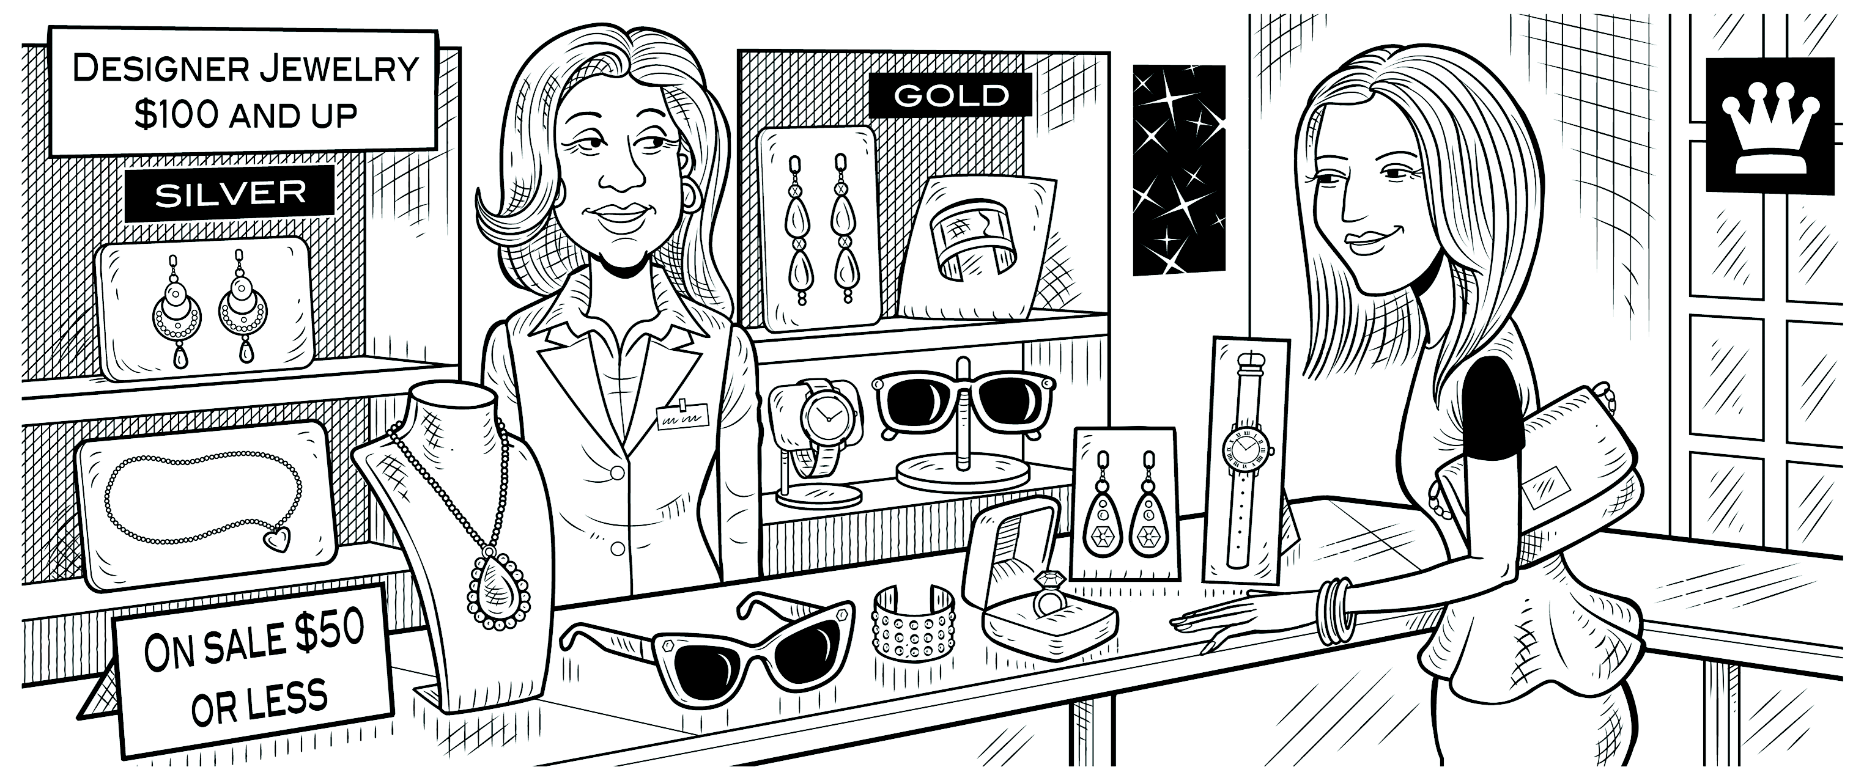
Lynn: Excuse me. How much is that necklace?
one
Clerk: Which oo ? They have different prices.
ones
Lynn: The long _________ over there.
Clerk: It’s $119.
those
Lynn: How about ________ earrings over there?
ones
Clerk: Do you mean the gold _______ __?
one
Lynn: No, the silver _______ __.
Clerk: They’re $149.99.
these
Lynn: $150 for a pair of earrings! Wow! How much are _________ earrings?
Clerk: They’re only $39.99.
this
Lynn: Hmm. Well, how much is _________ ring over here?
Clerk: It’s $29.50.
Lynn: Oh, that’s not bad.

