Discover the language

Watch the video (click on the youtube icon) and answer the questions.

**Tod          Mariela                 George         Sarah**

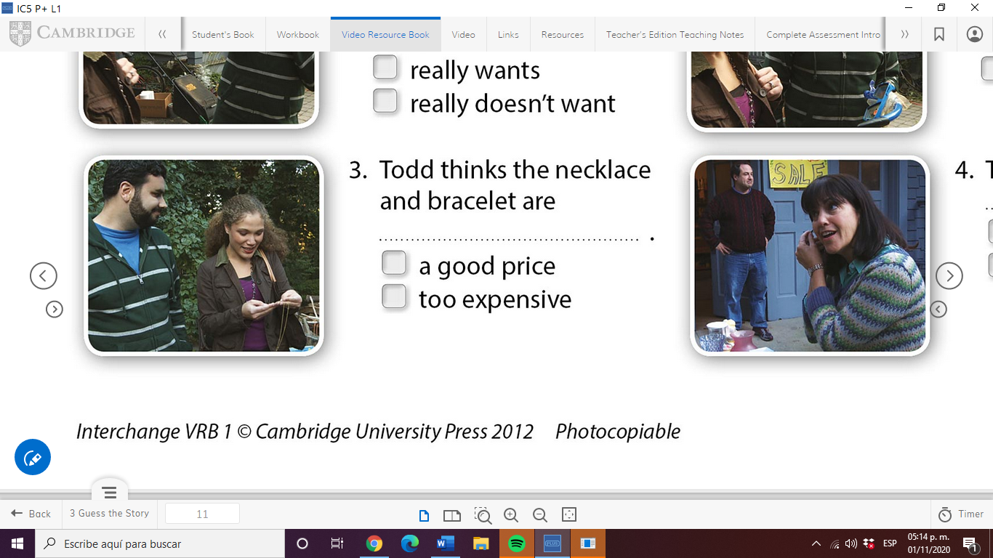        

|  |  |
| --- | --- |
| **Who says...** | **name** |
| Just look at **this** lovely old necklace. | Mariela |
| Oh, and look at **this** bracelet. | Mariela |
| Excuse me, how much are **these**? | Mariela |
| How much is **this** watch? | Mariela |
| Do you want **those**, too? | Sarah |
| Sarah, is **that** my mother's watch? | George |
| **This** watch is not for sale. | George |

The words **this/that/these/those** are called **DEMONSTRATIVES**

1. We use _**that**___ for a singular item near us.
2. We use __**this**___ for an item noun far from us.
3. We use __**these**__ for several items near us.
4. We use __**those**__ for several items far from us.

Check your answer below!!!

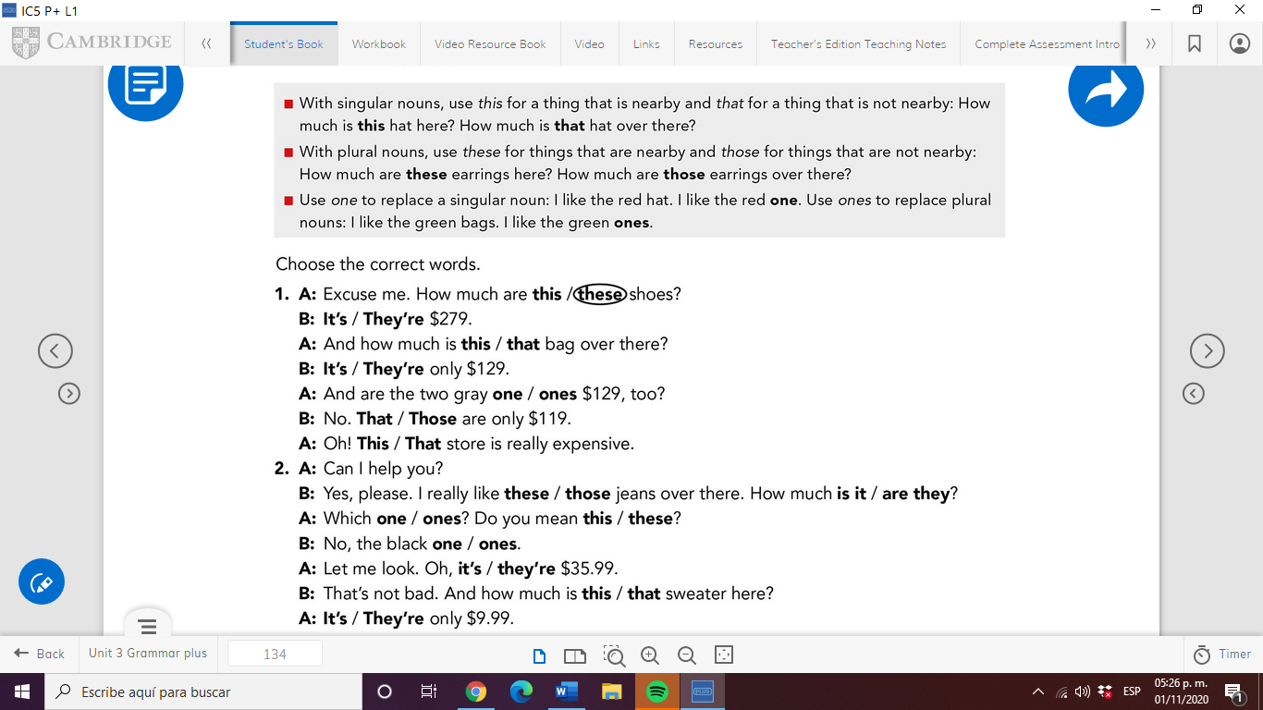

1

B: It’s

A: that

B: It’s

A: ones

B: That

A: This

2

B: those, are they

A: ones, these

B: ones

A: they’re

B: this

A: It’s

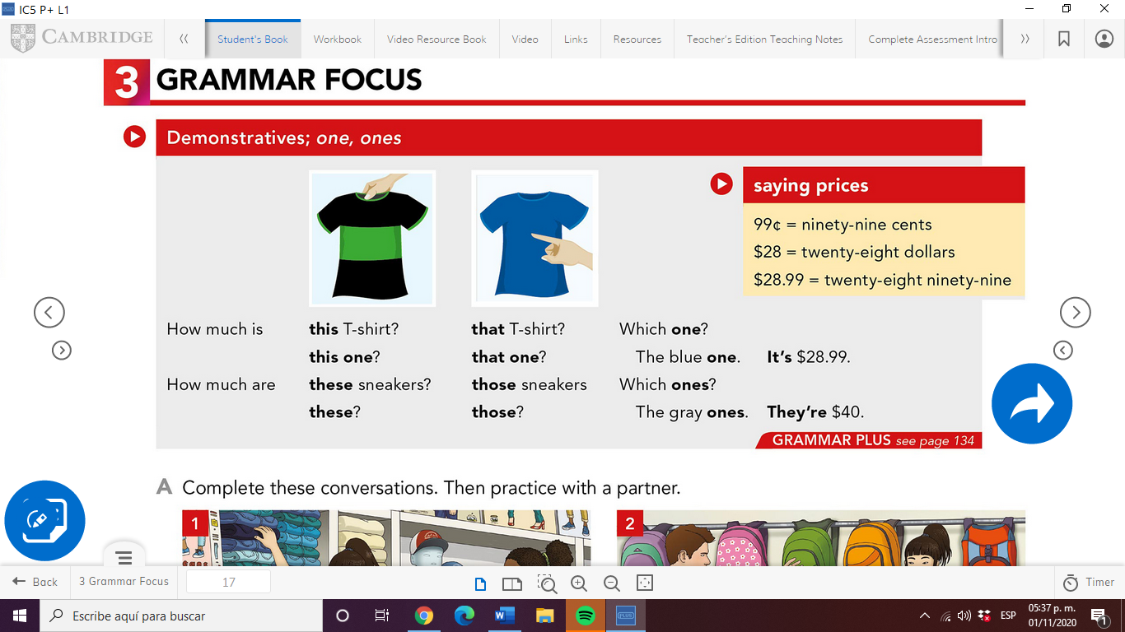

**WATCH THE VIDEO**

<https://www.youtube.com/watch?v=BcxmWhY-zx8>

**Posdata: Me confundo un poco con el tema aún (a pesar del vocabulario y videos), espero que estén bien: /**