Student: Daniela Guadalupe López Rocha.

Discover the language

Watch the video (click on the youtube icon) and answer the questions.

**Tod          Mariela                 George         Sarah**

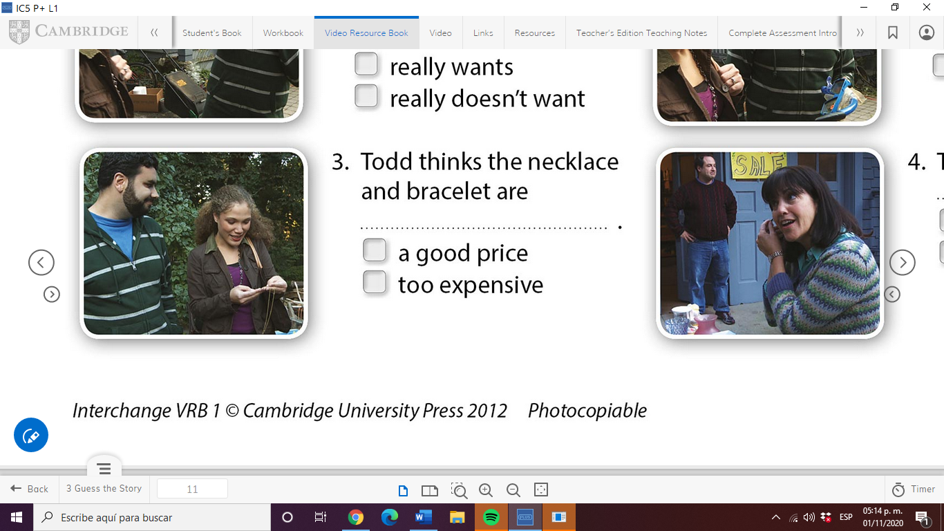                                  

|  |  |
| --- | --- |
| **Who says...** | **name** |
| Just look at **this** lovely old necklace. | Mariela |
| Oh, and look at **this** bracelet. | Mariela |
| Excuse me, how much are **these**? | Mariela |
| How much is **this** watch? | Mariela |
| Do you want **those**, too? | Sarah |
| Sarah, is **that** my mother's watch? | George |
| **This** watch is not for sale. | George |

The words **this/that/these/those** are called **DEMONSTRATIVES**

1. We use this for a singular item near us.
2. We use that for an item noun far from us.
3. We use these for several items near us.
4. We use those for several items far from us.

Check your answer below!!!

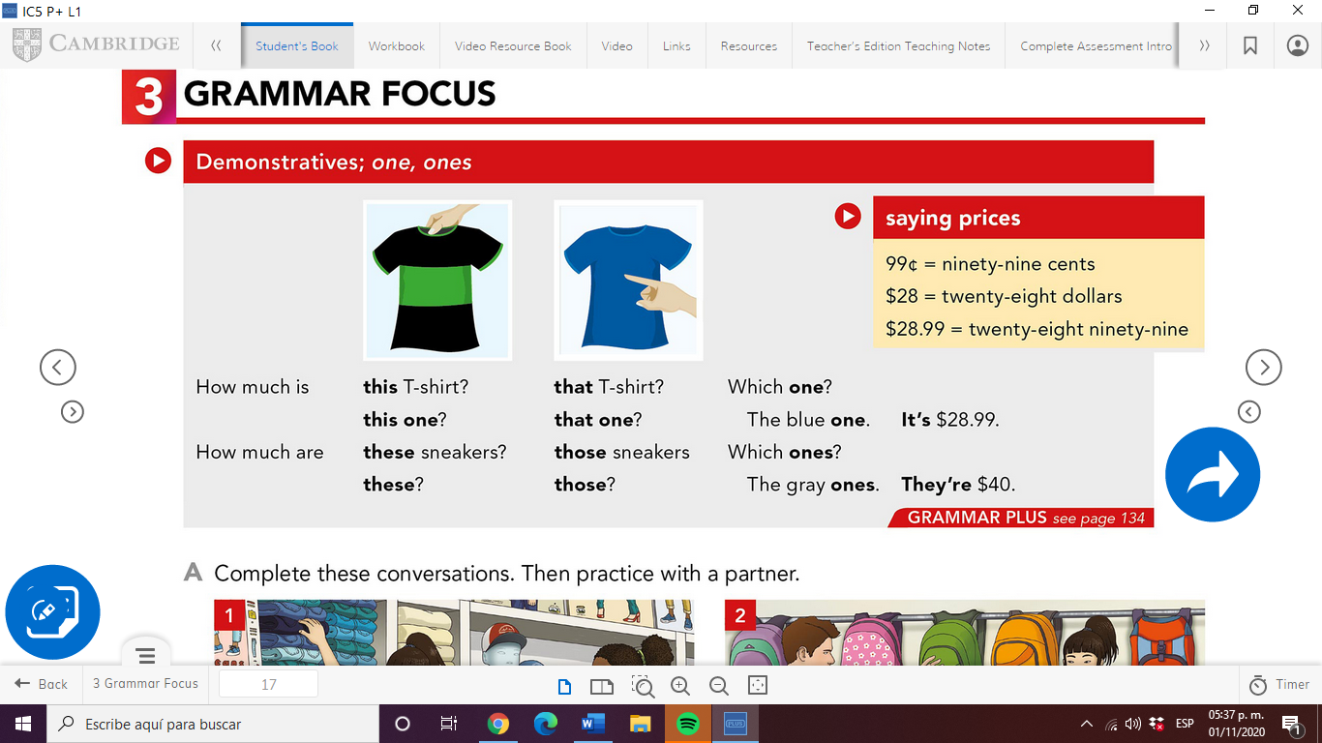

**WATCH THE VIDEO**

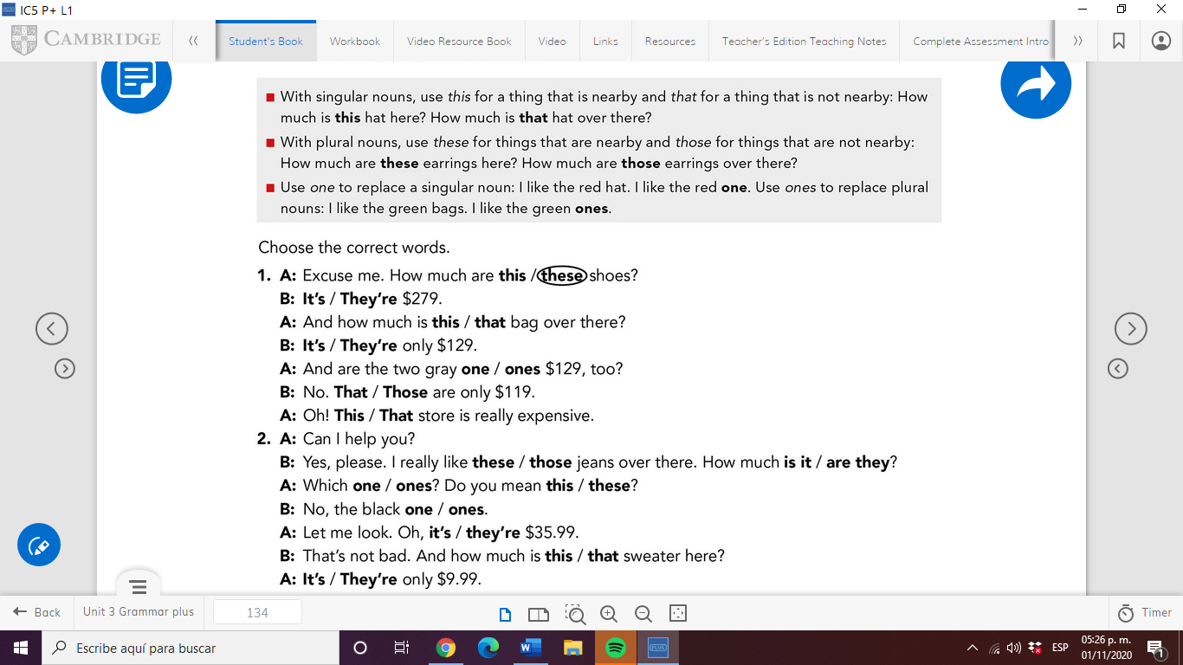<https://www.youtube.com/watch?v=BcxmWhY-zx8>