ESCUELA NORMAL DE EDUCACIÓN PREESCOLAR

Materia: Inglés

Docente: Brenda Bollain y Goytia de la Peña

Alumna: Graciela de la Garza Barboza

3° semestre, sección “A”

4 de noviembre de 2020

Discover the language

Watch the video (click on the youtube icon) and answer the questions.

**Tod Mariela George Sarah**

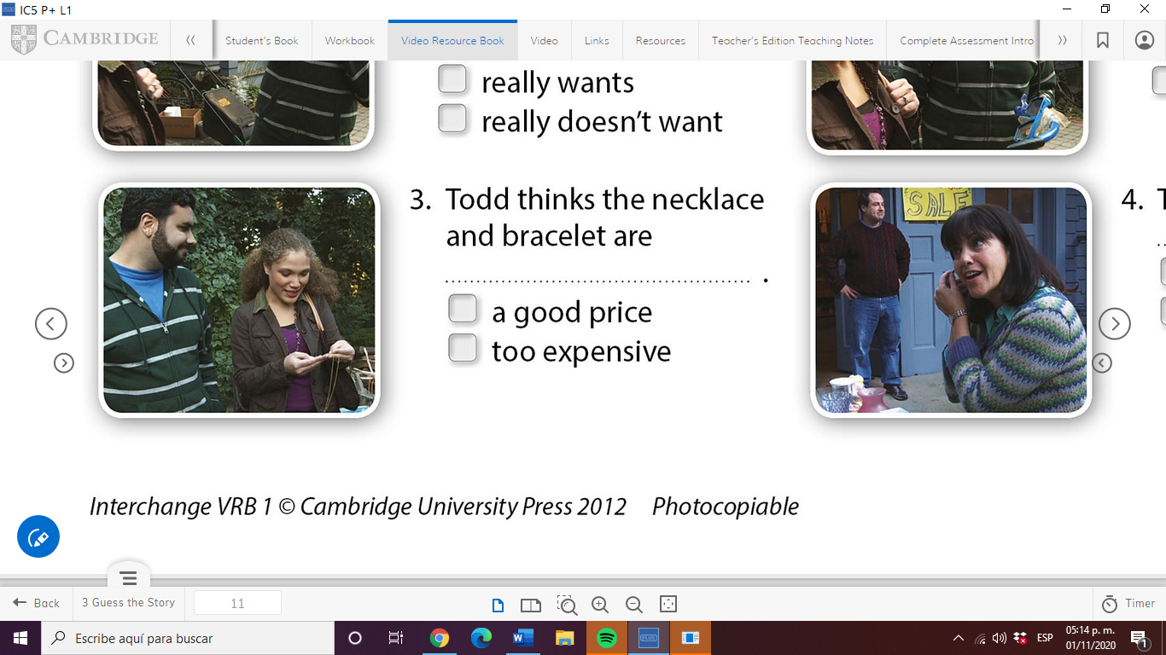 

|  |  |
| --- | --- |
| **Who says...** | **name** |
| Just look at **this** lovely old necklace. | Mariela. |
| Oh, and look at **this** bracelet. | Mariela. |
| Excuse me, how much are **these**? | Mariela. |
| How much is **this** watch? | Mariela. |
| Do you want **those**, too? | Sarah. |
| Sarah, is **that** my mother's watch? | George. |
| **This** watch is not for sale. | George. |

The words **this/that/these/those** are called **DEMONSTRATIVES**

1. We use _this___ for a singular item near us.
2. We use ___that_____ for an item noun far from us.
3. We use ___these_____ for several items near us.
4. We use ____those____ for several items far from us.

Check your answer below!!!

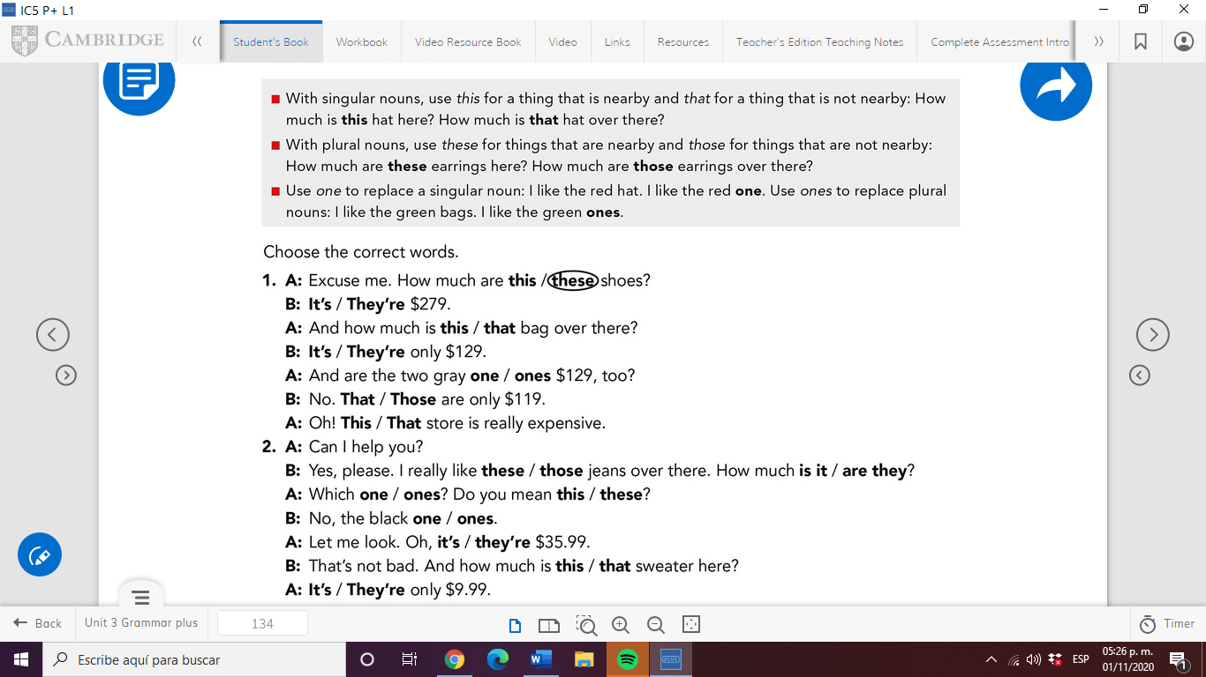

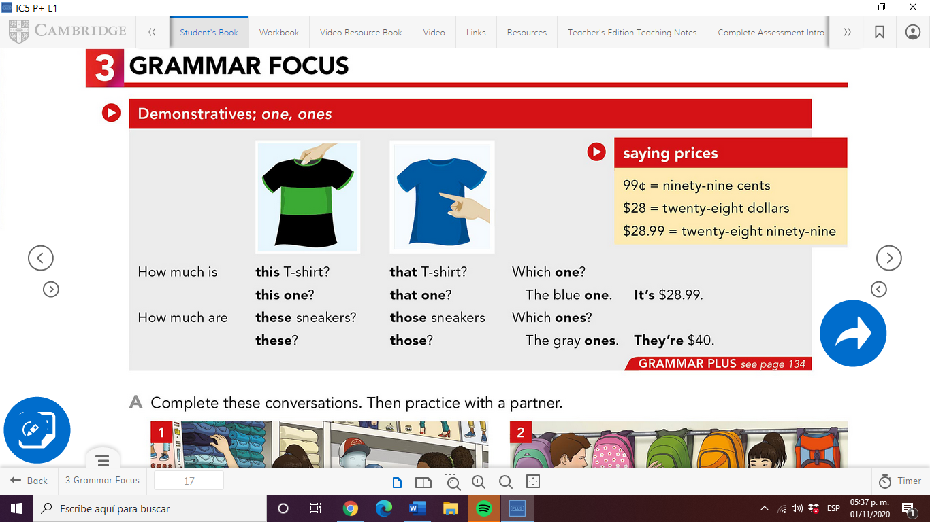

**WATCH THE VIDEO**

<https://www.youtube.com/watch?v=BcxmWhY-zx8>

<https://kahoot.it/challenge/515a977f-5af9-4fa7-ad69-272f3b11280d_1604276857365?&uid=SmVzc2ljYQ==>

