Discover the language

Watch the video (click on the youtube icon) and answer the questions.

**Tod Mariela George Sarah**

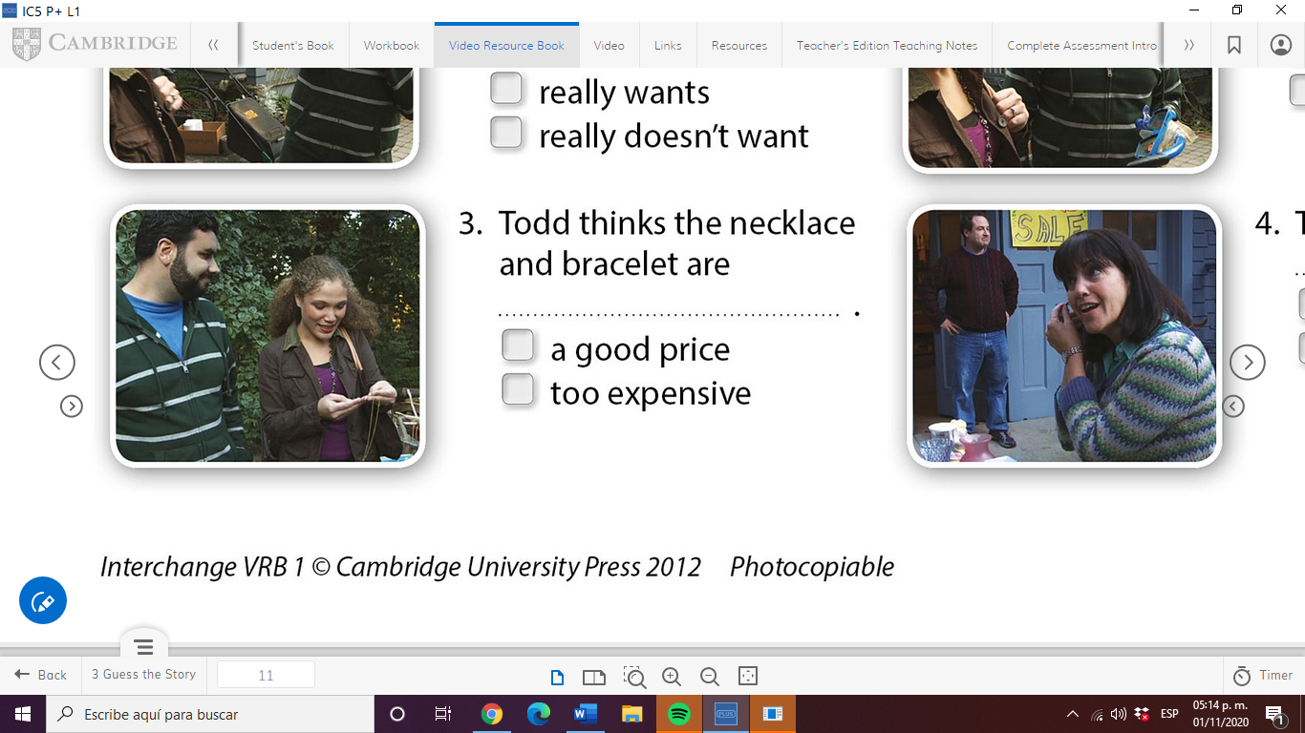 

|  |  |
| --- | --- |
| **Who says...** | **name** |
| Just look at **this** lovely old necklace. | Mariela |
| Oh, and look at **this** bracelet. | Mariela |
| Excuse me, how much are **these**? | Sarah |
| How much is **this** watch? | Mariela |
| Do you want **those**, too? | Sarah |
| Sarah, is **that** my mother's watch? | George |
| **This** watch is not for sale. | George |

The words **this/that/these/those** are called **DEMONSTRATIVES**

1. We use this for a singular item near us.
2. We use __that_____ for an item noun far from us.
3. We use __these___for several items near us.
4. We use ____those__for several items far from us.

Check your answer below!!!

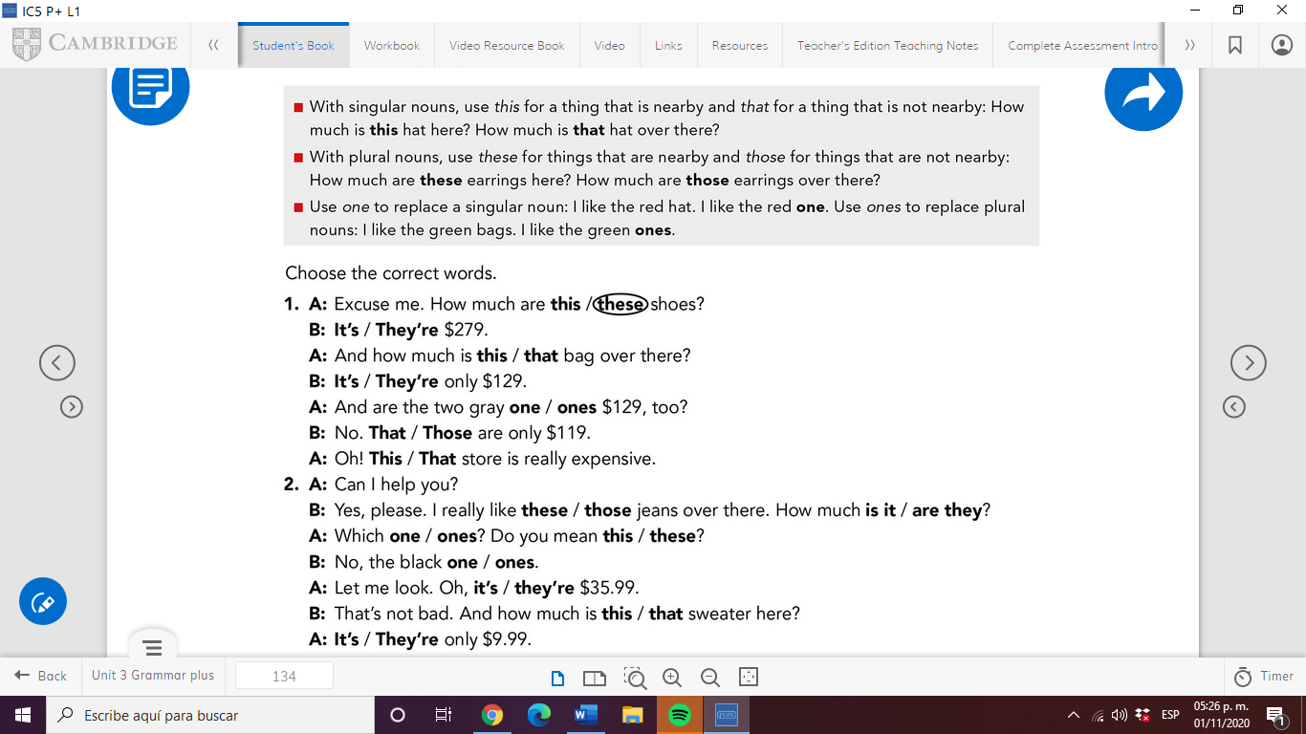

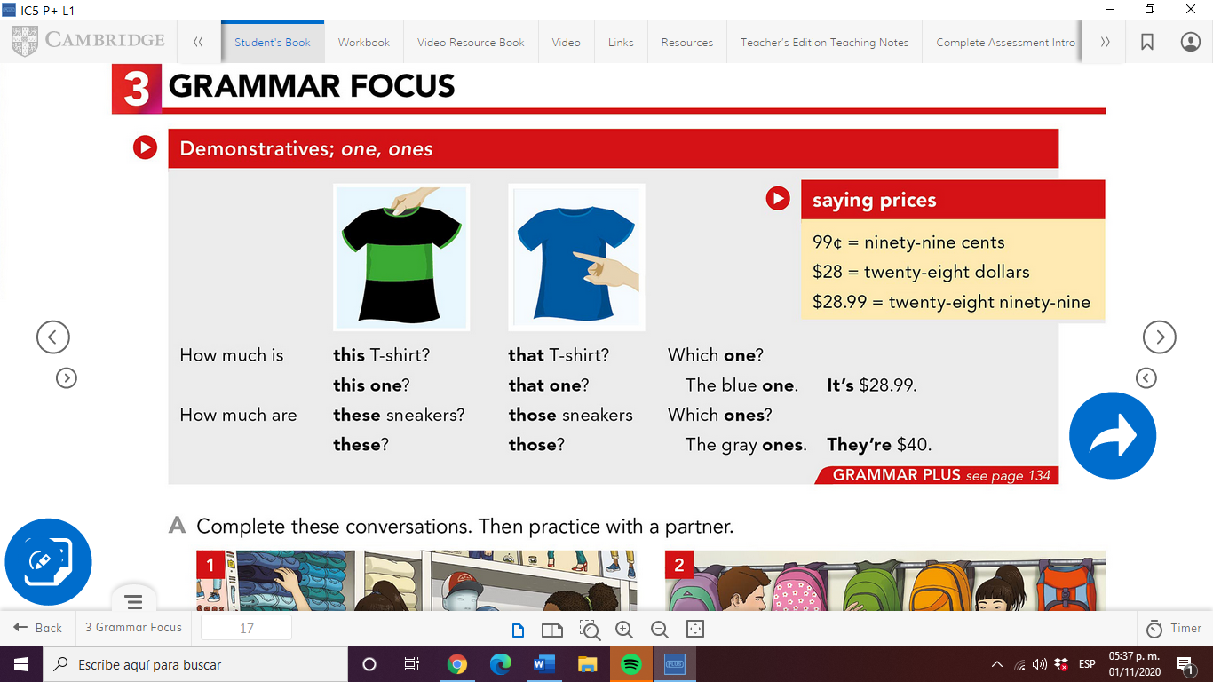

**WATCH THE VIDEO**

<https://www.youtube.com/watch?v=BcxmWhY-zx8>