**ESCUELA NORMAL DE EDUCACIÓN PREESCOLAR**

**ENGLISH B1**

**UNIT 1 – New Paths**

**Lessons 1 to 5 Extension Activities**

1. **Short report**

* Write a report (at least 150 words) including your answers to the following questions:
  + How do you usually feel when you are in a job interview? What things can you tell an employer about yourself to make him or her want to give you a job or promotion?
  + What make you a good candidate for the job?

Write your report here:

When I go to a job interview, I get nervous, but I focus on the abilities and skills that I must contribute and facilitate the position I want to achieve.

I am also looking for a way to communicate because I am interested in the position and how I contacted the interview.

I think I can talk to you about my experiences in different areas of work, in addition to the knowledge and areas of strength I have, I can talk about the position that interests me and the way in which I can adapt to what the position requesting.

I think I would be a good candidate, because I can adapt to situations and I try to prioritize the innovation of ideas to use my creativity to benefit.

I think the important thing when going to a job interview is the way we present ourselves, since the important thing is to go with a good attitude and presentation.

1. **SCREENSHOT**

* Complete lessons 1 to 5 from Unit 1, level 6, in the English for Success platform. Make a screenshot of your report and include it this document.

Include your screenshot here:

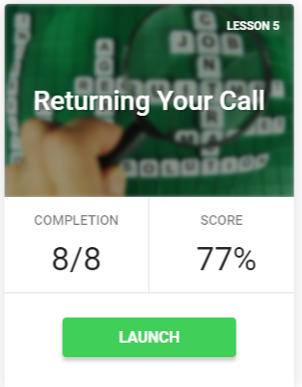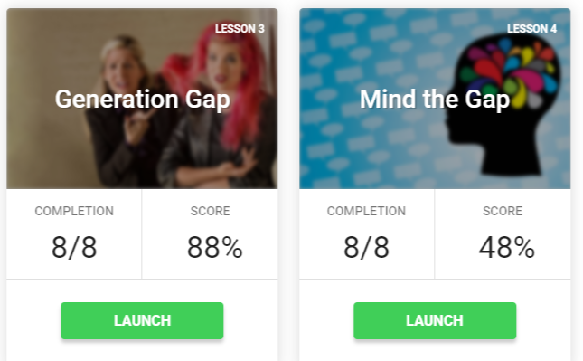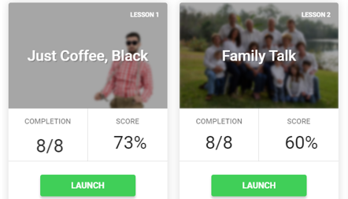

1. **EXPRESS YOUR IDEAS**

* In a 200-word paragraph explain how much influence doesyour family have on what you are going to do in the future. Do your and your family see your future differently? How?

Write your personal paragraph here:

**I personally believe that my family has a lot of impact and influence on what I have done, and the decisions that I have made.**

**I am currently in my penultimate year of the degree, and I think I would not be here if it were not for my family, because we have had many ups and downs, but the personal union that I have with my mother and my brother i motive to give continuity to my studies.**

**Currently this situation has caused many problems, my family and I believe that it is one more test to overcome, because from my perspective it is an opportunity to improve and vary the teaching process to which we were accustomed, since all this started to Without warning, no one was prepared for this situation, neither students nor teachers were trained to overcome this situation, however we have achieved it.**

**We do not see a future so different from what we live today, we simply believe that there will be more opportunities with respect to the labor and educational spheres, since our degree before was not so recognized and valued, and from this situation new ideas in the parents and communities.**