**ESCUELA NORMAL DE EDUCACIÓN PREESCOLAR**

**ENGLISH B1**

**UNIT 1 – New Paths**

**Lessons 1 to 5 Extension Activities**

1. **Short report**

* Write a report (at least 150 words) including your answers to the following questions:
  + How do you usually feel when you are in a job interview? What things can you tell an employer about yourself to make him or her want to give you a job or promotion?
  + What make you a good candidate for the job?

Write your report here:

At first I feel very nervous but sure of myself and my work, I try to speak as little as possible if asked, to be concrete in my answers and in a clear way. When I find myself in this situation, I talk about my skills and attitudes to whatever activity they put me on. I like to be responsible, respect my schedule, comply with what is asked of me, be honest in any situation, I try to show them with some work the commitment with what I do and that I try to do my best. In the same way, I talk about my work experience, how long it lasted in other places, and I present my letters of recommendation.

1. **SCREENSHOT**

* Complete lessons 1 to 5 from Unit 1, level 6, in the English for Success platform. Make a screenshot of your report and include it this document.

Include your screenshot here:

teacher the truth I had many problems with the platform some of the audios were not listened to and they did not show me all the activities that is why the low percentage :(

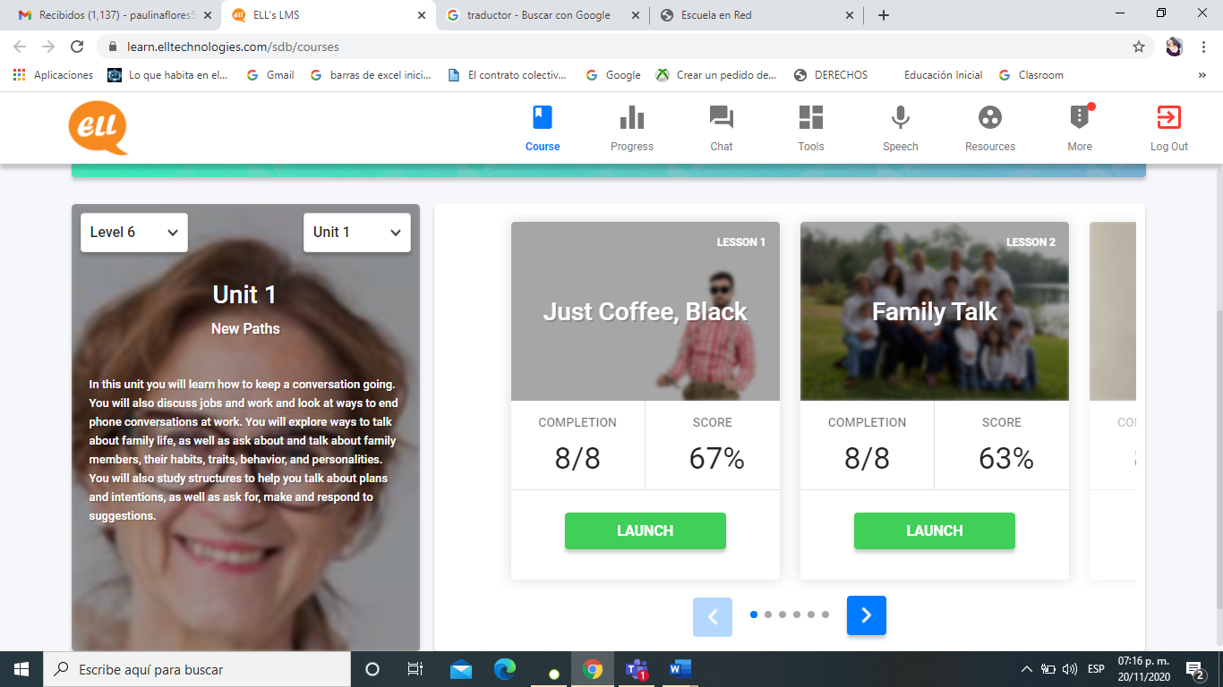 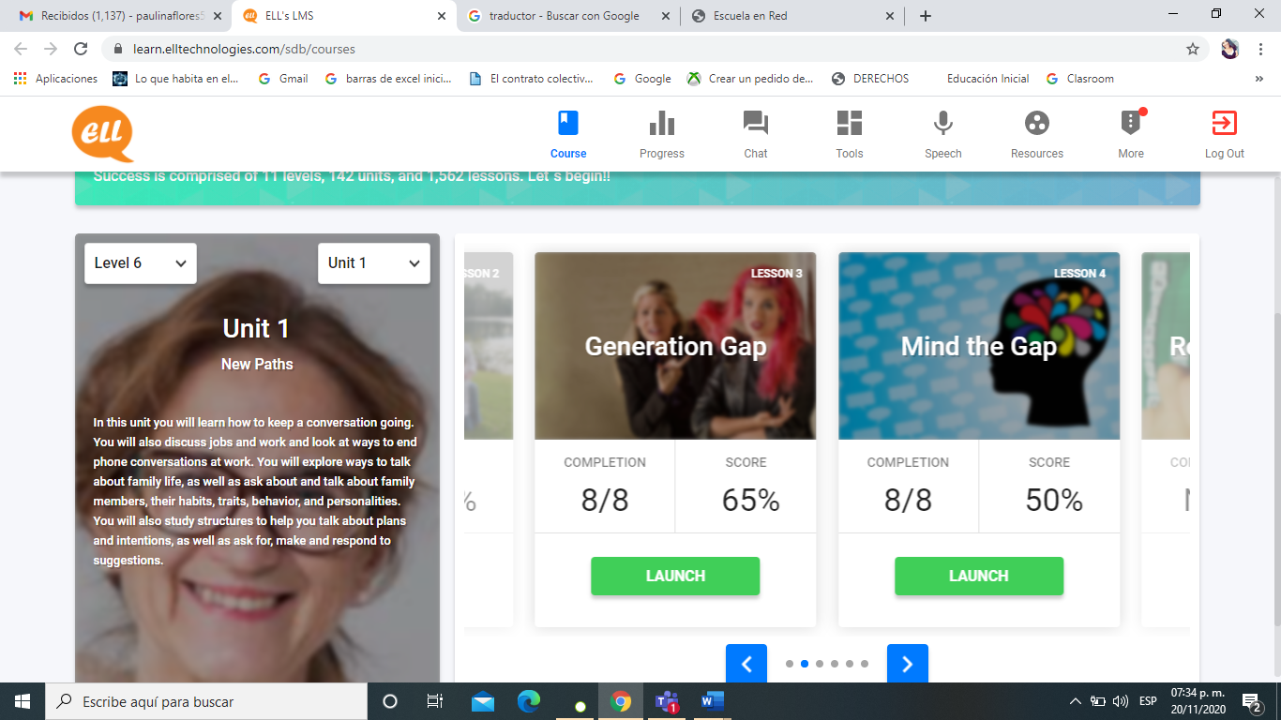 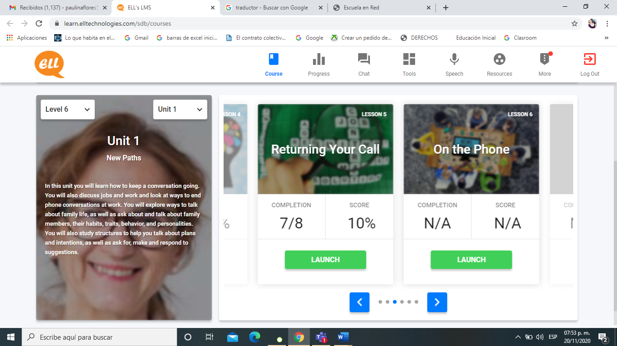

1. **EXPRESS YOUR IDEAS**

* In a 200-word paragraph explain how much influence does your family have on what you are going to do in the future. Do your and your family see your future differently? How?

Write your personal paragraph here:

Since I was little, I took into account what they told me about what would happen in my future, and what I wanted to be.

They, having other beliefs from living in another time, told me that I should study the same as them because it served them a lot in their future and that would happen the same with me. They influenced a large part in the decision that I would make about my future until I reached high school and I was making my own decisions to choose which career I would study although there were many options I went for the best one, which is preschool, at that time I told myself family that would take their advice a lot into account only if they would be constructive, because I already felt mature enough to choose the best for me and above all what I like, they took it in a good way and always support me in every decision. give their advice. That is why I consider that if we have different ways of thinking.