**ESCUELA NORMAL DE EDUCACIÓN PREESCOLAR**

**ENGLISH B1**

**UNIT 1 – New Paths**

**Lessons 1 to 5 Extension Activities**

1. **Short report**

* Write a report (at least 150 words) including your answers to the following questions:
  + How do you usually feel when you are in a job interview? What things can you tell an employer about yourself to make him or her want to give you a job or promotion?
  + What make you a good candidate for the job?

Write your report here:

I've only ever been to a job interview, when I was 17 and trying to get some money on summer vacation. When I am in a job interview, I feel a little nervous, but I try to flow in my vocabulary, to be confident and calm. The things I can say in a job interview are:

I am a patient, kind, responsible and respectful person. I like to help people. I enjoy working alone on projects or homework but also in a team, only if the members are as committed as I am and show responsibility as a TEAM. I am good at talking to people or giving announcements. I can use digital media or social networks, make videos or images to promote something, with basic tools. I maintain a good image of myself and although I may be insecure or doubtful, I know my ability. I am a reliable person for any position or task that may be assigned to me, I abide by the rules and instructions that they tell me.

1. **SCREENSHOT**

* Complete lessons 1 to 5 from Unit 1, level 6, in the English for Success platform. Make a screenshot of your report and include it this document.

Include your screenshot here:

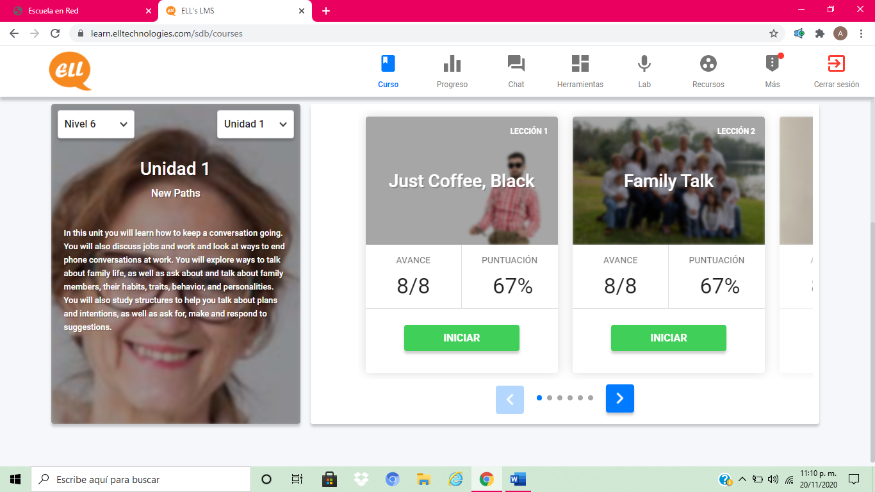

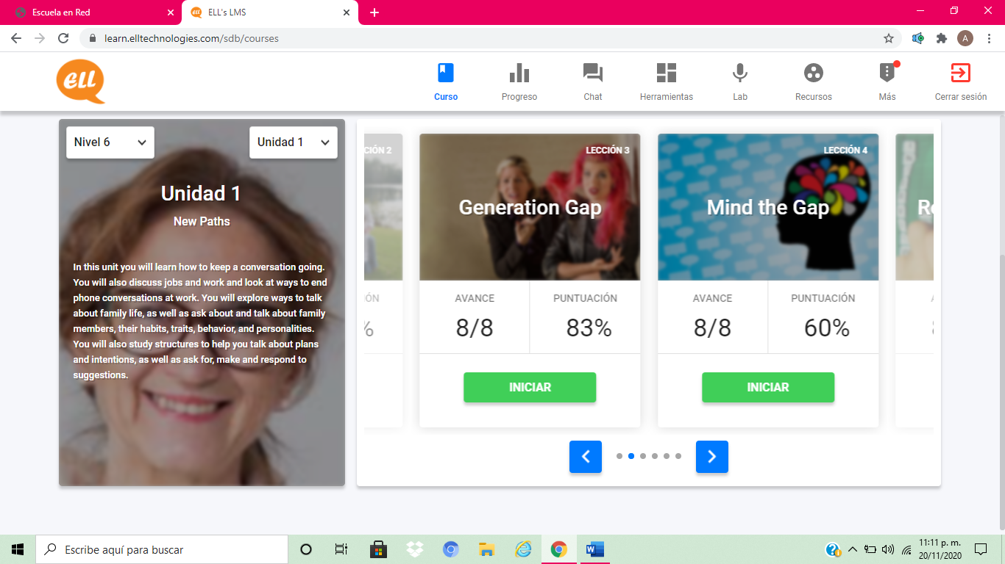

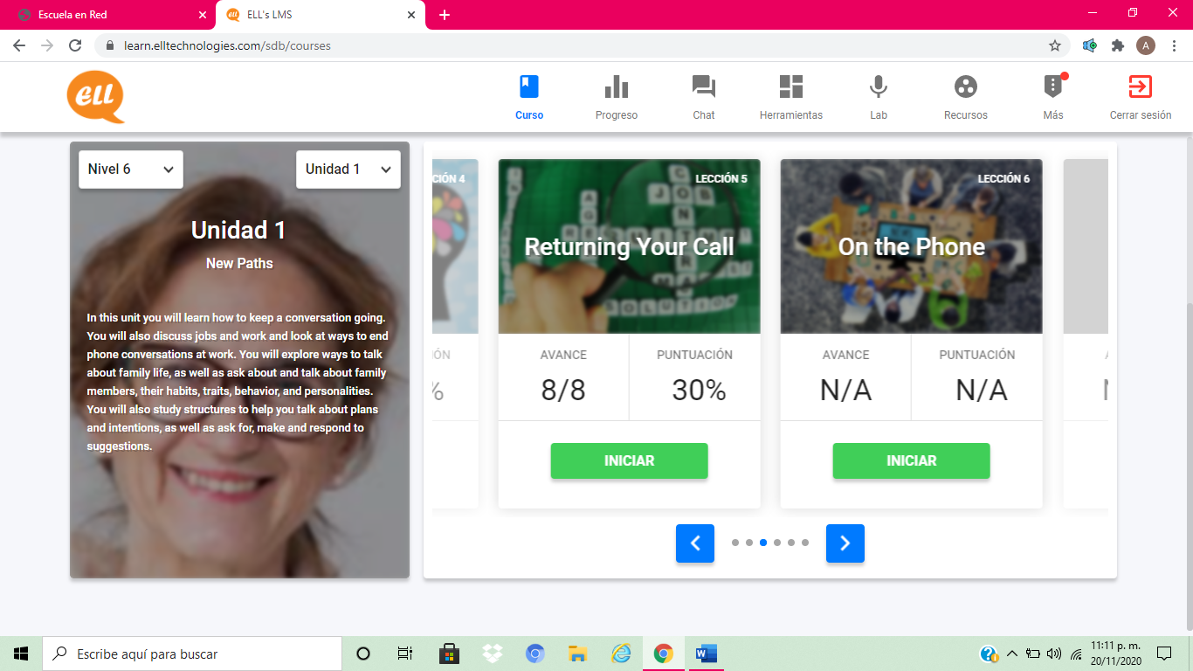

1. **EXPRESS YOUR IDEAS**

* In a 200-word paragraph explain how much influence does your family have on what you are going to do in the future. Do your and your family see your future differently? How?

Write your personal paragraph here:

My family has a lot of influence on my future due to the closeness we maintain now, in addition to the fact that my parents have given me everything to achieve development in different aspects, they have supported me financially and support me emotionally. I would like you to be in the most important moments of my life, since my graduation, my wedding, when I’m pregnant, even in the important moments of my children. Now, the future of the members of my family are going to a different destination, my brothers are married and have children, for reasons of work and stability for their family, they have to go live in Monclova. Meanwhile, my parents are in Ciudad Acuña and I am here now, due to the contingency due to COVID 19, but I hope to finish my studies in Saltillo in 2022. I do not know which path I will take, but I hope that anyone who will take either in Saltillo or Acuña, I plan to leave my parents' house and live in my own space at my own expense.

We may be doing different things, but I think we all want to be in constant communication.