**ESCUELA NORMAL DE EDUCACIÓN PREESCOLAR**

**ENGLISH B1**

**UNIT 1 – New Paths**

**Lessons 1 to 5 Extension Activities**

1. **Short report**

* Write a report (at least 150 words) including your answers to the following questions:
  + How do you usually feel when you are in a job interview? What things can you tell an employer about yourself to make him or her want to give you a job or promotion?
  + What make you a good candidate for the job?

Write your report here:

Usually in a job interview I feel nervous and anxious, But I think it is important to show that we are not. Days before I prepare my things and think what I'm going to say, I feel enthusiastic

something that interviewers pay attention to is that the candidate feels confident about himself.

So, it's important to mention our qualities and attitudes, the things you're good at.

I could say that I am a person sure of myself, organized, passionate about what I do, I like to help others and work as a team. I like to learn new things and keep preparing myself more and more.

I ‘m a good candidate for the job because I studied to work on this, it is also what I like to do, I think this makes me perform better. my personal and work qualities perfectly fit the available vacancy

1. **SCREENSHOT**

* Complete lessons 1 to 5 from Unit 1, level 6, in the English for Success platform. Make a screenshot of your report and include it this document.

Include your screenshot here:

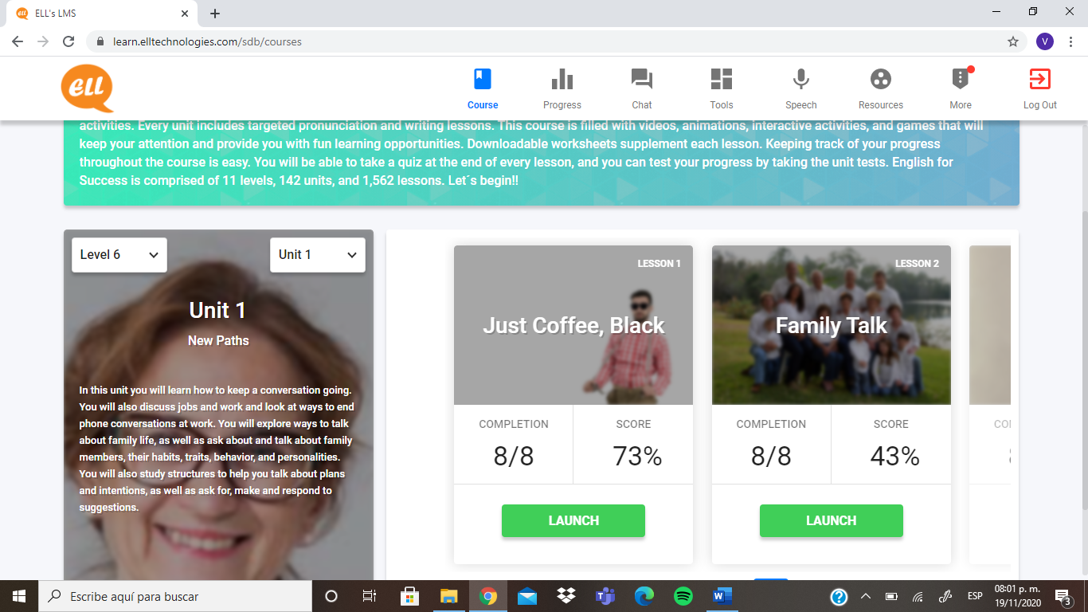

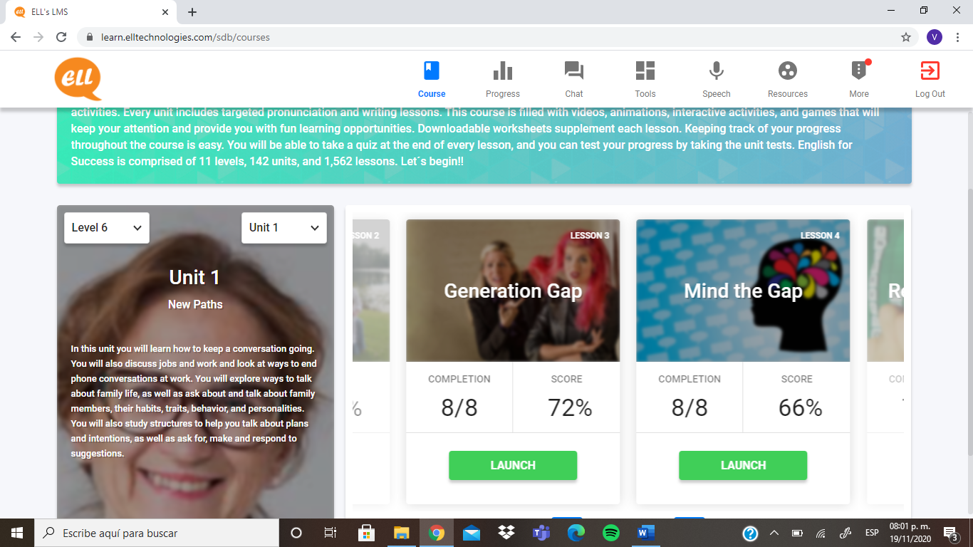

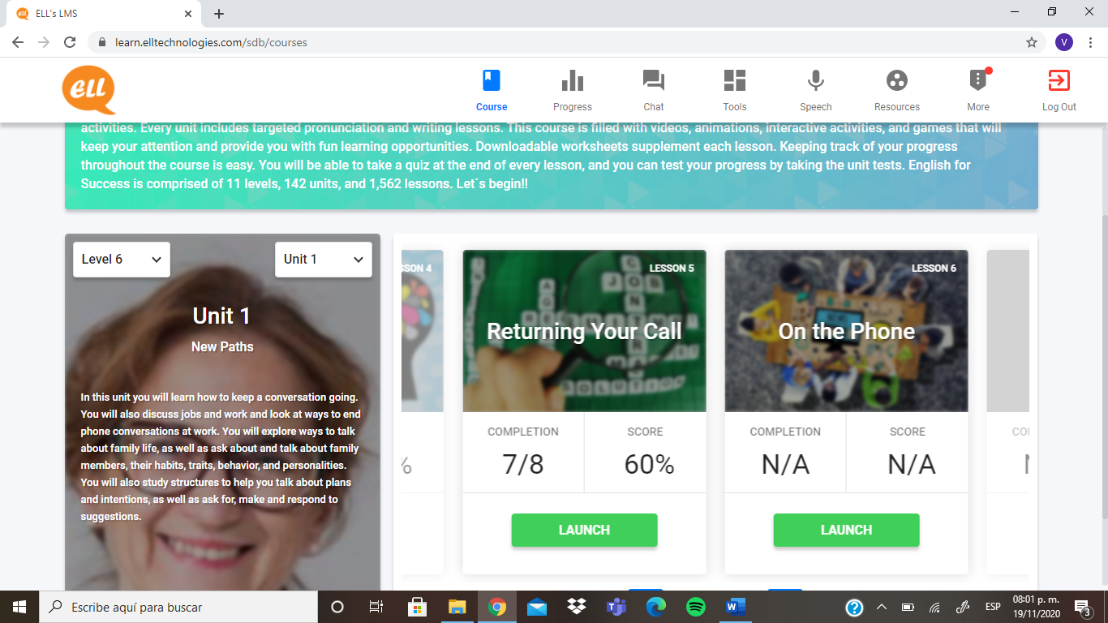

1. **EXPRESS YOUR IDEAS**

* In a 200-word paragraph explain how much influence does your family have on what you are going to do in the future. Do your and your family see your future differently? How?

Write your personal paragraph here:

I think my family influences my future a lot, Because since I was little, they have taught me many things, values, such as being responsible, honest, being kind to others, forming my own personality, Although they gave me the freedom to choose my tastes, I think they greatly influenced the person I am now and the person I want to be later. they gave me the opportunity to study, and above all to choose to study what I liked to.

my family and I see my future in the same way, in some things, for example, we all wait for me to continue studying, finish my teaching career, get a good job and be stable in my working life.

On the other hand, we do not agree on decisions of my personal life, like the age when I want to get married, whether I want to have children, where i want to live, etc.

although they always support me in my decisions, and I think that is important for what I want to achieve and the person I want to be in the future.