**ESCUELA NORMAL DE EDUCACIÓN PREESCOLAR**

**ENGLISH B1**

**UNIT 1 – New Paths**

**Lessons 1 to 5 Extension Activities**

1. **Short report**

* Write a report (at least 150 words) including your answers to the following questions:
  + How do you usually feel when you are in a job interview? What things can you tell an employer about yourself to make him or her want to give you a job or promotion?
  + What make you a good candidate for the job?

Write your report here:

Being in a job interview I think I would feel a little nervous, but sure of myself and what I know and study to be able to get the job.

In order to get the job it is important that they know that I can exploit my full potential and learning’s. I consider that I am a happy, positive person, that the problems of house do not affect me to be able to carry out my work and to give the best of my.

I am a good candidate for the job because I am a responsible, creative, punctual person, sometimes I can get stressed but I continue to do my jobs.

1. **SCREENSHOT**

* Complete lessons 1 to 5 from Unit 1, level 6, in the English for Success platform. Make a screenshot of your report and include it this document.

Include your screenshot here:

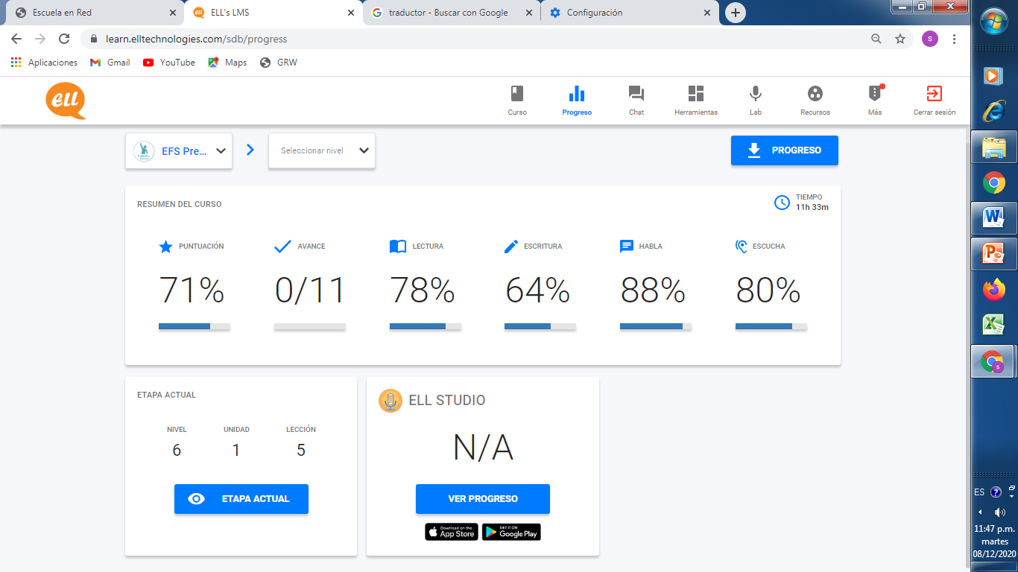

1. **EXPRESS YOUR IDEAS**

* In a 200-word paragraph explain how much influence does your family have on what you are going to do in the future. Do your and your family see your future differently? How?

Write your personal paragraph here:

Since I was little I knew what I wanted to be when I grew up, my dream has always been to be a preschool teacher. When I was in high school to go out, my family made me change my mind because of the pay issues of being a teacher, so I took a nursing exam, I passed the exam but I didn't like it and I left nursing, I got pregnant and I had to wait for that my baby was born so that I could follow my dreams of being a teacher and I am achieving it. Today my family supports me.