**ESCUELA NORMAL DE EDUCACIÓN PREESCOLAR**

**ENGLISH B1.2**

**UNIT 3 “LEND A HAND”**

**GRAMMAR**

Remember that we have two kinds of requests: direct and indirect. Complete the exercises and focus on the grammar structures for each kind of request.

* **VIDEO – DIRECT REQUESTS**

Go to https://www.youtube.com/watch?v=GQryco2Ih10 and watch the video analyzing the examples presented. Pay attention on the use of the verb (present, past or gerund).

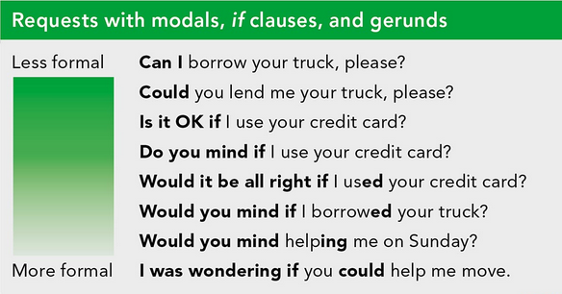

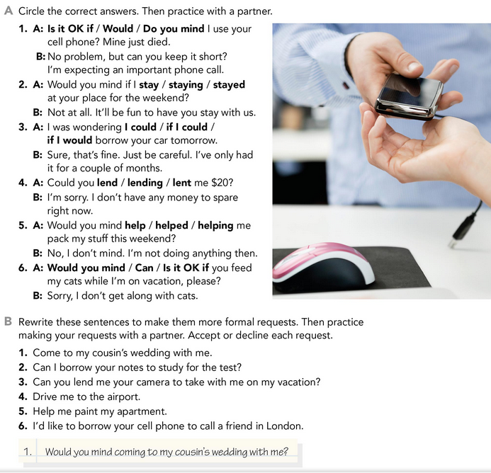

* **PRACTICE**



2. Would you mind borrowing your notes to study for the test? I’m sorry, I don´t do it.

3. Would you mind if you landed me your camera to take with me on vacation? Fine. no problem.

4. I was wondering if you could drive me to the airport. That’s ok. I guess.

5. Would you mind helping me paint my apartment? Unfortunately my hand is hurt and I can't move it.

6. Would you right if I borrowed your cell phone to call a friend in London? Sorry, but i have a plan and international calls are very expensive.

* **PRACTICE**

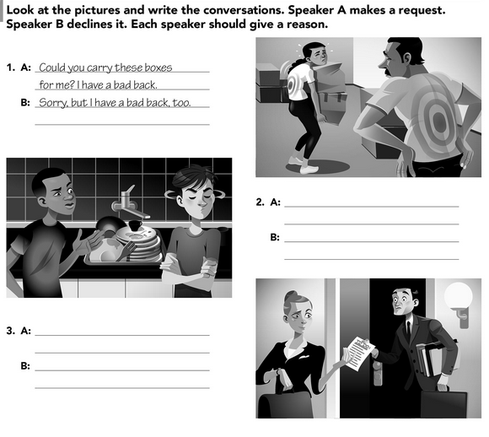

Sorry, but I late to my date.

Could you please make these notes for me?

Right now I do it, because my head hurts.

Could you wash the dishes today it's your turn?

* **VIDEO – INDIRECT REQUESTS**

Go to <https://www.youtube.com/watch?v=fAXjwcFInko&t=83s> and watch the video analyzing the examples presented.

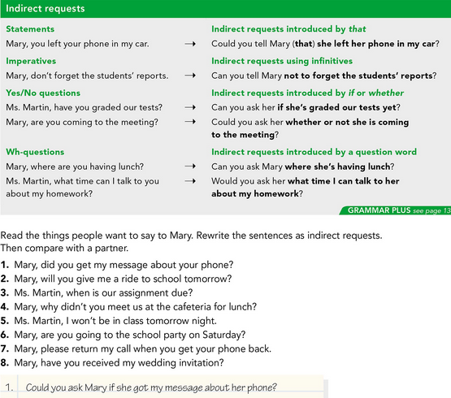

* **PRACTICE**



2. Could you ask Mary is she takes me to school tomorrow?

3. Could you ask Mrs. Martin when our allowance is due?

4. Can you ask Mary why she didn´t meet us in the cafeteria for lunch?

5. Can you tell Mrs. Martin that I won’t be in class tomorrow night?

6. Can you ask Mary if she going to the school party on Saturday?

7. Can you tell Mary to call me back when she gets her phone back?

8. Could you ask Mary if she received my wedding invitation?

* **PRACTICE**

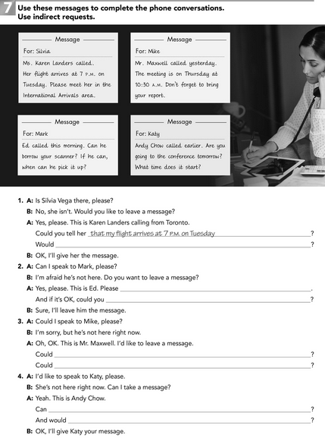

**You borrowed your scanner**

**You can he pick up**

**don´t foget to bring you report**

**The meeting is on Thursday at 10:30 am**

**Please meet her in the internationals arrivals area**