**ESCUELA NORMAL DE EDUCACIÓN PREESCOLAR**

**ENGLISH B1.2**

**UNIT 3 “LEND A HAND”**

**GRAMMAR**

Remember that we have two kinds of requests: direct and indirect. Complete the exercises and focus on the grammar structures for each kind of request.

* **VIDEO – DIRECT REQUESTS**

Go to https://www.youtube.com/watch?v=GQryco2Ih10 and watch the video analyzing the examples presented. Pay attention on the use of the verb (present, past or gerund).

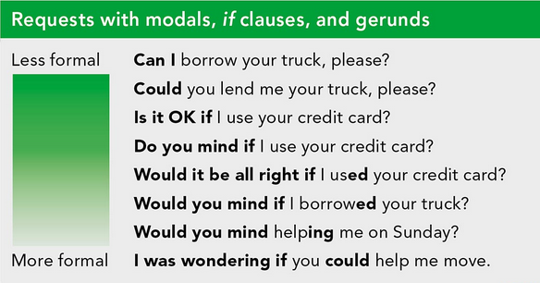

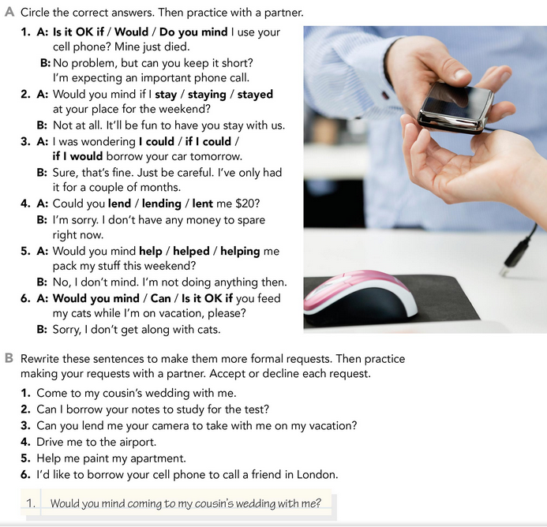

* **PRACTICE**



2. **Would you mind if I borrowed your grades to study for the exam?**

3. **I was wondering if you could lend me your camera to take me on vacation.**

4. **Would you mind taking me to the airport?**

5. **Would it be all right if you helped me paint my apartment?**

6. **I was wondering if you could borrow your cell phone to call a friend in London.**

* **PRACTICE**

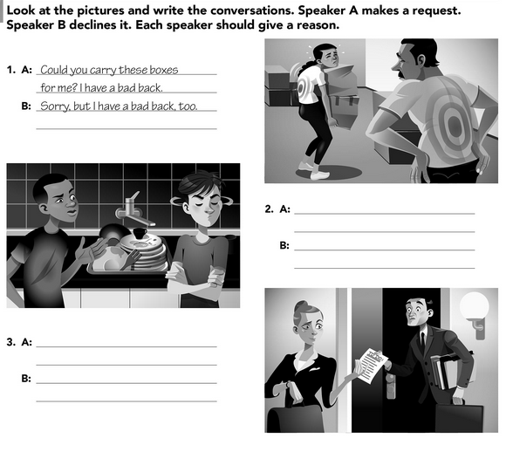

**Can you wash the fret please?**

**I'm sorry, boss, but it's my departure time.**

**No, you don't see that I have a lot of tables to attend to.**

**Would you mind checking this report again?**

* **VIDEO – INDIRECT REQUESTS**

Go to <https://www.youtube.com/watch?v=fAXjwcFInko&t=83s> and watch the video analyzing the examples presented.

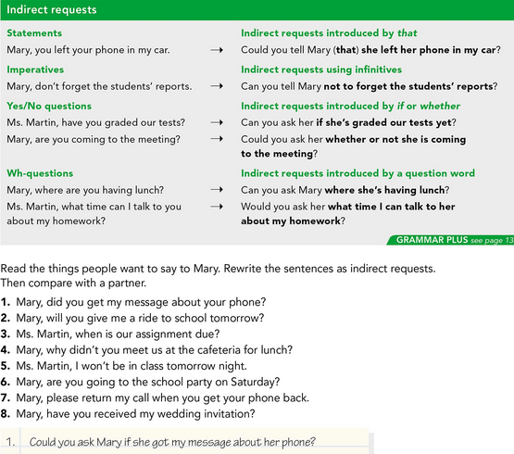

* **PRACTICE**



2. **Can you ask Mary if she's give me a ride to school tomorrow?**

3. **Would you ask Mrs. Martin when you sell our assignment?**

4. **Can you tell me Mary why you didn't meet us at the cafeteria for lunch?**

5. **Could you tell me that she won't be in class tomorrow night?**

6. **Could you ask her if she's going to the school party on Saturday?**

7. **Would you call me Back Mary when you get your phone back?**

8. **Can you ask him if he's received my wedding invitation?**

* **PRACTICE**

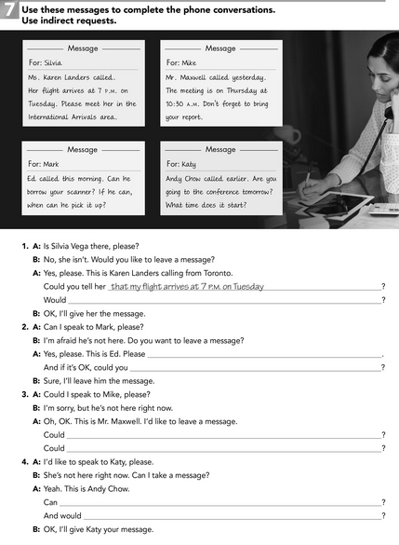

**you ask her what time it starts**

**you ask if she's going to the conference tomorrow**

**you tell not to forget to bring your report**

**you tell him the meeting is Thursday at 10:30 a.m.**

**ask him when I can pick him up**

**can he borrow your scanner?**

**Would you ask her meet in the International Arrivals area?**