**ESCUELA NORMAL DE EDUCACIÓN PREESCOLAR**

**ENGLISH B1.2**

**UNIT 3 “LEND A HAND”**

**GRAMMAR**

Remember that we have two kinds of requests: direct and indirect. Complete the exercises and focus on the grammar structures for each kind of request.

* **VIDEO – DIRECT REQUESTS**

Go to https://www.youtube.com/watch?v=GQryco2Ih10 and watch the video analyzing the examples presented. Pay attention on the use of the verb (present, past or gerund).

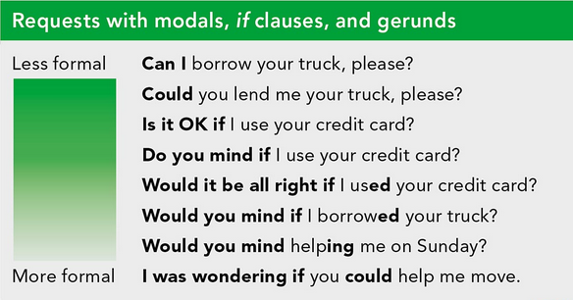

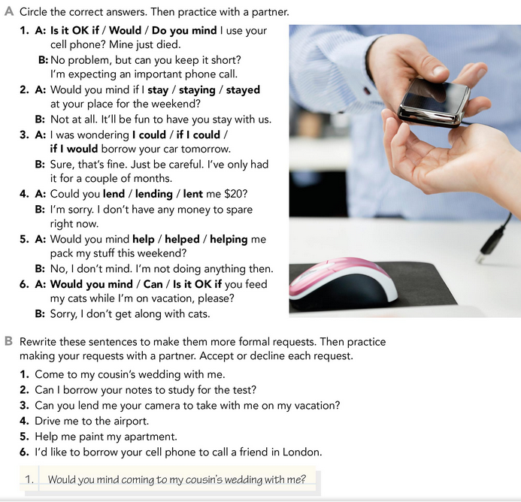



* **PRACTICE**



2. would you mind if I borrowed your notes to study for the test?

3. I was wondering if you could lend me your camera to take with me on vacation.

4. Would you mind driving me to the airport?

5. Would you mind helping me paint my apartment.?

6. I was wondering if I borrowed your cell phone to call a friend in London

* **PRACTICE**

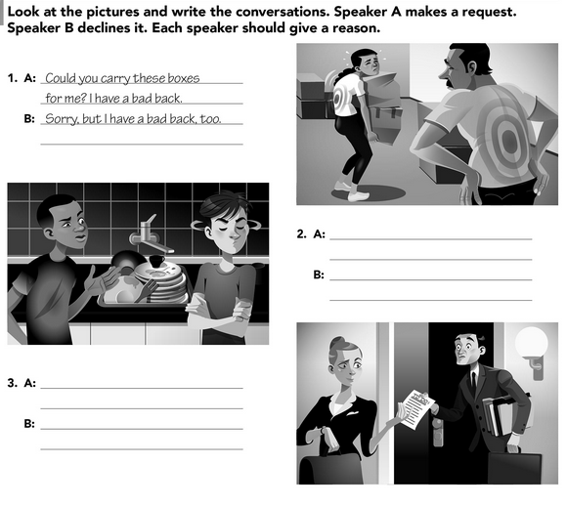

2. A. Do you mind if wash the dishes you used?

B. Sorry i'm late for work

3. A. I was wondering if you could check the files please?

B. I'm sorry I have a lot of work.

* **VIDEO – INDIRECT REQUESTS**

Go to <https://www.youtube.com/watch?v=fAXjwcFInko&t=83s> and watch the video analyzing the examples presented.

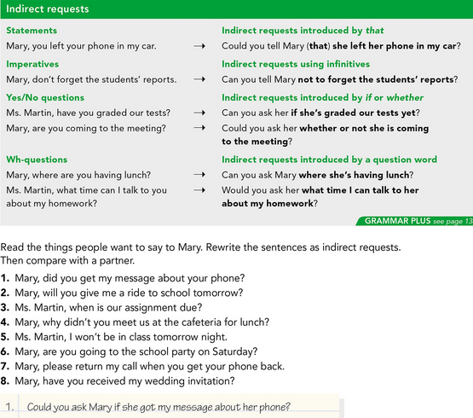

* **PRACTICE**



2. Can you ask Mary if she gave me a ride to school tomorrow?

3. Would you ask her when is our assignment due?

4. Can you ask Mary why didn’t she’s meet us at the cafeteria for lunch?

5. Could you tell Ms. Martin, that I won’t be in class tomorrow night?

6. Could you ask her whether or not she is going to the school party on Saturday?

7. Can you tell Mary return my call when she got our phone back?

8. Can you ask her if she’s received my wedding invitation?

* **PRACTICE**

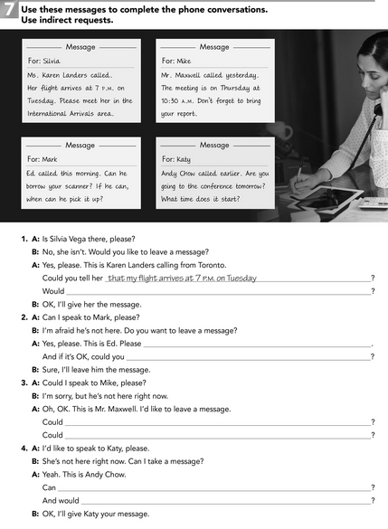

1. Would you ask meet I in the International Arrivals Area?
2. Could you tell you if her called this morning?
3. Could you tell her that the meeting is on Thursday at 10:30 am?

Could you tell Mike no to forget to bring our report?

1. Can you ask Katy if she going to the conference?