**ESCUELA NORMAL DE EDUCACIÓN PREESCOLAR**

**ENGLISH B1.2**

**UNIT 3 “LEND A HAND”**

**GRAMMAR**

Remember that we have two kinds of requests: direct and indirect. Complete the exercises and focus on the grammar structures for each kind of request.

* **VIDEO – DIRECT REQUESTS**

Go to https://www.youtube.com/watch?v=GQryco2Ih10 and watch the video analyzing the examples presented. Pay attention on the use of the verb (present, past or gerund).

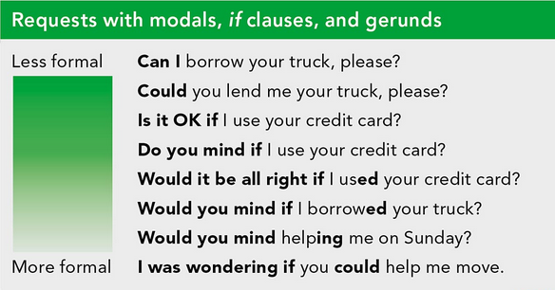

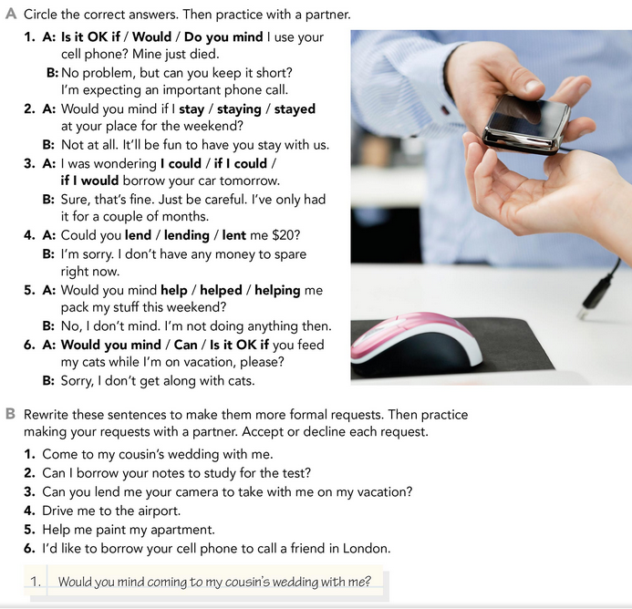

* **PRACTICE**



2. Would you mind if you borrowing your notes to study for the test?

3. I was wondering if you could lend me your camera to take with me on my vacation, please?

4. Would you mind driving me to the airport.

5. Do you mind if you help me painting my apartment.

6. Would it be all right if I borrow your cell phone to call a friend in London?

* **PRACTICE**

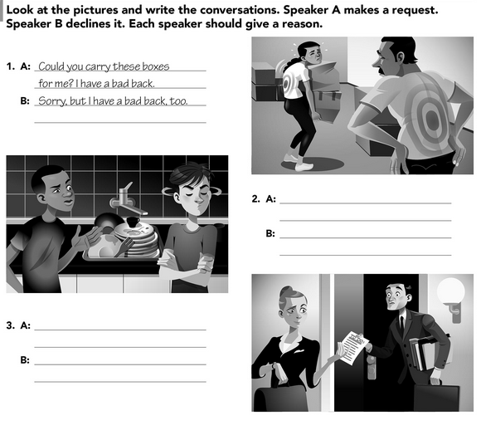

Catalina, could you please make these notes for me?

Sorry, I’m late to my date, it will be in other chance.

Jhon, could you wash those dishes? They have a week there.

No, I don´t have time to do that, wash them you.

* **VIDEO – INDIRECT REQUESTS**

Go to <https://www.youtube.com/watch?v=fAXjwcFInko&t=83s> and watch the video analyzing the examples presented.

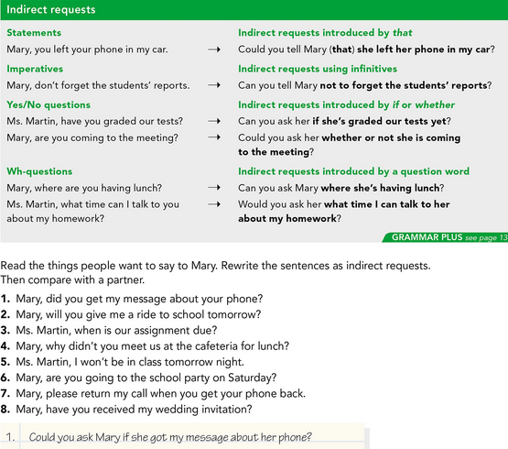

* **PRACTICE**



2.

3.

4.

5.

6.

7.

8.

* **PRACTICE**

