**ESCUELA NORMAL DE EDUCACIÓN PREESCOLAR**

**ENGLISH B1.2**

**UNIT 3 “LEND A HAND”**

**GRAMMAR**

Remember that we have two kinds of requests: direct and indirect. Complete the exercises and focus on the grammar structures for each kind of request.

* **VIDEO – DIRECT REQUESTS**

Go to https://www.youtube.com/watch?v=GQryco2Ih10 and watch the video analyzing the examples presented. Pay attention on the use of the verb (present, past or gerund).

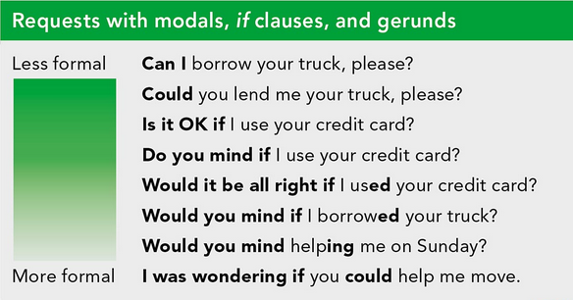

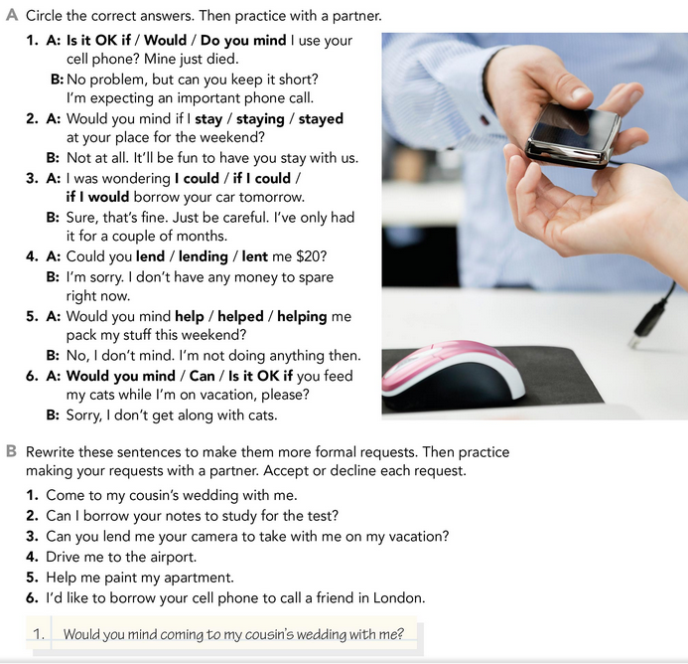

* **PRACTICE**



2. Could you lend me your notes to study for the test?

3. Would you mind lending me your camera to take with me on my vacations?

4. I was wondering if you could drive me to the airport.

5. Would you mind helping me paint my apartment?

6. It’s OK if I used your cell phone to call a friend in London?

* **PRACTICE**

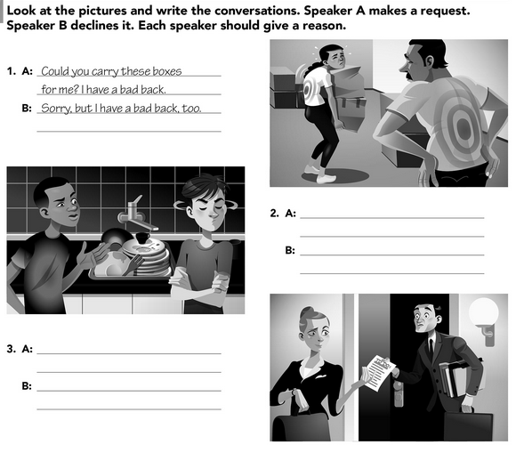

Fine. No problem. Here you go

I was wondering if you could lend me your notes to complete my work

Sorry, but wetting my hands really bothers me.

Would you mind helping me wash the dishes?

* **VIDEO – INDIRECT REQUESTS**

Go to <https://www.youtube.com/watch?v=fAXjwcFInko&t=83s> and watch the video analyzing the examples presented.

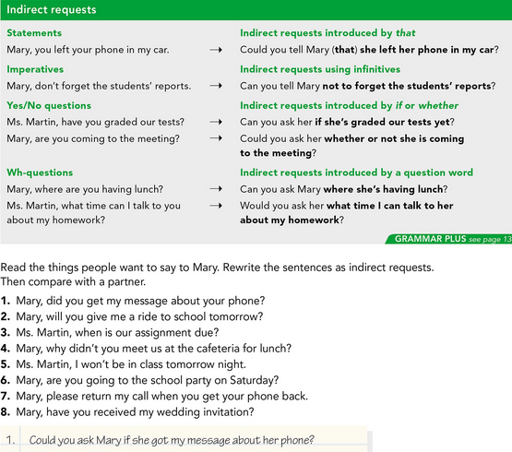

* **PRACTICE**



2. Could you ask Mary if she will give me a ride to school tomorrow?

3. Would you ask Ms. Martin when is the assignment due?

4. Can you ask Mary why didn’t she meet us at the cafeteria for lunch?

5. Could you tell Ms. Martin I won’t be in class tomorrow night?

6. Can you ask Mary if she is going to the school party on Saturday?

7. Can you tell Mary not to forget return my call when she gets her phone back, please?

8. Could you ask Mary if she received my wedding invitation?

Fine. No problem.

* **PRACTICE**



