**ESCUELA NORMAL DE EDUCACIÓN PREESCOLAR**

**ENGLISH B1.2**

**UNIT 3 “LEND A HAND”**

**GRAMMAR**

Remember that we have two kinds of requests: direct and indirect. Complete the exercises and focus on the grammar structures for each kind of request.

* **VIDEO – DIRECT REQUESTS**

Go to https://www.youtube.com/watch?v=GQryco2Ih10 and watch the video analyzing the examples presented. Pay attention on the use of the verb (present, past or gerund).

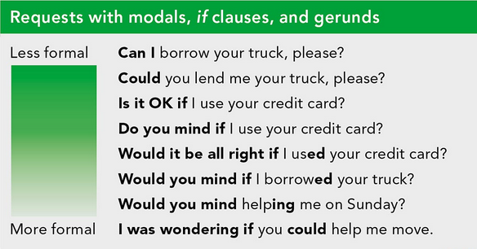

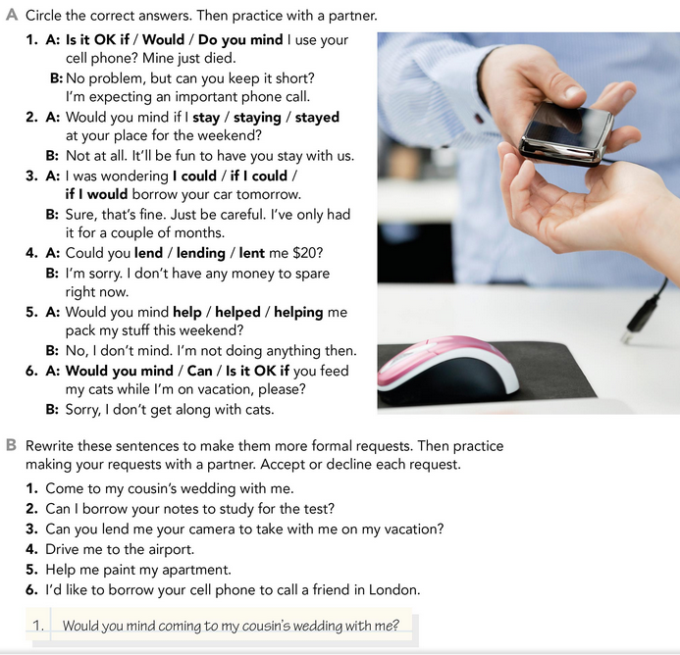

* **PRACTICE**



2. I was wondering if I could borrow your notes to study for the test?

3. Would you mind lend me your camera to take with me on my vacation?

4. Do you mind if you drive me to the airport?

5. Could you please help me to paint my apartment?

6. Is it ok if I borrow your cell phone to call a friend in London?

* **PRACTICE**

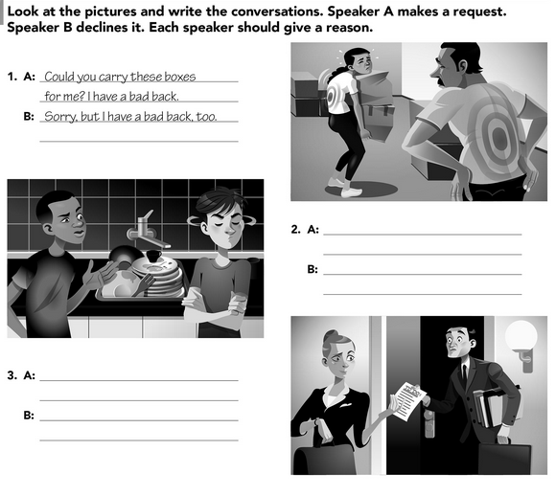`

Sorry, But I can’t, I’m going late to work.

Can you help me to complete my stuff? I’m very busy

Sorry, but I did it yesterday. Today is your turn.

Do you mind if you help me watching the dishes?

* **VIDEO – INDIRECT REQUESTS**

Go to <https://www.youtube.com/watch?v=fAXjwcFInko&t=83s> and watch the video analyzing the examples presented.

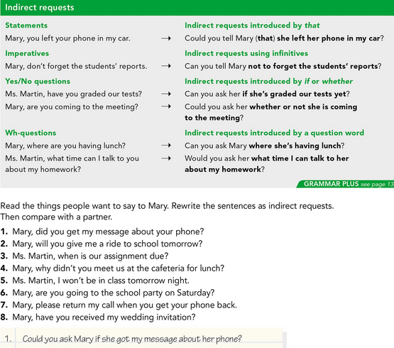

* **PRACTICE**



2. Could you ask Mary if she will give a ride to school tomorrow?

3. Would you mind ask Ms. Martin when is our assignment due?

4. Can you ask Mary why she didn’t meet us at the cafeteria for lunch?

5. Could you tell Ms. Martin I won’t be in class tomorrow night?

6. Could you ask Mary whether or not she’s going to the school party on Saturday?

7. Can you tell Mary not to forget return my call when she gets her phone back?

8. Can you ask Mary if she received my wedding invitation?

* **PRACTICE**

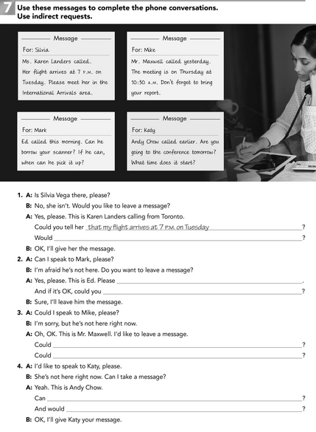

You ask her what time does it start

You ask her if she will go to the conference tomorrow

You tell him not to forget bring his report

You tell him the meeting will be on Thursday at 10:30 am

ask him when can I pick it up

Can you ask him if I could borrow his scanner?

You please tell her to meet me in the international arrivals area