**nESCUELA NORMAL DE EDUCACIÓN PREESCOLAR**

**ENGLISH B1.2**

**UNIT 3 “LEND A HAND”**

**GRAMMAR**

Remember that we have two kinds of requests: direct and indirect. Complete the exercises and focus on the grammar structures for each kind of request.

* **VIDEO – DIRECT REQUESTS**

Go to https://www.youtube.com/watch?v=GQryco2Ih10 and watch the video analyzing the examples presented. Pay attention on the use of the verb (present, past or gerund).

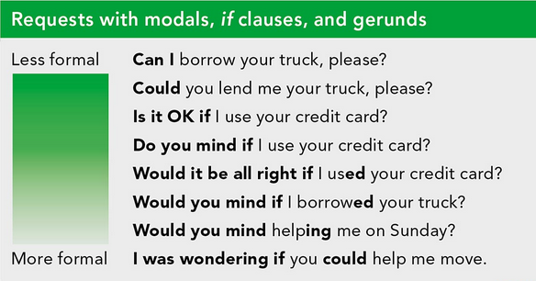

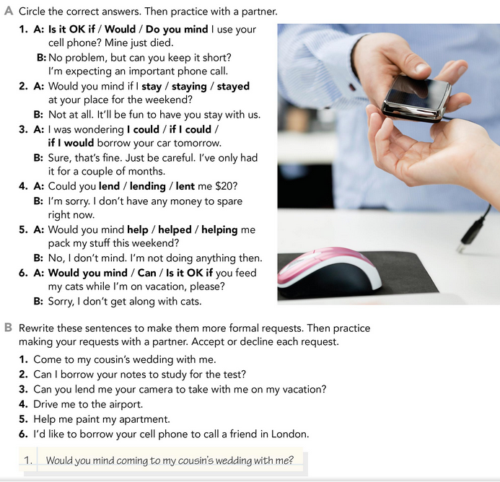

* **PRACTICE**



2. would you mind if borrowed your notes to study for the test?

3. Would you mine lending me your camera to take with me on my vacation?

4.would you mine driving me to the airport?

5.would you mine helping me paint to my apartment?

6. would you mind if borrowed your cell phone to call a friend in London?

* **PRACTICE**

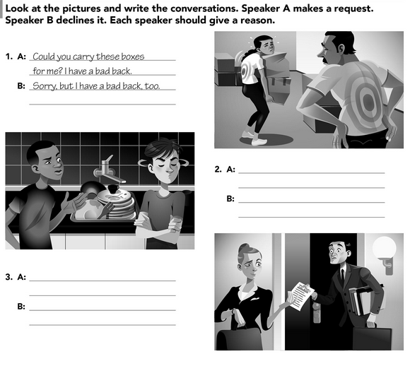

Could you deliver my work for me? I`m late for a date

Sorry, I don’t have a time

Could you wash dirty dishes for me?

Sorry but It’s your turn

* **VIDEO – INDIRECT REQUESTS**

Go to <https://www.youtube.com/watch?v=fAXjwcFInko&t=83s> and watch the video analyzing the examples presented.

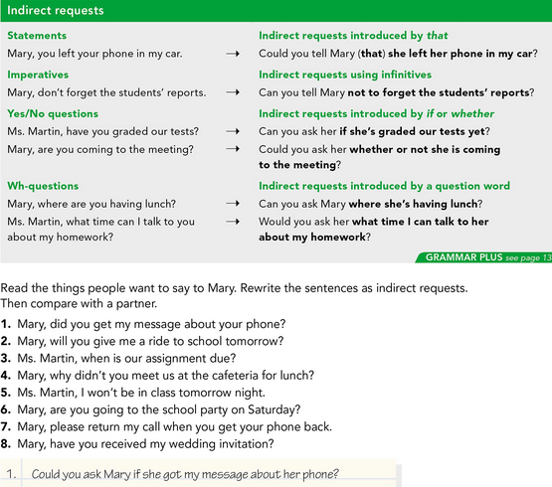

* **PRACTICE**



2. could you tell mary if she can take me to school tomorrow?

3.Could you ask Ms. Martin when is our assignment due?

4. Could you ask Mary why she didn't meet us in the cafeteria for lunch?

5. can I tell Ms. Martin I won’t be in class tomorrow night?

6. could you ask Mary if she will go to the school party on Saturday?

7. could you tell Mary to call me back when i get her phone back

8. Can i ask Mary if she has received my wedding invitation?

* **PRACTICE**

