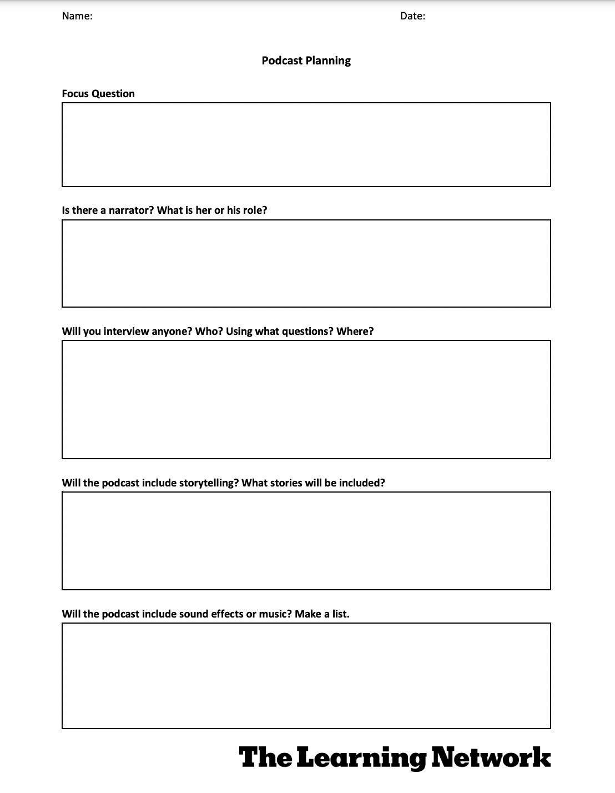Berenice del Carmen Ruiz Ramos 4 febrero 2021

Yes.

The song ribs as a soundtrack, and some sad but emotive sound I found on spotify

Yes. One of when I was in high school and the differences I see now than I’m about to finish my career and my siblings are in high school

Yes. My friend Daniella.

What do you do when you feel sad?

How do you cope with anger?

Are you happy?

There will be an invented narrator that introduces me, Berenice, the one who talks in the podcast. (I live alone I have to improvise)

How do we manage emotions?

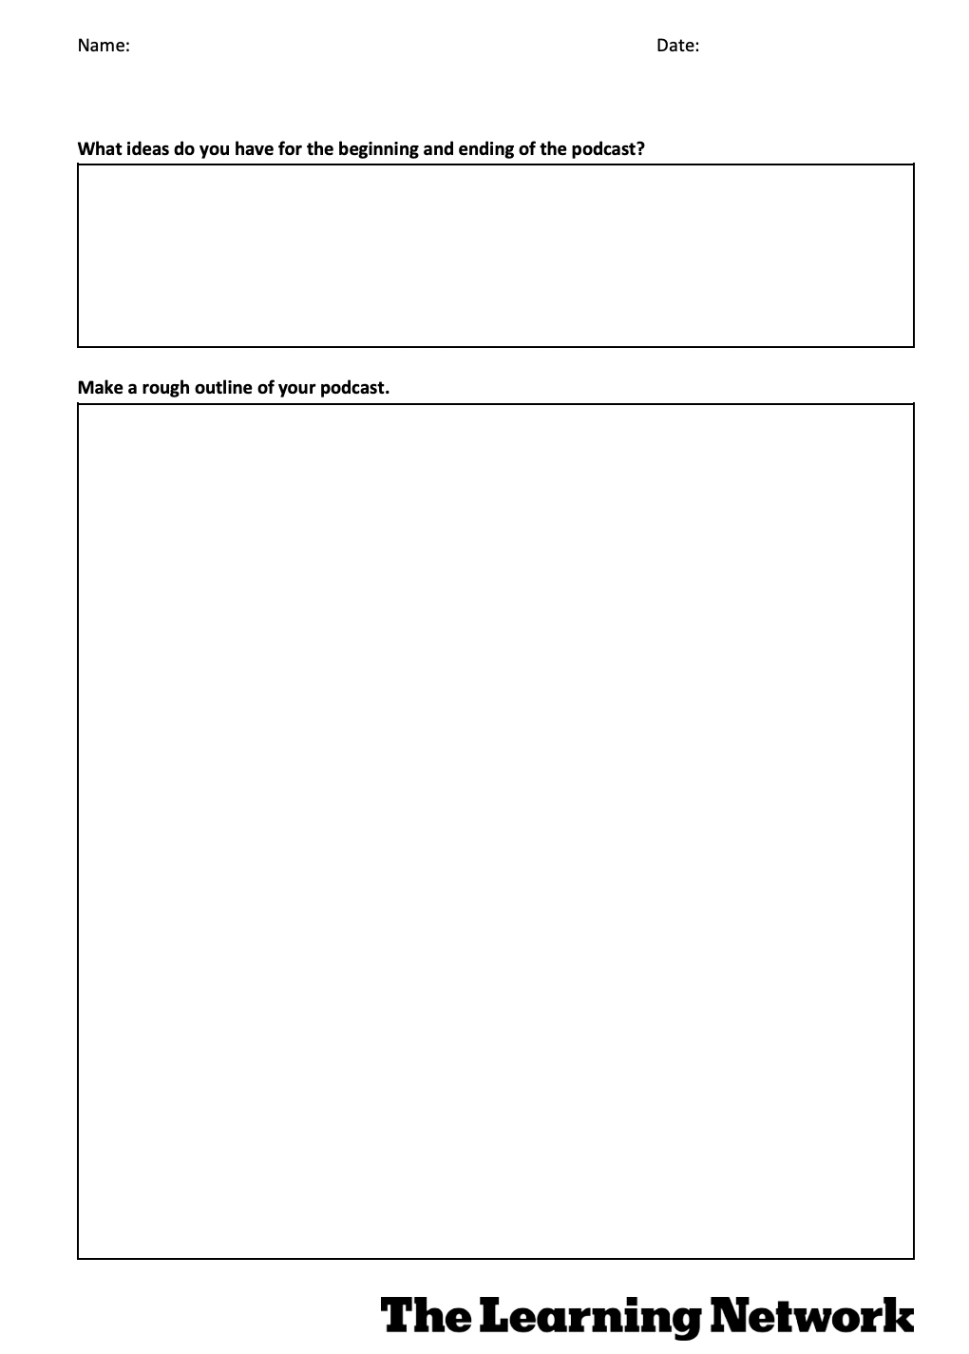

Have you ever feel like you didn’t get over an emotion? Or that you are completely quiet but suddenly you remember that one time when your mother said something that made you feel sad?. This is more common than you think, people are not used to face their emotions when they experience it, they subprime it and postpose it for other time, but eventually you come across a lot of things you never talked about. This is actually making your life not enjoyable, causing you stress and probably the cause of a lot of the problems your dealing with. I want to share with you a little bit of the facts I know about the emotions and how you shouldn’t replace it or try to don’t feel them.

I’m going to start it with an invented narrator that will present me as a student who is concerned about the way people face their emotions, I’m going to present an example of a friend an my own from when I was Younger, To finish I’m going to invite all of the listeners to face whatever they feel in te moment.