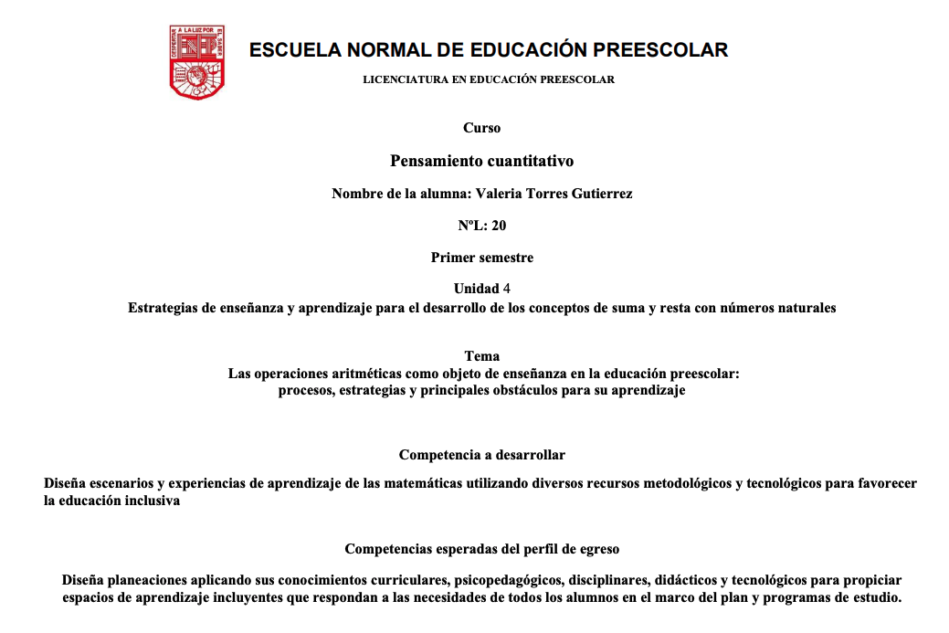

https://www.youtube.com/watch?v=MJu9-hkVDpE&feature=youtu.be