**ENGLISH III. SHARING INFORMATION AND IDEAS**

**Semester I**

Learning Evidence Unit 1

***This is US!***

|  |  |
| --- | --- |
| ***Aims:*** | ***Introduce oneself; introduce someone; check information; exchange personal information; say hello and good-bye; practice asking and answering questions with be and simple present.***  ***Describe work and school; ask for and give opinions; describe daily schedules*** |

Imagine you and your teammates are all exchange students at a new school in a foreign country. Create a conversation where you meet for the first time. Video record yourselves and turn in this evidence by sharing the link to your video.

You have to use several expressions from each type in the Language Summary unit 1 and unit 2. Highlight each of the expressions using colors.

**Types of expressions:**

|  |  |
| --- | --- |
| * Saying hello * Saying good-bye * Exchanging personal information * Introducing someone * Asking about someone * Thanking someone * Checking information * Making suggestions * Apologizing * Agreeing | * Talking about school/work * Asking for more information * Talking about daily schedules * Expressing interest * Expressing surprise * Starting a sentence |

**1. Plan (Monday 19th)**

Write a script

**2. Prepare (Wednesday 21st)**

Practice the conversation

**3. Present (Friday 23rd)**

Have a video conference meeting you can record and perform the conversation.

**Turn in the conversation script and the link to your video in this activity.**

**It is due to Friday October 23rd, 2020.**

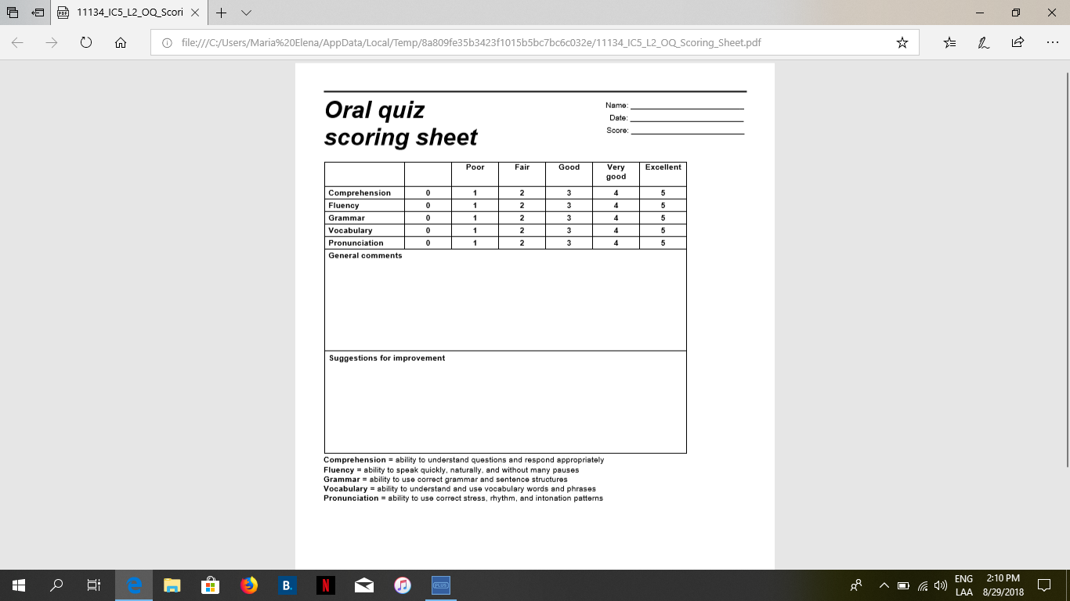

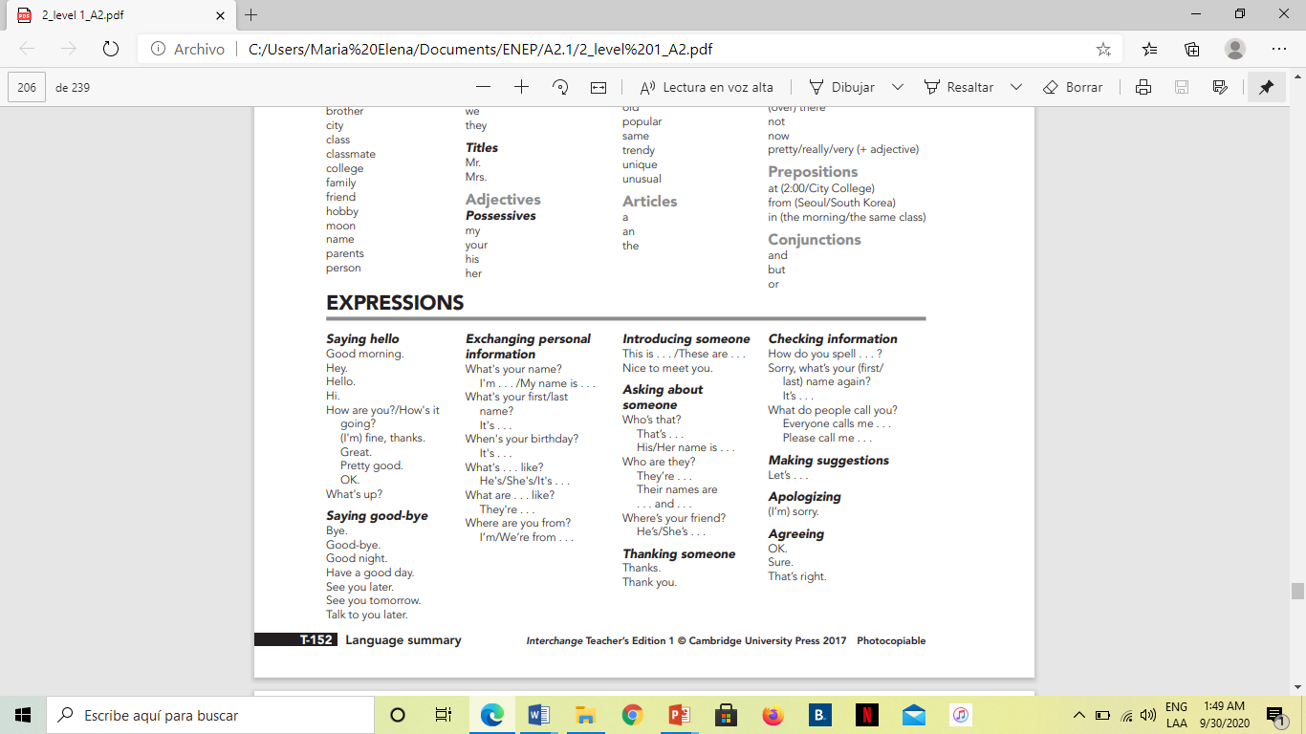

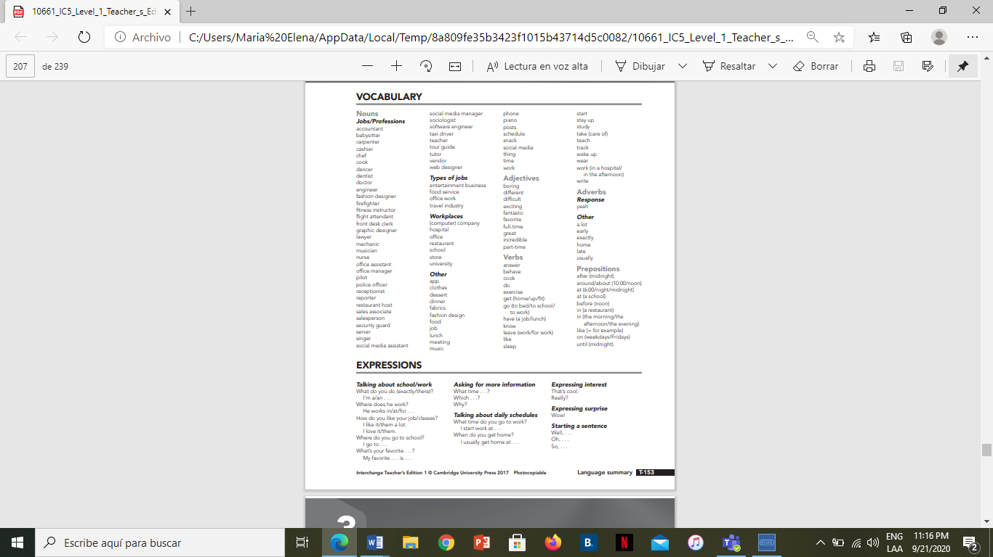

SUGGESTIONS: Topics you could talk about

