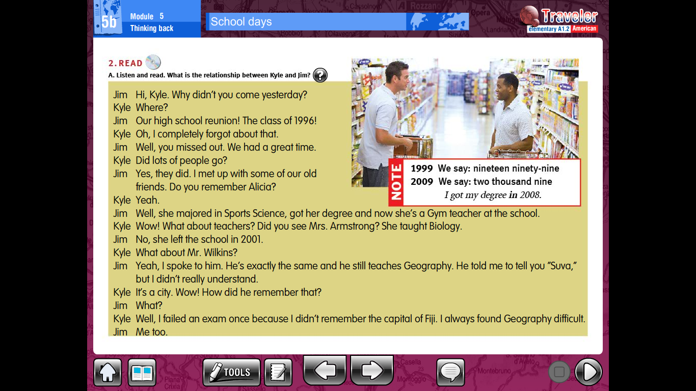

5b School days

Now, answer the following questions. Have questions and answers in your notebook.

1. When did Kyle and Jim finish school?
2. Why didn’t Kyle go to the school reunion?
3. Did Jim have a good time at the school reunion?
4. Did lots of people go to the school reunion?
5. What does Alicia do?
6. What did Mrs Armstrong teach?
7. Did Jim speak to Mr Wilkins?
8. Has Mr Wilkins changed?
9. What was Mr Wilkin’s message for Kyle?
10. What is “Suva”?