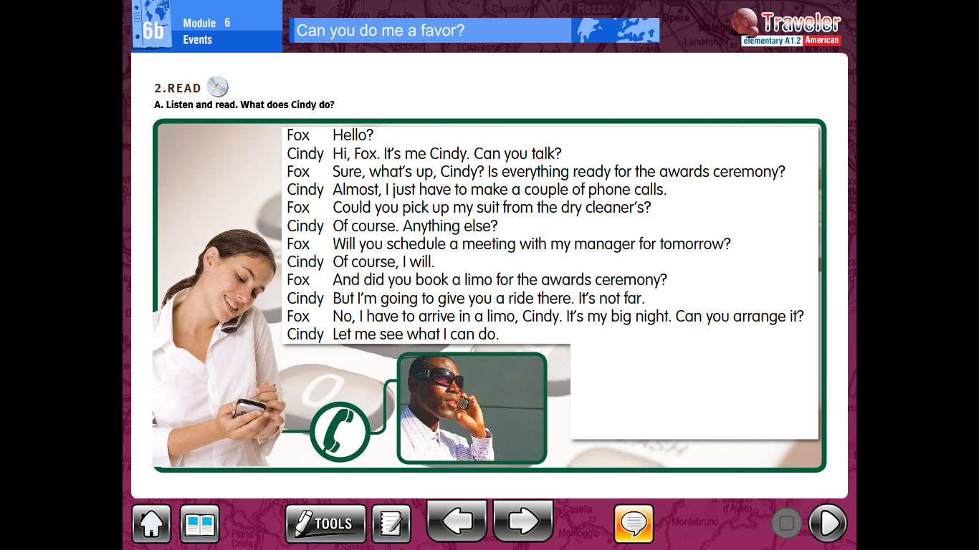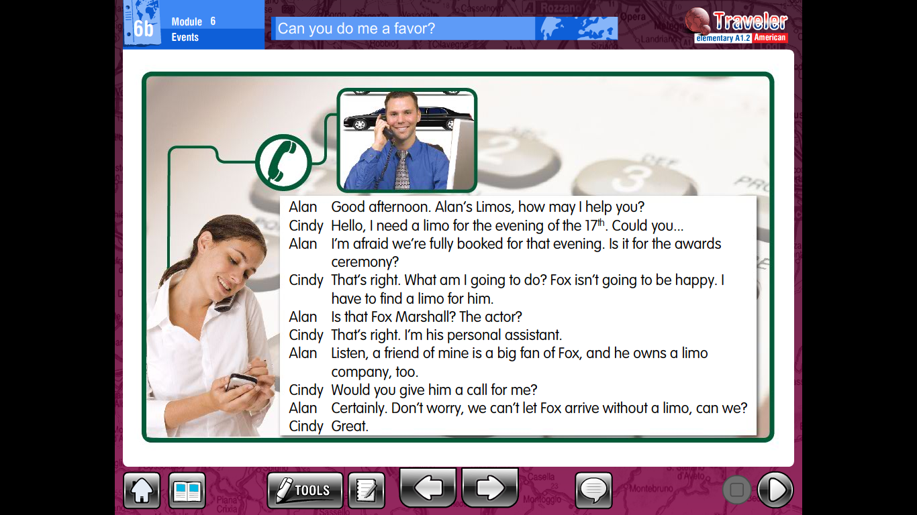

Answer the following comprehension questions in your notebook. You may print or copy the questions.

1. What does Cindy need to do before the ceremony?
2. Does Fox accept her offer?
3. What does Alan do?
4. What does Alan’s friend do?
5. Who is going to provide Fox with a limo?
6. What is happening on the evening of the 17th?
7. Who is Fox Marshall?
8. Who does Fox want to meet tomorrow?
9. How does Fox want to arrive at the ceremony?
10. Why does Cindy call Alan?
11. What is Alan going to do help Cindy?