Normal school of preschool education.

Licenciature in preschool education

2020-2021

2nd semester

Name of the subject: English

Name of the teacher: Beatriz Eugenia Valdés Rodriguez.

Name of the student: Mayra Alejandra Ferrer Flores #2

Activity 1

Saltillo, Coahuila de Zaragoza

March 2021

**ACTIVITY 1**

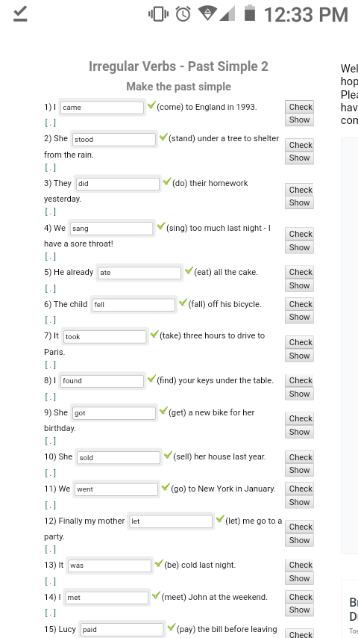

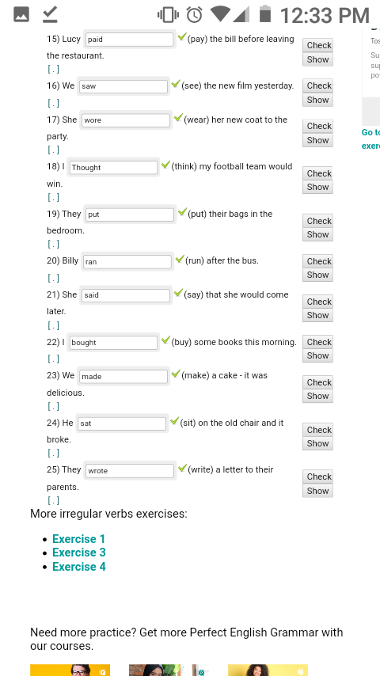

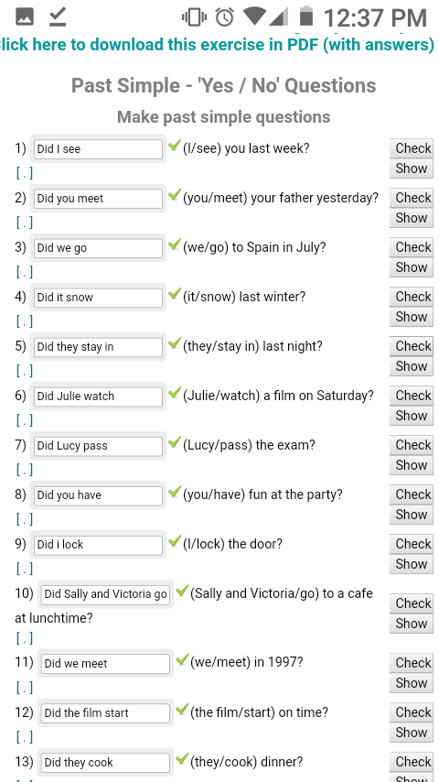

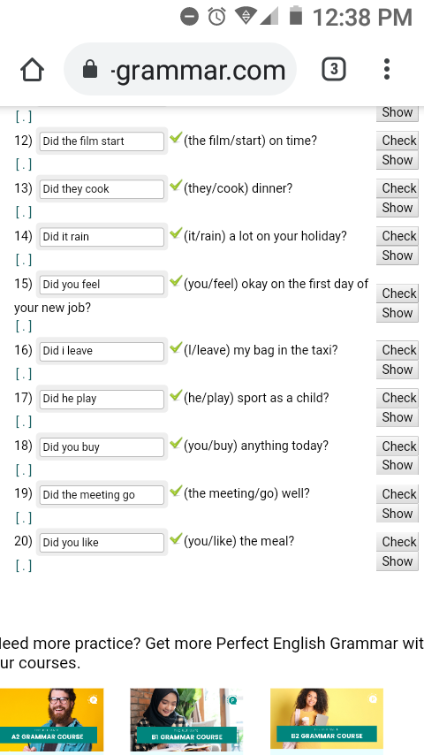

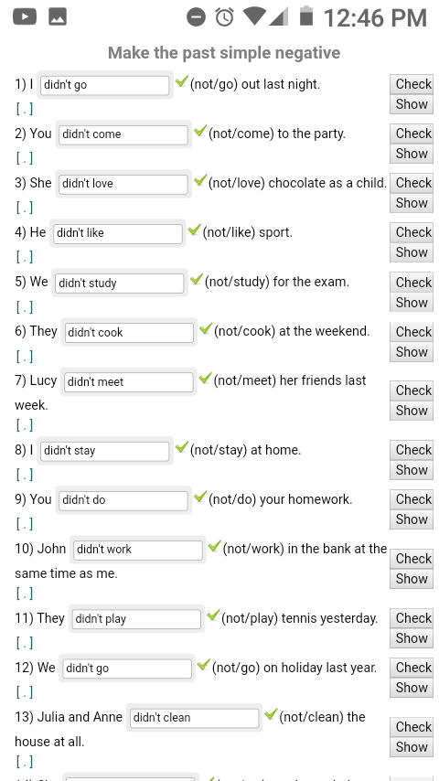

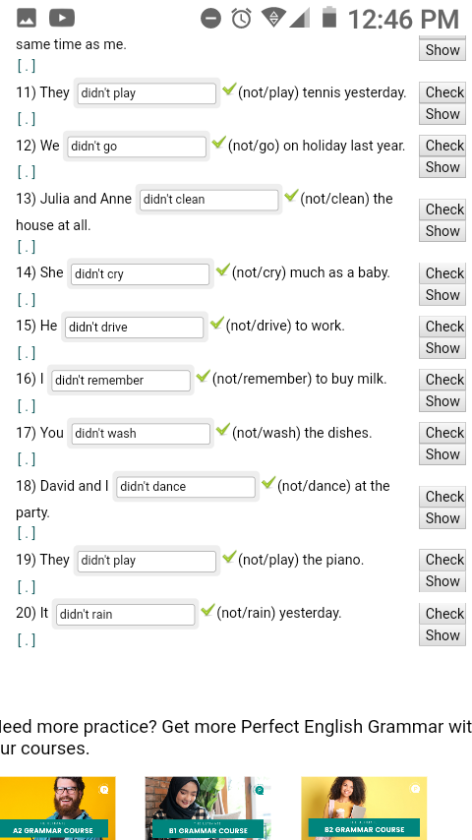

**ACTIVITY 2**

PAGE 45 GRAMMAR FOCUS

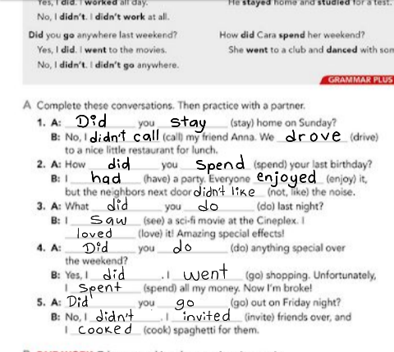

**Regular verbs in past:**

* Like- liked
* Love- loved
* Play- played
* Clean- cleaned
* Talk- talked
* Walk- walked
* Work- worked
* Study- studied
* Invite- invited
* Watch- watched
* Wash- washed
* Stay- stayed
* Live- lived
* Listen- listened

**Irregular verbs in past**

* Teach- taught
* Think- thought
* Buy- bought
* Eat- ate
* Drink- drank
* Do- did
* Have- had
* Drive- drove
* See- saw
* Sing- Sang
* Spend- spent
* Go- went
* Write- wrote