Escuela Normal de Educación Preescolar

Homework 1

Ingles A2.1

Titular: Beatriz Eugenia Valdes Rodríguez

Alumnos: Suárez García Debanhi Yolanda

Segundo semestre

Sección C

Marzo del 2021

**Make a list of free times activities**

1. Go to swim
2. Go to the cinema
3. Watch TV
4. Spend time with family
5. Go out with friends
6. Surf the internet
7. Play video games
8. Play a musical instrument
9. Listen to music
10. Read
11. Write
12. Go to the park
13. Go to cultural locations and events
14. Go shopping
15. Cook
16. Study something
17. Art and crafts
18. Gardening
19. Exercise and play a sport

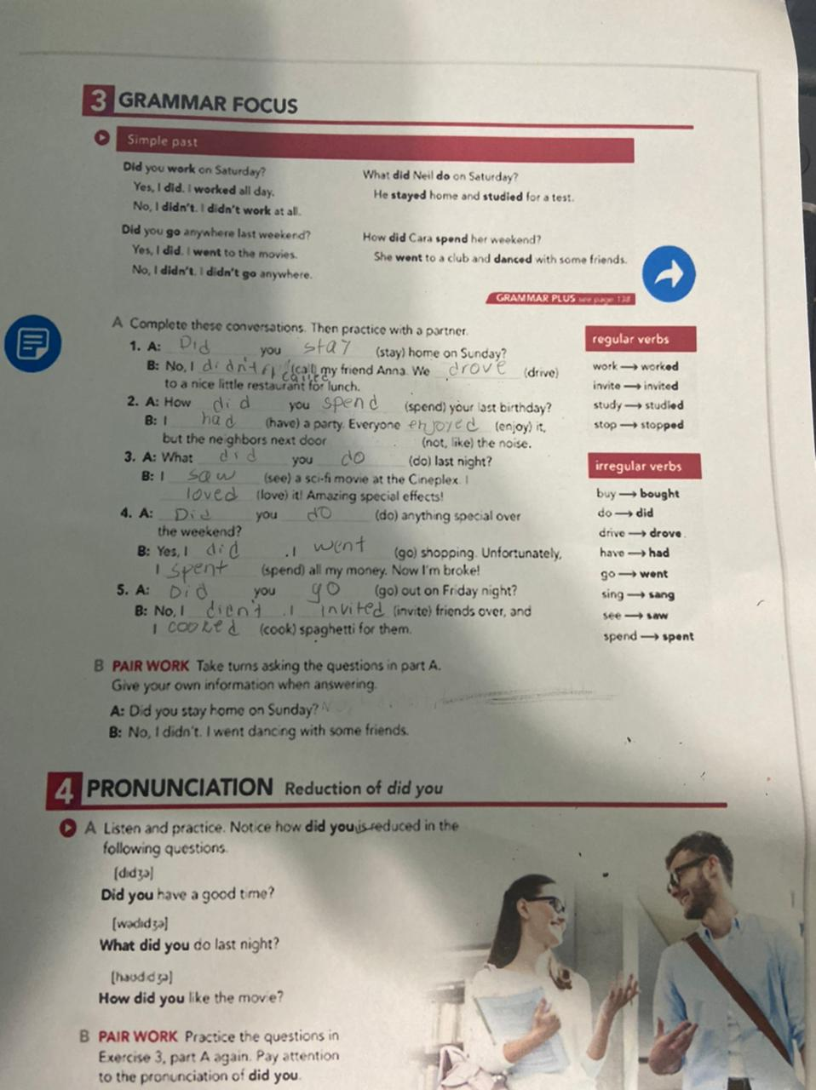

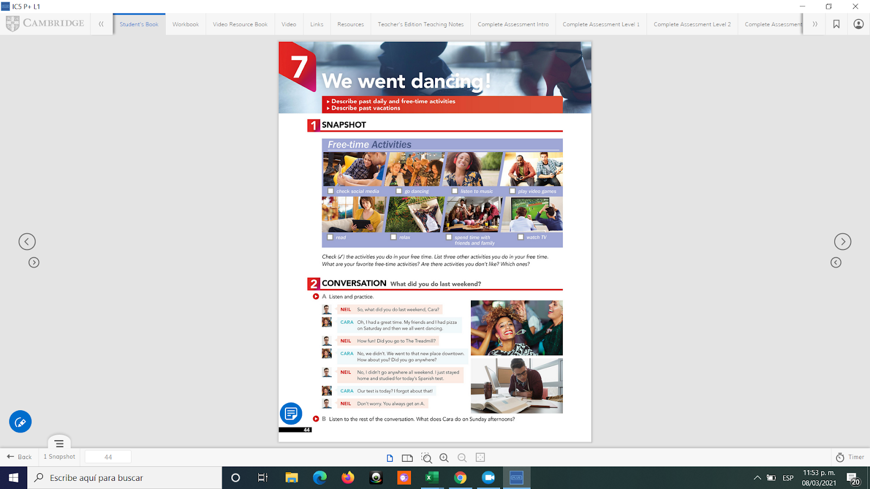

**Regular verbs write the past form**

Like : liked

Love : loved

Play : played

Clean : cleaned

Talk: talked

Walk: walked

Work: worked

Study: studied

Invite: invited

Watch: watched

Wash: washed

Stay: stayed

Live: lived

Listen: listened

**Irregular verbs- write the past form**

Teach: taught

Think: thought

Buy: bought

Eat: ate

Drink: drank

Do: did

Have: had

Drive: drove

See: saw

Sing: sang

Spend: spent

Go: went

Write: wrote

