**ESCUELA NORMAL DE EDUCACIÓN PREESCOLAR**

**ENGLISH A2.2**

**WEEK 1 ACTIVITIES - “REVIEW”**

**VOCABULARY**

Dear students, during the week we will review the **present simple and the present continuous form**s. Complete your activities and upload your document to Escuela en Red.

**ACTIVITY 1 – DAILY ROUTINES AND ACTIONS VOCABULARY – 40 PTS.**

Paste a picture for each action included in the following chart.

|  |  |  |  |
| --- | --- | --- | --- |
| **DAILY ROUTINES** | | | |
| **ACTION** | **PICTURE** | **ACTION** | **PICTURE** |
| Get up | Print Quiz: Daily routines (lengua extranjera - 6º - Secundaria - daily  routines - daily routines vocabulary) | Take a shower | Mujer joven tomar un baño con ducha en el baño. | Vector Premium |
| Go to work | Hombre de negocios ir a trabajar diseño de dibujos animados de vectores |  Vector Premium | Wake up | Premium Vector | Happy cute little kid girl wake up in the morning |
| Go to school | ᐈ Ir al colegio dibujo animado de stock, vectores ir a la escuela |  descargar en Depositphotos® | Go home | Ilustración De Niños Ir A Casa Del Colegio Fotos, Retratos, Imágenes Y  Fotografía De Archivo Libres De Derecho. Image 28270094. |
| Have breakfast | I have breakfast - Stock Illustration [9922892] - PIXTA | Go to bed | Es hora de ir a la cama. Canciones infantiles |
| Have lunch | Dieta 10 en la oficina | Comida para oficina, Comida oficina, Comida  saludable | Brush my teeth | Niño de dibujos animados cepillarse los dientes | Vector Premium |
| Have dinner | Dietas: la comida más importante del día es la cena y no el desayuno -  Cucinare | Get dressed | Get Dressed Cartoon High Res Stock Images | Shutterstock |
| Do homework | Premium Vector | Cute little kid girl confused do homework | Work out | Fitness Woman Cartoon | Fitness design, Fit women, Workout posters |

|  |  |  |  |
| --- | --- | --- | --- |
| **COMMON VERBS** | | | |
| **ACTION** | **PICTURE** | **ACTION** | **PICTURE** |
| Eat | Kids Eating Images | Free Vectors, Stock Photos & PSD | Watch | A qué distancia debemos ver nuestra televisión? | Tu Optometrista |
| Drink | Feliz niño lindo niña beber agua después... | Premium Vector #Freepik  #vector #agua #ninos… | Gráficos de niños, Imagenes animadas de niños,  Dibujo de niños jugando | Dance | Dibujos animados de pareja de baile | Vector Premium |
| Listen | Ilustración de un Niño con la mano apretada contra su oreja en un gesto de  Escucha | Rutina diaria de niños, Niños en la escuela, Actividades de arte  para preescolares | Go | Chico lindo ir a la escuela de dibujos animados | Vector Premium |
| Smile | Sonreir | imágenes de gráficos png gratis - Lovepik | Touch | Ilustración de Vector De Dedo Tocar Gesto Dedo Índice Dibujado A Mano Dibujo  y más Vectores Libres de Derechos de Agarrar - iStock |
| Walk | Emoji 🚶 Persona caminando para copiar pegar | wpRock | Type | How to type Spanish accents (+ those other fiddly symbols ü, ñ, ¿, ¡) |
| Run | Young Girl Running Vectores en stock - FreeImages.com | Read | Read-Read-Read LEER | Verbos, Verbos irregulares |
| Look | What IT work will look like in 2030 | CIO | Write | Write. Wrote. Written. Writing. is she writing a letter? | Speech  activities, Irregular verbs, Writing |
| Speak | Speak- spoke- spoken- hablar | Verbos | Drive | 117 Ilustraciones de Aprender A Conducir - Getty Images |
| Draw | How to Draw a Cartoon Mouse From Transformice - zooshii Style - YouTube | Take | How to Tell the Differences Between Take and Took: 3 Steps |

**ACTIVITY 2 – DEFINITIONS – 20 PTS.**

Match the definitions with a word from the vocabulary on activity 1.

***Example:*** You do this after a long day and just before you fall asleep. *Go to bed*

*DAILY ROUTINES*

1. You do this in the morning because it is the most important meal of the day. _Have breakfast_
2. You do this to make your body and hair clean. _Take a shower__
3. You do this three times a day after you eat. _Brush my theet____
4. You do this to learn after school. __Do homework___
5. You do this to stay fit and healthy. _Work out_

*COMMON VERBS*

1. We do this when we want to hear something. _Listen__
2. We do this when we talk to somebody. __speak___
3. We do this on paper when we take notes. _Write__
4. We do this when we are very happy. _Smile__
5. We do thin when we go to a party and listen to music. _Dance__

**ACTIVITY 3 – GAP FILL – 20 PTS.**

Write the action to fill the gap.

I usually get up at 6:00 a.m, then I __take__ a shower and ____get____ dressed with a nice outfit. At 7:00 a.m. I __have ___ breakfast with my family and at eight o’clock I _go_______ to school, where I learn a lot of things and meet with my friends. My school finishes at 2:00 p.m. and then I ____go____ home by bus. I usually ___have____ chicken for lunch and at 5:00 p.m. I _____do_____ my homework. After the homework I ___work out___ to stay fit and healthy and at 9::00 p.m. I __brush_____ my teeth and __go_____ to bed.

**ACTIVITY 4 – SPEAKING AND PRONUNCIATION – 20 PTS.**

Go to https://padlet.com/alvaradocris87/cdyptcca6vtz95by or scan the QR code and record yourself reading the actions in the chart. LOOK AT THE EXAMPLE ADDED TO THE PADLET, **REMEMBER TO WRITE YOUR NAME IN YOUR RECORDING.**



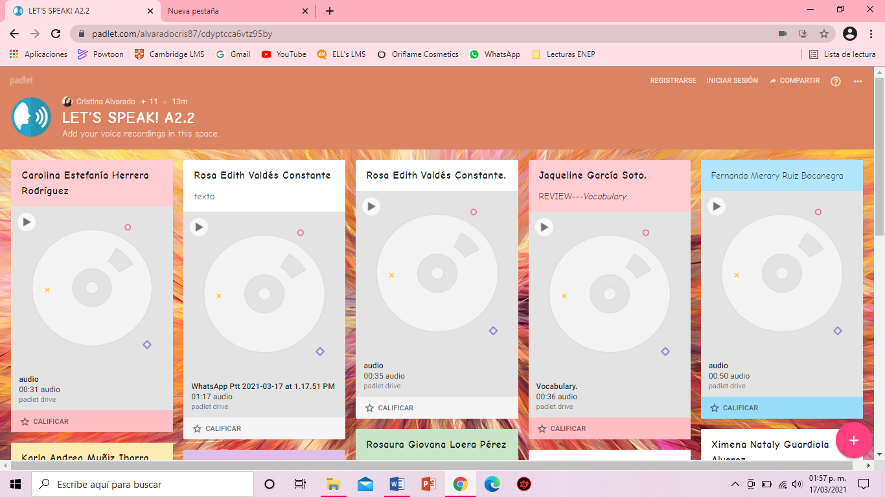

You can check the pronunciation of the words in the Cambridge Dictionary <https://dictionary.cambridge.org/us/dictionary/learner-english/> .