vocabulary - EVENTS
Your Vocabulary Log
Make a vocabulary log. Write words or draw pictures to help you remember. 20 PTS.
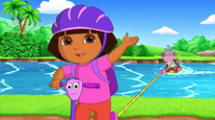



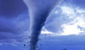


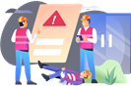

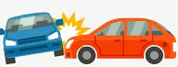






experience +
party +
casuality 0
quandary -
catastrophe -
urgency -
vacation +
event -
fortunate +
accident -
secret -
moment 0
happening 0
estimate 0
victory +
accomplishment +
Practice
A Classify the words in your vocabulary log. Write + for positive words,
– for negative words, or 0 for neutral words. 20 PTS.

B Complete the chart with words from your vocabulary log. 20 PTS.

Headline | Event
1. Famous athlete still missing | mystery
2. Student finds $250,000 in restroom | lucky break
3. Thousands welcome victorious soccer team home | triumph
4. Robber and police officer have same name | coincidence
5. Family sails around the world | adventure
6. Huge earthquake destroys 5,000 homes | disaster

C Complete the chart with recent events from the news. 20 PTS.

Headline | Event
A fire causes the loss of biodiversity in Arteaga. | disaster
A highly contagious virus causes the death of thousands of people around the world. | emergency
The development of a vaccine against covid-19. | success

ACTIVITY 4 – SPEAKING AND PRONUNCIATION – 20 PTS.

Go to https://padlet.com/alvaradocris87/btrml0zwovpq7dv2 or scan the QR code and record yourself reading the actions in the chart. LOOK AT THE EXAMPLE ADDED TO THE PADLET, REMEMBER TO WRITE YOUR NAME IN YOUR RECORDING.



You can check the pronunciation of the words in the Cambridge Dictionary https://dictionary.cambridge.org/us/dictionary/learner-english/.

