vocabulary – EVENTS 17-03-21

Maria Fernanda Dávila bustos

Your Vocabulary Log

Make a vocabulary log. Write words or draw pictures to help you remember. **20 PTS.**

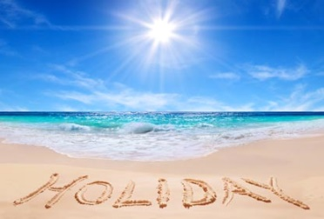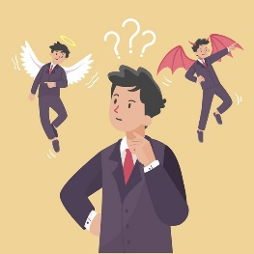Adventure

Holiday

Dilemma

Celebration

Incident

Disaster

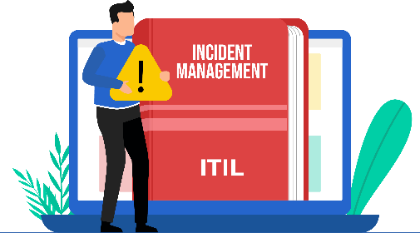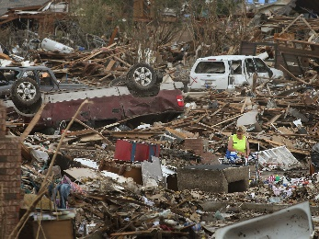

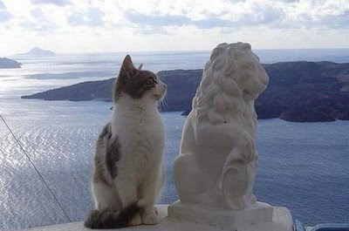Coincidence

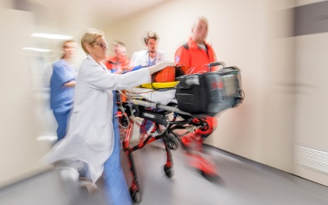

Lucky break

Emergency

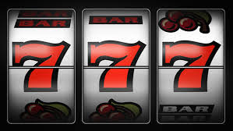

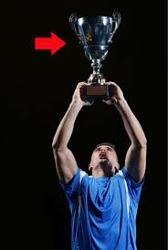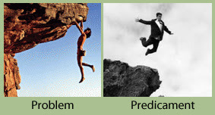

Triumph

Success

Predicament

Phenomenon

Occasion

Mystery

Mishap

Practice

**A Classify the words in your vocabulary log. Write + for *positive words*,   
–** for *negative words*, or **0** for *neutral words*. **20 PTS.**

+

**Adventure**

+

**Celebration**

0

**Coincidence**

-

**Dilemma**

-

**Disaster**

-

**Emergency**

+

**Holiday**

-

**Incident**

+

**Lucky Break**

-

**Mishap**

0

**Mystery**

+

**Occasion**

-

**Phenomenon**

+

**Predicament**

+

**Success**

+

**Triumph**

B Complete the chart with words from your vocabulary log. **20 PTS.**

|  |  |
| --- | --- |
| **Headline** | **Event** |
| 1. Famous athlete still missing | mystery |
| 2. Student finds $250,000 in restroom | Lucky Break |
| 3. Thousands welcome victorious soccer team home | Celebration |
| 4. Robber and police officer have same name | Coincidence |
| 5. Family sails around the world | Adventure |
| 6. Huge earthquake destroys 5,000 homes | Disaster |

C Complete the chart with recent events from the news. **20 PTS.**

|  |  |
| --- | --- |
| **Headline** | **Event** |
| Homer won a title for being the best footballer | *Triumph* |
| The forest fire got out of control. | *Emergency* |
| The doctor had a little accident with the hypo. | *Incident* |

**ACTIVITY 4 – SPEAKING AND PRONUNCIATION – 20 PTS.**

Go to <https://padlet.com/alvaradocris87/btrml0zwovpq7dv2> or scan the QR code and record yourself reading the actions in the chart. LOOK AT THE EXAMPLE ADDED TO THE PADLET, **REMEMBER TO WRITE YOUR NAME IN YOUR RECORDING.**

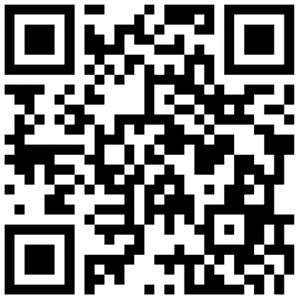

You can check the pronunciation of the words in the Cambridge Dictionary https://dictionary.cambridge.org/us/dictionary/learner-english/.