p0vocabulary - EVENTS
Your Vocabulary Log
Make a vocabulary log. Write words or draw pictures to help you remember. 20 PTS.
+ Adventure: Exciting events.
+ Celebration: Party, important event.
0 Coincidence: Surprise, unexpected, unusual.
- Dilemma: Problem, trouble, hard.
- Disaster: Ruin, destruction.
- Emergency: Unforeseen events.
+ Holiday: Tradition, vacations, celebration.
- Incident: Interruption, accident, unexpected event.
+ Lucky break: Chance, coincidence.
- Mishap: Delay the time, accident.
0 Mystery: Question, search, tracks.
0 Occasion: Moment, acts.
- Phenomenon: Amazing, sudden.
0 Predicament: Imagination, believe.
+ Success: Improvement, goals, victory.
+ Triumph: Success, accomplishments.
Practice
A Classify the words in your vocabulary log. Write + for positive words,
– for negative words, or 0 for neutral words. 20 PTS.

B Complete the chart with words from your vocabulary log. 20 PTS.

Headline | Event
1. Famous athlete still missing | mystery
2. Student finds $250,000 in restroom | Lucky break
3. Thousands welcome victorious soccer team home | Celebration
4. Robber and police officer have same name | Coincidence
5. Family sails around the world | Adventurous
6. Huge earthquake destroys 5,000 homes | Phenomenon

C Complete the chart with recent events from the news. 20 PTS.

Headline | Event
Ash falls from the Popocatepetl in Puebla, México. | Phenomenon
In Mexico, there are the first cases of Covid-19. | Emergency
Celebrating Mexico’s independence with fireworks in the city center | Celebration

ACTIVITY 4 – SPEAKING AND PRONUNCIATION – 20 PTS.

Go to https://padlet.com/alvaradocris87/btrml0zwovpq7dv2 or scan the QR code and record yourself reading the actions in the chart. LOOK AT THE EXAMPLE ADDED TO THE PADLET, REMEMBER TO WRITE YOUR NAME IN YOUR RECORDING.

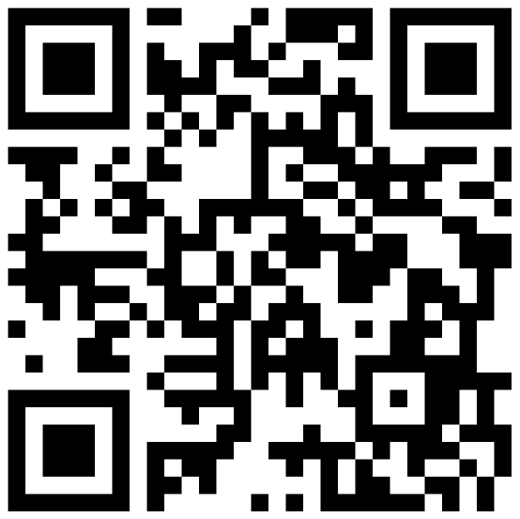

You can check the pronunciation of the words in the Cambridge Dictionary https://dictionary.cambridge.org/us/dictionary/learner-english/.

