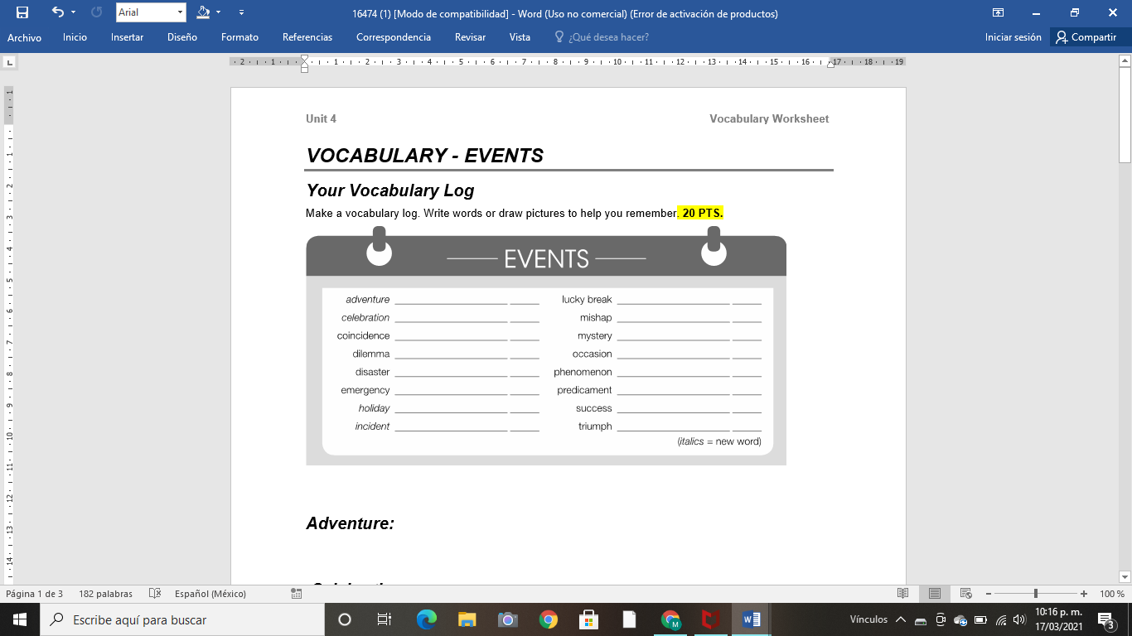

Adventure:



Celebration:



Coincidence:



Dilemma:

Disaster:

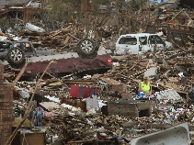

Emergency:

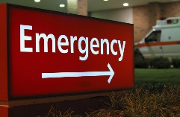

Holiday:



Incident:



Lucky break:

Mishap:



Mystery:



Occasion:

Phenomenon:



Predicament:



Success:



Triumph

Practice

A Classify the words in your vocabulary log. Write **+** for *positive words*,   
**–** for *negative words*, or **0** for *neutral words*. **20 PTS.**

+ Adventure

+ Celebration

0 Coincidence

- Dilemma

- Disaster

- Emergency

+ Holiday

- Incident

+ Lucky break

- Mishap

0 Mystery

0 Occasion

- Phenomenon0 Predicament: Imagination, believe.

+ Success

+ Triumph

B Complete the chart with words from your vocabulary log. **20 PTS.**

|  |  |
| --- | --- |
| **Headline** | **Event** |
| 1. Famous athlete still missing | mystery |
| 2. Student finds $250,000 in restroom | Lucky break |
| 3. Thousands welcome victorious soccer team home | Celebration |
| 4. Robber and police officer have same name | Coincidence |
| 5. Family sails around the world | Adventurous |
| 6. Huge earthquake destroys 5,000 homes | Phenomenon |

C Complete the chart with recent events from the news. **20 PTS.**

|  |  |
| --- | --- |
| **Headline** | **Event** |
| Ash falls from the Popocatepetl in Puebla, México. | Phenomenon |
| In Mexico, there are the first cases of Covid-19. | Emergency |
| Celebrating Mexico’s independence with fireworks in the city center | Celebration |

**ACTIVITY 4 – SPEAKING AND PRONUNCIATION – 20 PTS.**

Go to <https://padlet.com/alvaradocris87/btrml0zwovpq7dv2> or scan the QR code and record yourself reading the actions in the chart. LOOK AT THE EXAMPLE ADDED TO THE PADLET, **REMEMBER TO WRITE YOUR NAME IN YOUR RECORDING.**



You can check the pronunciation of the words in the Cambridge Dictionary https://dictionary.cambridge.org/us/dictionary/learner-english/.