**ESCUELA NORMAL DE EDUCACIÓN PREESCOLAR**

**ENGLISH B1.2**

**BOOK UNIT 4 – WHAT HAPPENED?**

**GRAMMAR**

Dear students, during the week we will review the **simple past and the past continuous**. Complete your activities and upload your document to Escuela en Red.

**ACTIVITY 1 – SIMPLE PAST VS. PAST CONTINUOUS – 20 PTS.**

Read the following information and analyze the examples. Visit the website and upload a screenshot of your activity.

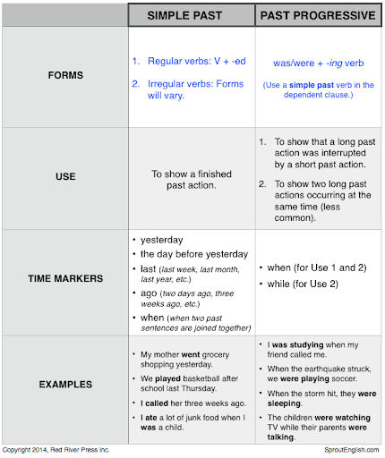

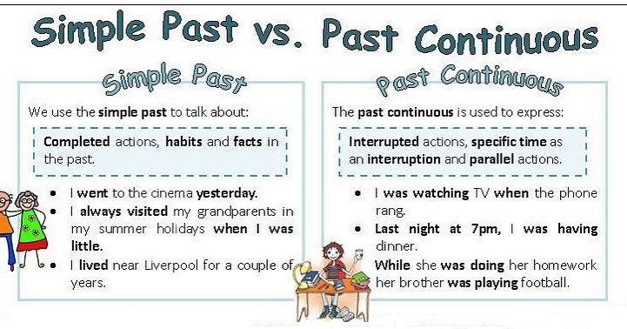

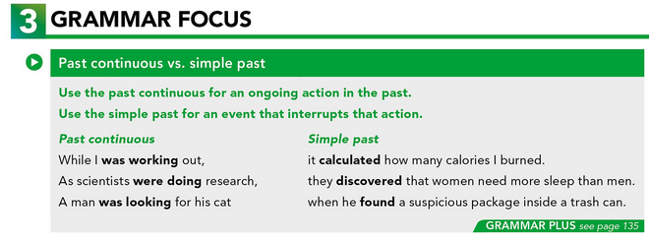

**WATCH THE VIDEO:**

https://www.youtube.com/watch?v=VLj-Dbz-CWk

**WEBSITE:**

GO TO <https://agendaweb.org/exercises/verbs/past-continuous/simple-continuous-1> , COMPLETE THE EXERCISE AND PASTE A SCREENSHOT OF YOUR ACTIVITY BELOW.

**ACTIVITY 2 – PAST CONTINUOUS VS. SIMPLE PAST – 20 PTS.**

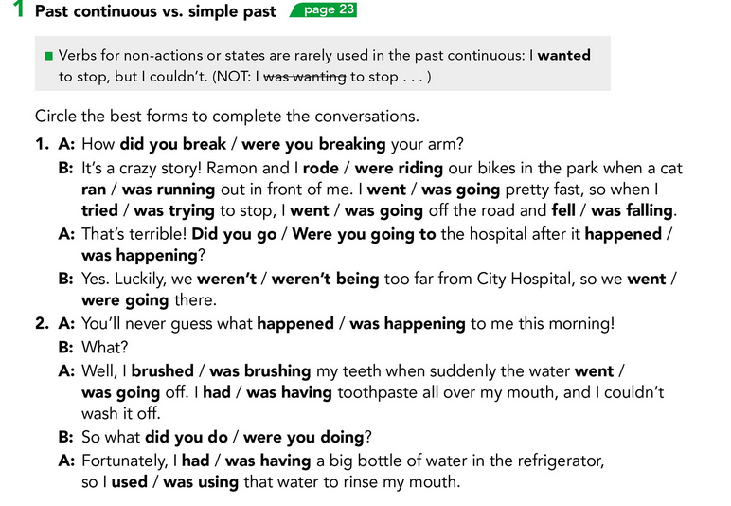

1. **Did you break**
2. **Were riding/ ran/ was going /tried/was going/fell**
3. **Did you go/happened**
4. **Weren´t/went**
5. **Was happening**
6. **Was brushing/went/had/**
7. **Did you do**
8. **Had/was using**

**ACTIVITY 3 – GAP FILL – 20 PTS.**

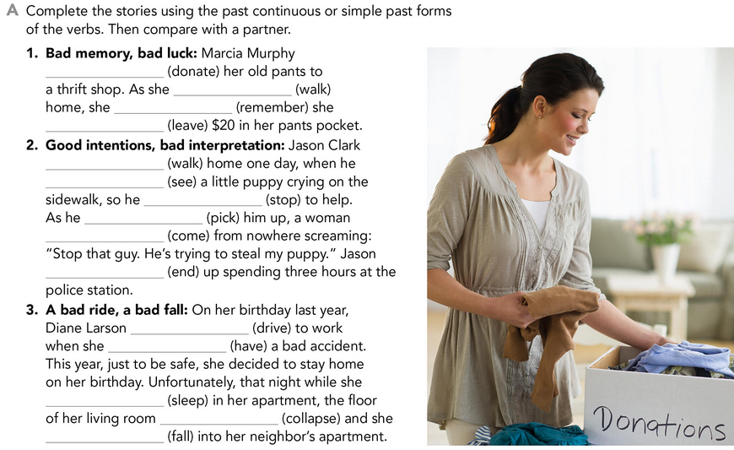

1-Marcia Murphy Donated her old pants to a thrift shop. As she was walking home, she remembered she leave $20 in her pants pocket.

2- Jason Clark were walking home one day, when he saw a little puppy crying on the sidewalk, so he stopped to help. As he picked up, a woman came from nowhere screaming: “stop that guy. He´s trying to steal m puppy”. Jason ended up spending three hours at the police station.

3- On her birthday last year, Diane Larson was driving to work when she had a bad accident. This year just to be safe, she decided to stay home on her birthday. Unfortunately, that right while she was sleeping in her apartment, the floor of her living room collapsed, and she fallen into her neighbor’s apartment**.**

**ACTIVITY4 – FILL THE GAPS – 20 PTS**

THE SCHüRMANN FAMILy

Complete the email with the past continuous or simple past forms of the verbs in parentheses.

|  |
| --- |
| From: Kate Date: September 10 Subject: Information for project on families |
| Hi Ray, I think I have the information we need for the project. I (1) __Were looking (look) online yesterday when I  (2) _______was__found_______ (find) a site about the Schürmann family. The Schürmanns are a Brazilian family who  (3) ____were sailing___________ (sail) around the world.  Vilfredo Schürmann (4) _____were running _________ (run) his own company when he and his wife  (5) _____________decided ___ (decide) to start a completely new life. They (6) _got _ (get) on their  sailboat and (7) _____leave_________ (leave)! They (8) _____spend___________ (spend) the next ten years sailing.  As they (9) __were traveling ________ (travel) around the world, millions of Brazilians (10) ________followed ________ (follow)  their adventures on TV. They (11) _______came _________ (come) back to Brazil in 1994.  What do you think? Is this interesting enough for our project? Kate |

**ACTIVITY 5 – READING A STORY ALOUD – 20 PTS.**

Go to https://padlet.com/alvaradocris87/cdyptcca6vtz95by or scan the QR code and record yourself reading the four chapters of the following story, identify the past continuous and the simple past and then focus on your intonation while you’re reading to make it interesting. **REMEMBER TO WRITE YOUR NAME IN YOUR RECORDING.**



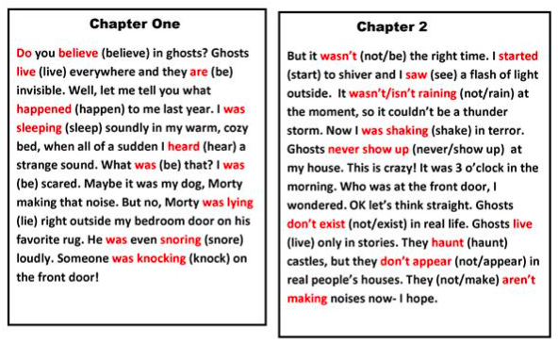

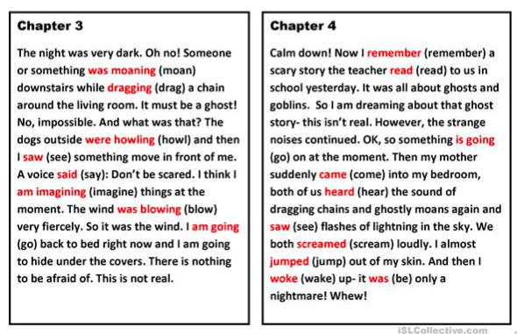

You can check the pronunciation of the words in the Cambridge Dictionary https://dictionary.cambridge.org/us/dictionary/learner-english/.