**ESCUELA NORMAL DE EDUCACIÓN PREESCOLAR**

**ENGLISH B1.2**

**BOOK UNIT 4 – WHAT HAPPENED?**

**GRAMMAR**

Dear students, during the week we will review the **simple past and the past continuous**. Complete your activities and upload your document to Escuela en Red.

**ACTIVITY 1 – SIMPLE PAST VS. PAST CONTINUOUS – 20 PTS.**

Read the following information and analyze the examples. Visit the website and upload a screenshot of your activity.

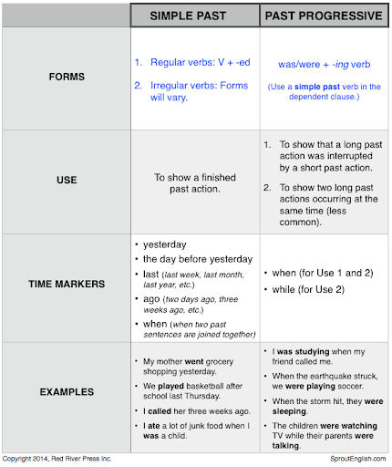

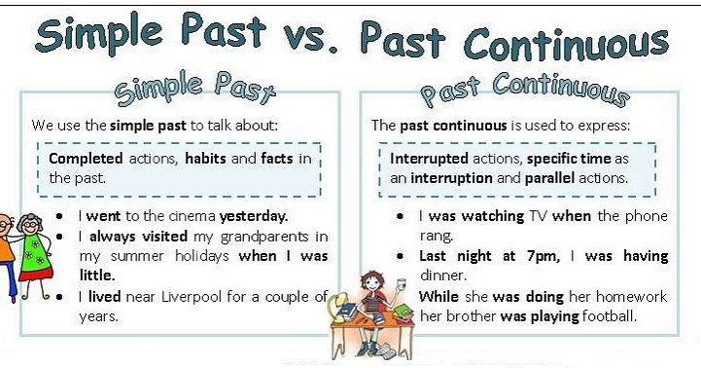

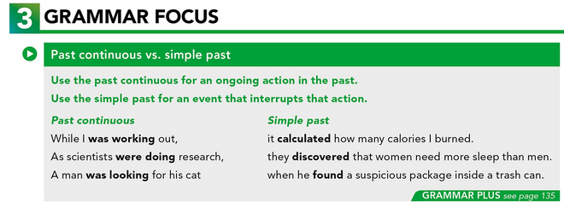

**WATCH THE VIDEO:**

https://www.youtube.com/watch?v=VLj-Dbz-CWk

**WEBSITE:**

GO TO <https://agendaweb.org/exercises/verbs/past-continuous/simple-continuous-1> , COMPLETE THE EXERCISE AND PASTE A SCREENSHOT OF YOUR ACTIVITY BELOW.

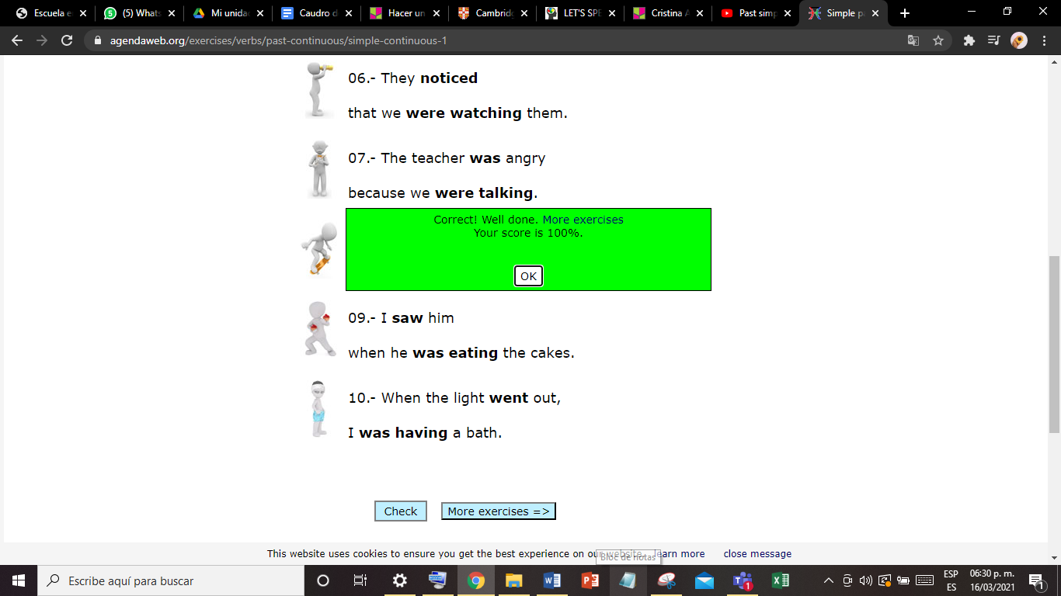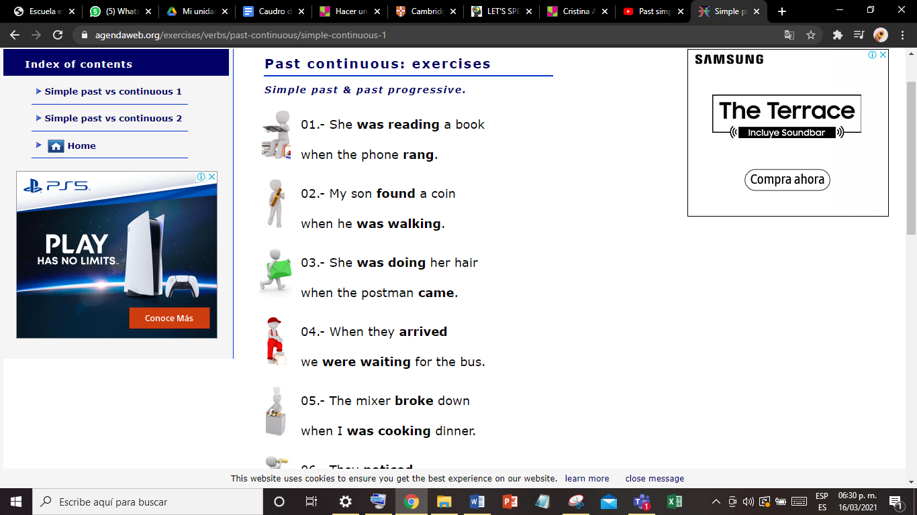

**ACTIVITY 2 – PAST CONTINUOUS VS. SIMPLE PAST – 20 PTS.**

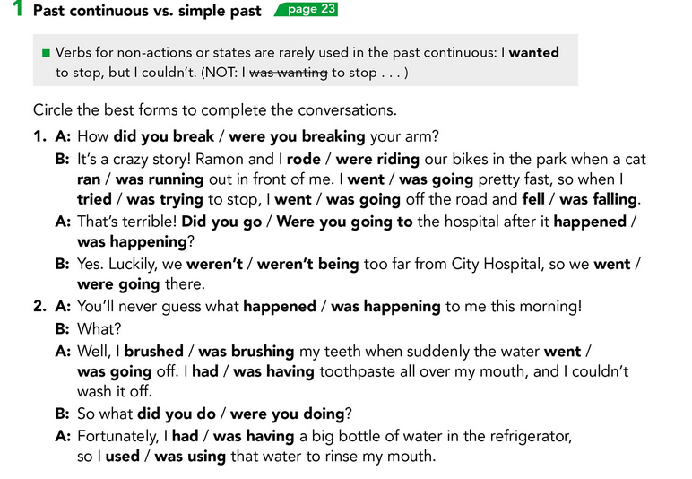

**1.-**

**A: did you break**

**B: were riding / ran / was going / tried / went / fell**

**A: Did you go / happened**

**B: weren’t / went**

**2.-**

**A: happened**

**A: was brushing / went / had**

**B: did you do?**

**A: had / used**

**ACTIVITY 3 – GAP FILL – 20 PTS.**

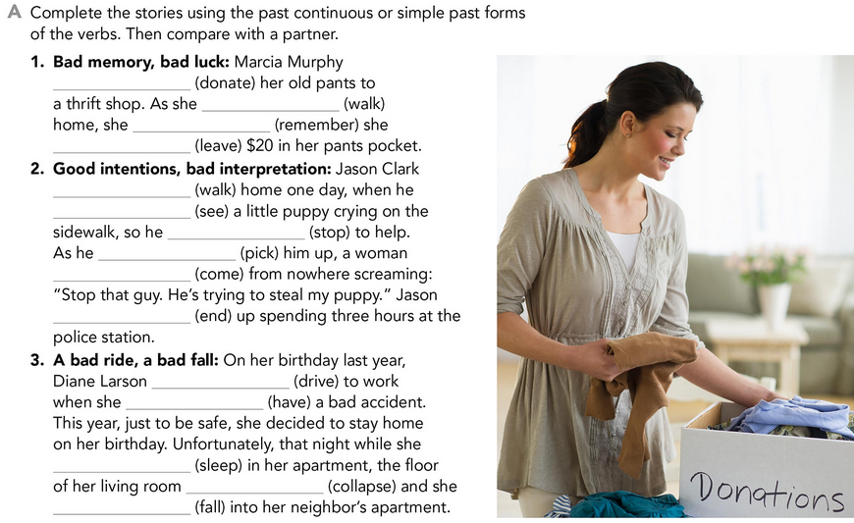

**1. –**

**donated**

**was walking**

**remembered**

**left**

**2.-**

**was walking**

**saw**

**stopped**

**was picking**

**came**

**ended**

**3.-**

**was driving**

**had**

**was sleeping**

**was collapsing**

**fell**

**ACTIVITY4 – FILL THE GAPS – 20 PTS**

THE SCHüRMANN FAMILy

Complete the email with the past continuous or simple past forms of the verbs in parentheses.

|  |
| --- |
| From: Kate Date: September 10 Subject: Information for project on families |
| Hi Ray, I think I have the information we need for the project. I (1) was looking (look) online yesterday when I  (2) found (find) a site about the Schürmann family. The Schürmanns are a Brazilian family who  (3) sailed (sail) around the world.  Vilfredo Schürmann (4) was running (run) his own company when he and his wife  (5) decided (decide) to start a completely new life. They (6) got (get) on their  sailboat and (7) left (leave)! They (8) spent (spend) the next ten years sailing.  As they (9) was traveling (travel) around the world, millions of Brazilians (10) followed (follow)  their adventures on TV. They (11) came (come) back to Brazil in 1994.  What do you think? Is this interesting enough for our project? Kate |

**ACTIVITY 5 – READING A STORY ALOUD – 20 PTS.**

Go to https://padlet.com/alvaradocris87/cdyptcca6vtz95by or scan the QR code and record yourself reading the four chapters of the following story, identify the past continuous and the simple past and then focus on your intonation while you’re reading to make it interesting. **REMEMBER TO WRITE YOUR NAME IN YOUR RECORDING.**



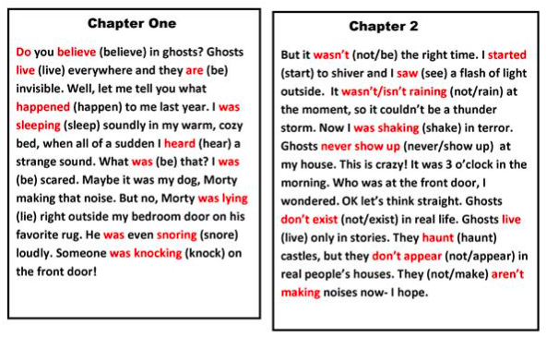

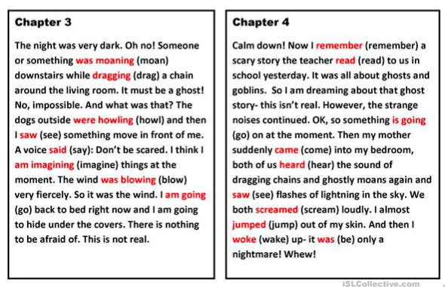

You can check the pronunciation of the words in the Cambridge Dictionary https://dictionary.cambridge.org/us/dictionary/learner-english/.