**ESCUELA NORMAL DE EDUCACIÓN PREESCOLAR**

**ENGLISH A2.2**

**WEEK 1 ACTIVITIES - “REVIEW”**

**GRAMMAR**

Dear students, during the week we will review the **present simple and the present continuous form**s. Complete your activities and upload your document to Escuela en Red.

**ACTIVITY 1 – PRESENT SIMPLE VS. PRESENT CONTINUOUS – 20 PTS**

Watch the video, read the following information and analyze the information presented.

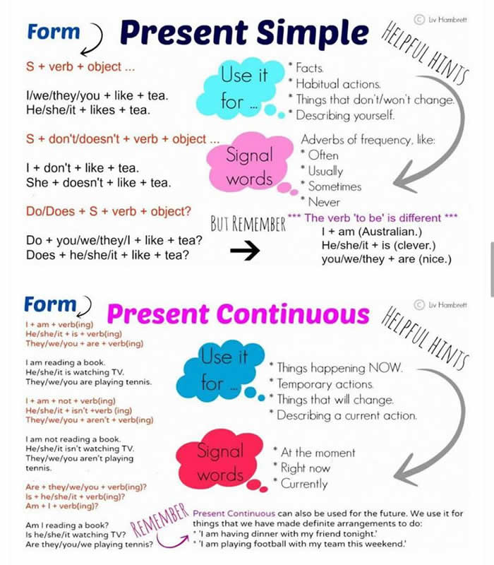

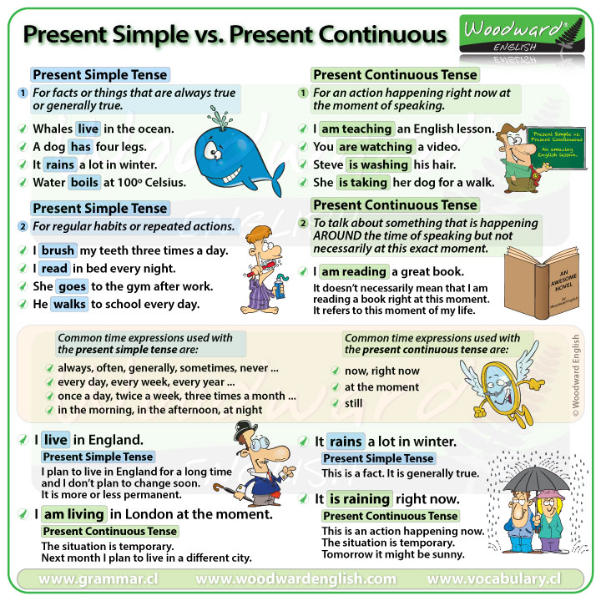

WATCH THE VIDEO:

<https://www.youtube.com/watch?v=3B_6pS8a0jk&t=49s>

PRACTICE IN THE FOLLOWING LINK AND PASTE A SCREENSHOT OF YOUR WORK.

<https://learnenglishkids.britishcouncil.org/grammar-practice/present-simple-and-present-continuous>

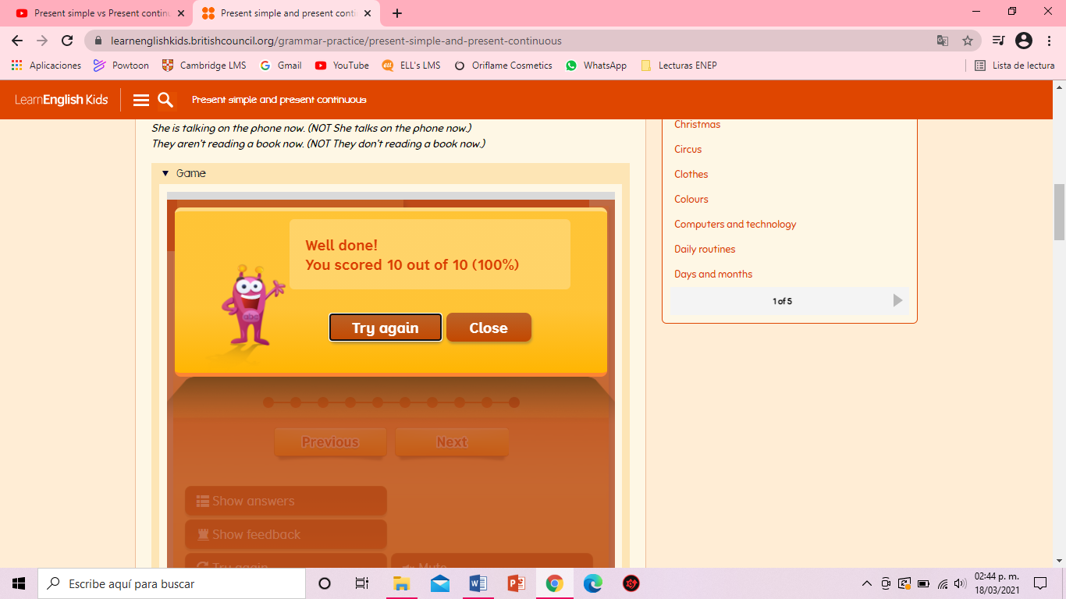

**ACTIVITY 2 – WORKSHEETS – 60 PTS.**

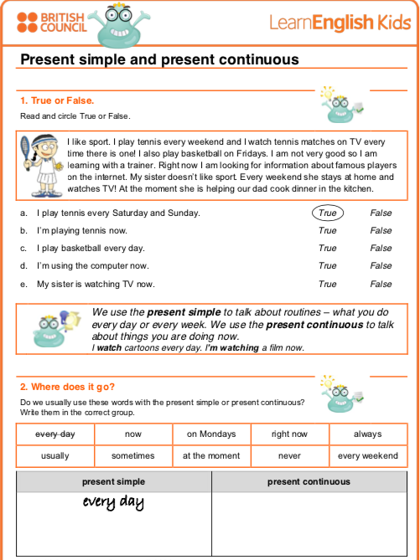

Everyday Every weekend

On Mondays

Always Never

Usually Sometimes

Now

Rigth now

At the moment

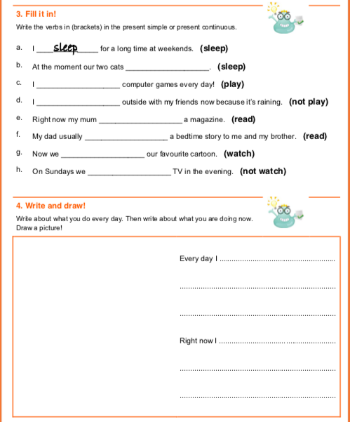

am doing my english homework.

Watching virtual class in the morning.

are not watching

Are watching

read

Is reading

am not playing

play

Are sleeping

**ACTIVITY 4 – SPEAKING AND PRONUNCIATION – 20 PTS.**

Go to https://padlet.com/alvaradocris87/cdyptcca6vtz95by or scan the QR code and record yourself reading the following paragraph, identify the present simple and the present continuous and then focus on your intonation while you’re reading to make it interesting. **REMEMBER TO WRITE YOUR NAME IN YOUR RECORDING.**



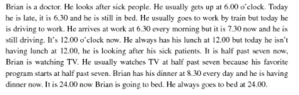

You can check the pronunciation of the words in the Cambridge Dictionary <https://dictionary.cambridge.org/us/dictionary/learner-english/>

