**ESCUELA NORMAL DE EDUCACIÓN PREESCOLAR**

**ENGLISH A2.2**

**WEEK 1 ACTIVITIES - “REVIEW”**

**GRAMMAR**

Dear students, during the week we will review the **present simple and the present continuous form**s. Complete your activities and upload your document to Escuela en Red.

**ACTIVITY 1 – PRESENT SIMPLE VS. PRESENT CONTINUOUS – 20 PTS**

Watch the video, read the following information and analyze the information presented.

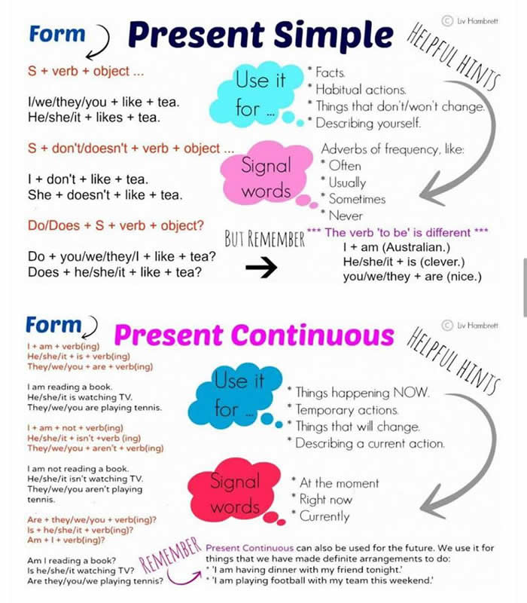

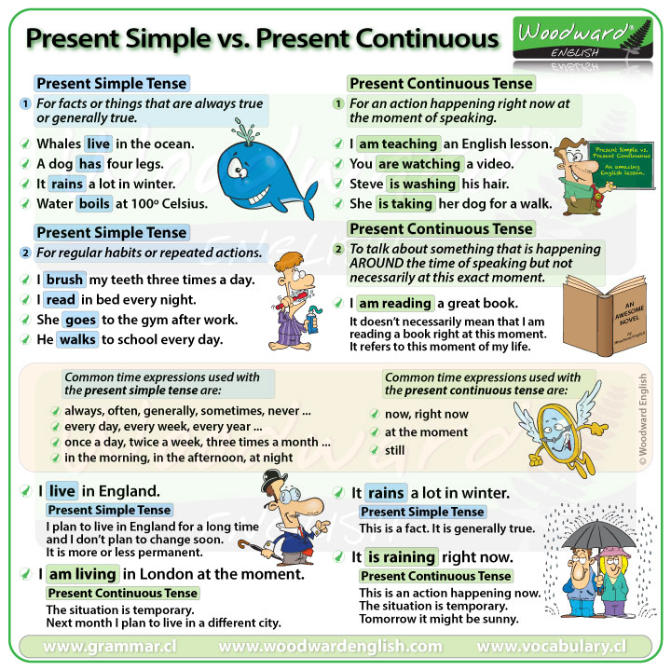

WATCH THE VIDEO:

<https://www.youtube.com/watch?v=3B_6pS8a0jk&t=49s>

PRACTICE IN THE FOLLOWING LINK AND PASTE A SCREENSHOT OF YOUR WORK.

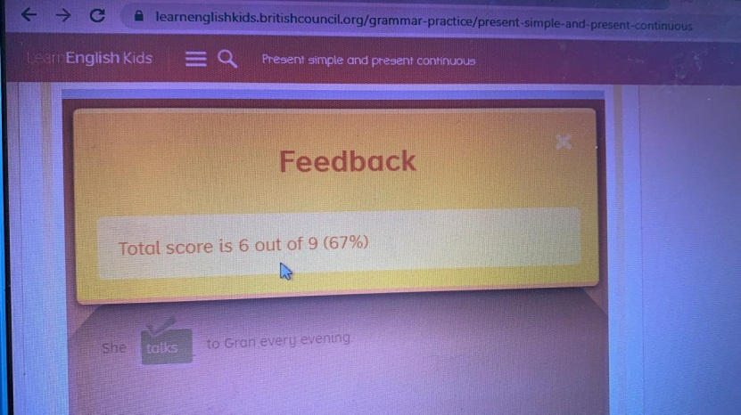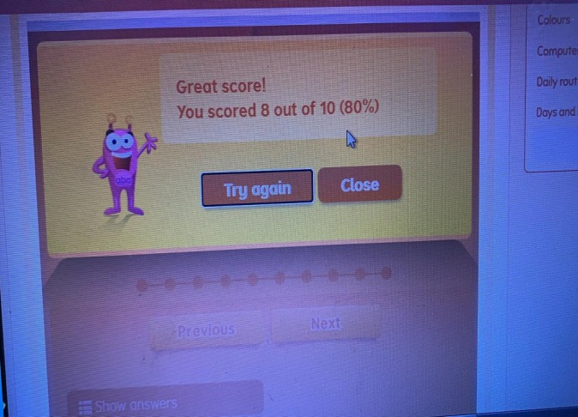<https://learnenglishkids.britishcouncil.org/grammar-practice/present-simple-and-present-continuous>

**ACTIVITY 2 – WORKSHEETS – 60 PTS.**

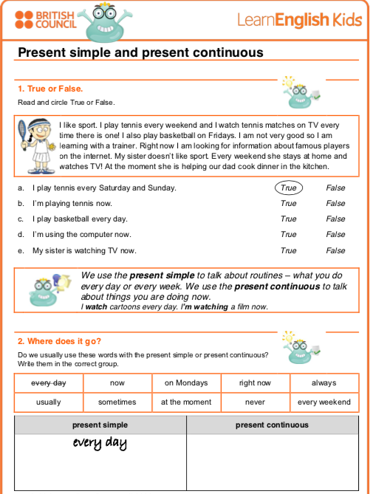

Never

At the moment

Now

On Mondays

Right now

Sometimes

Always

Never

Usually

Every weekend

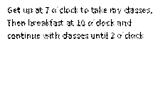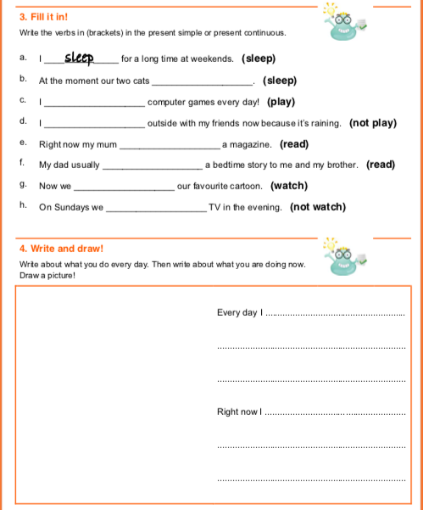

i´m finishing my english homework,

While I eat yogurt with fruit

Get up at 7 o´clock to take my classes,

Then breakfast at 10 o´clock and

continue with classes until 2 o´clock

Not watching

watch

reading

read

Not playing

play

sleeping

**ACTIVITY 4 – SPEAKING AND PRONUNCIATION – 20 PTS.**

Go to https://padlet.com/alvaradocris87/cdyptcca6vtz95by or scan the QR code and record yourself reading the following paragraph, identify the present simple and the present continuous and then focus on your intonation while you’re reading to make it interesting. **REMEMBER TO WRITE YOUR NAME IN YOUR RECORDING.**



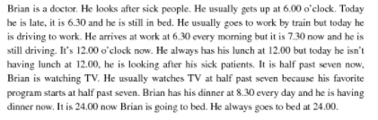

You can check the pronunciation of the words in the Cambridge Dictionary https://dictionary.cambridge.org/us/dictionary/learner-english/.