**ESCUELA NORMAL DE EDUCACIÓN PREESCOLAR**

**ENGLISH A2.2**

**WEEK 1 ACTIVITIES - “REVIEW”**

**GRAMMAR**

Dear students, during the week we will review the **present simple and the present continuous form**s. Complete your activities and upload your document to Escuela en Red.

**ACTIVITY 1 – PRESENT SIMPLE VS. PRESENT CONTINUOUS – 20 PTS**

Watch the video, read the following information and analyze the information presented.

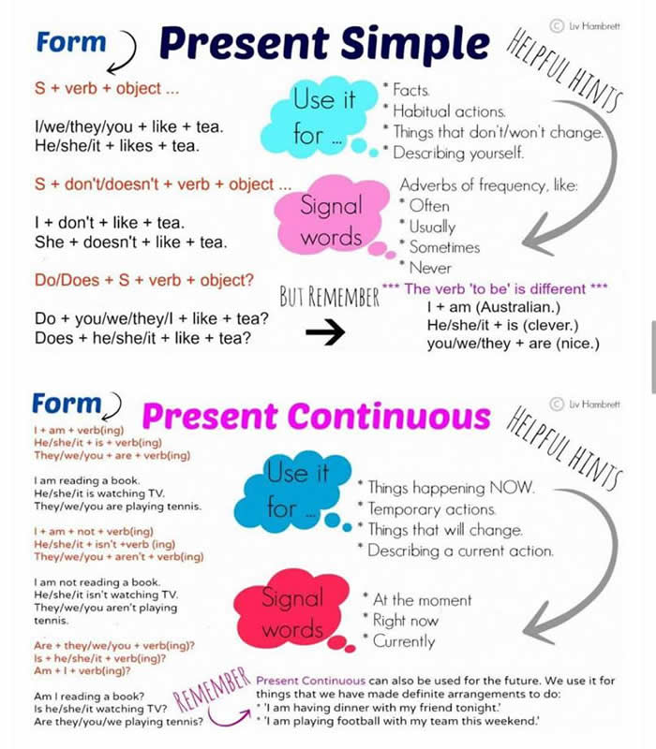

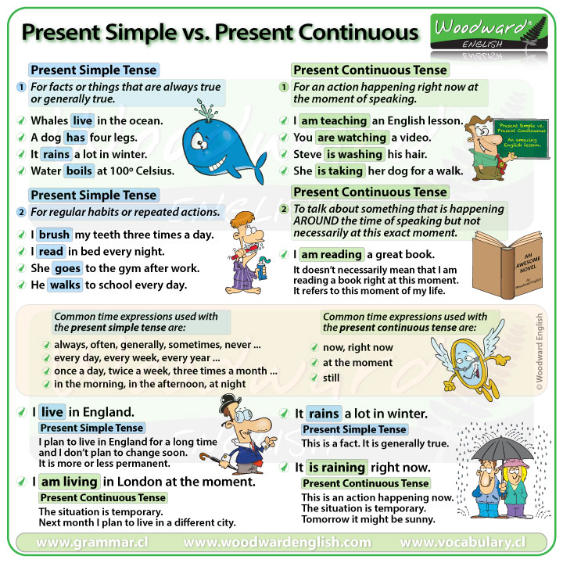

WATCH THE VIDEO:

<https://www.youtube.com/watch?v=3B_6pS8a0jk&t=49s>

PRACTICE IN THE FOLLOWING LINK AND PASTE A SCREENSHOT OF YOUR WORK.

<https://learnenglishkids.britishcouncil.org/grammar-practice/present-simple-and-present-continuous>

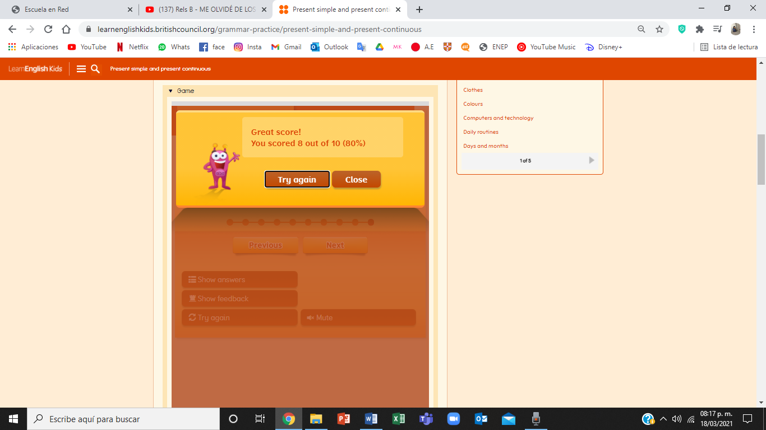

**ACTIVITY 2 – WORKSHEETS – 60 PTS.**

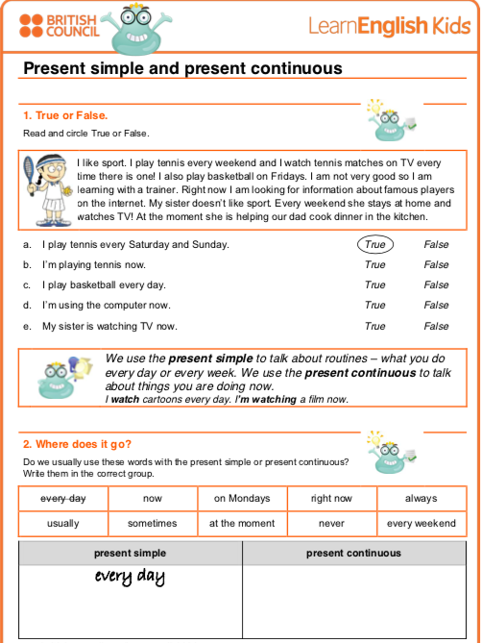

Now

Right now

At the moment

On Mondays

Always

Usually

Sometimes

Never

Every weekend

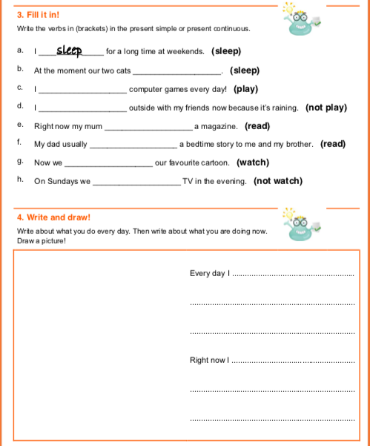

Monday and Tuesday I take classes in the mornings in the afternoons I dedicate myself to doing my homework, Wednesday, Thursday and Friday I go to work taking care of some girls, I take my classes together with them, in the afternoons I work.

I do homework over dinner.

am not playing

play

slepping

aren´t watch

are watching

reads

is reading

**ACTIVITY 4 – SPEAKING AND PRONUNCIATION – 20 PTS.**

Go to https://padlet.com/alvaradocris87/cdyptcca6vtz95by or scan the QR code and record yourself reading the following paragraph, identify the present simple and the present continuous and then focus on your intonation while you’re reading to make it interesting. **REMEMBER TO WRITE YOUR NAME IN YOUR RECORDING.**



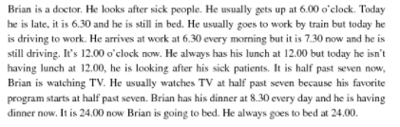

You can check the pronunciation of the words in the Cambridge Dictionary https://dictionary.cambridge.org/us/dictionary/learner-english/.