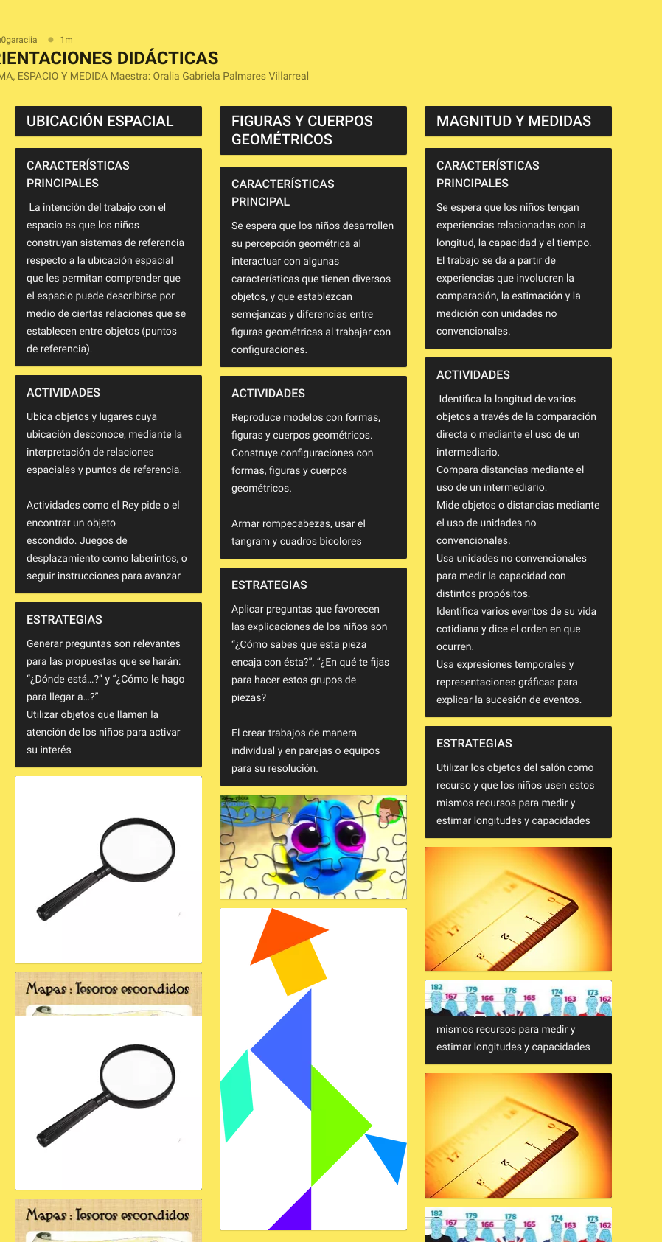

https://padlet.com/LuceroGarciaVela/gqhv52lqwvinu7qm