Dibeth Atziri Carreón March 23rd, 2021

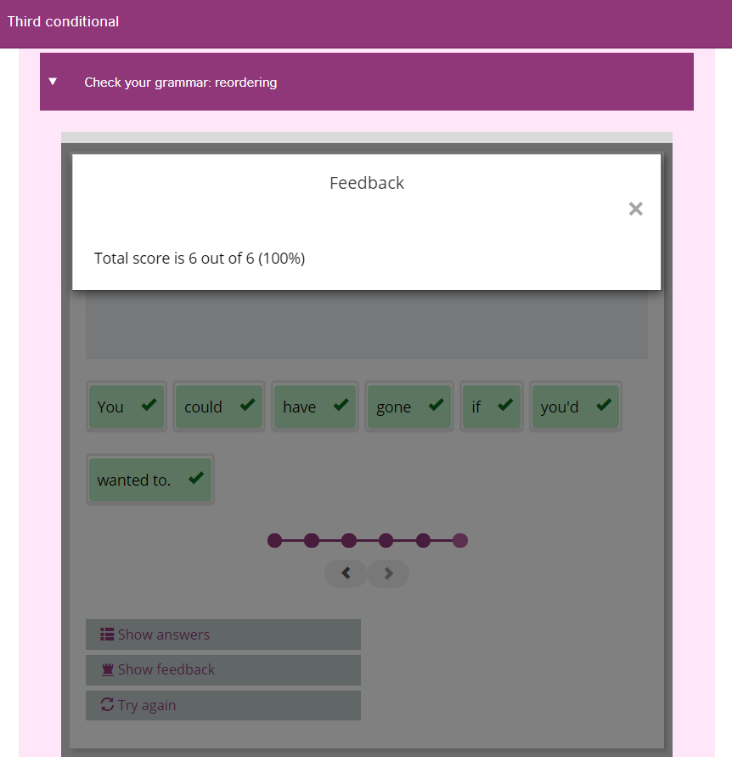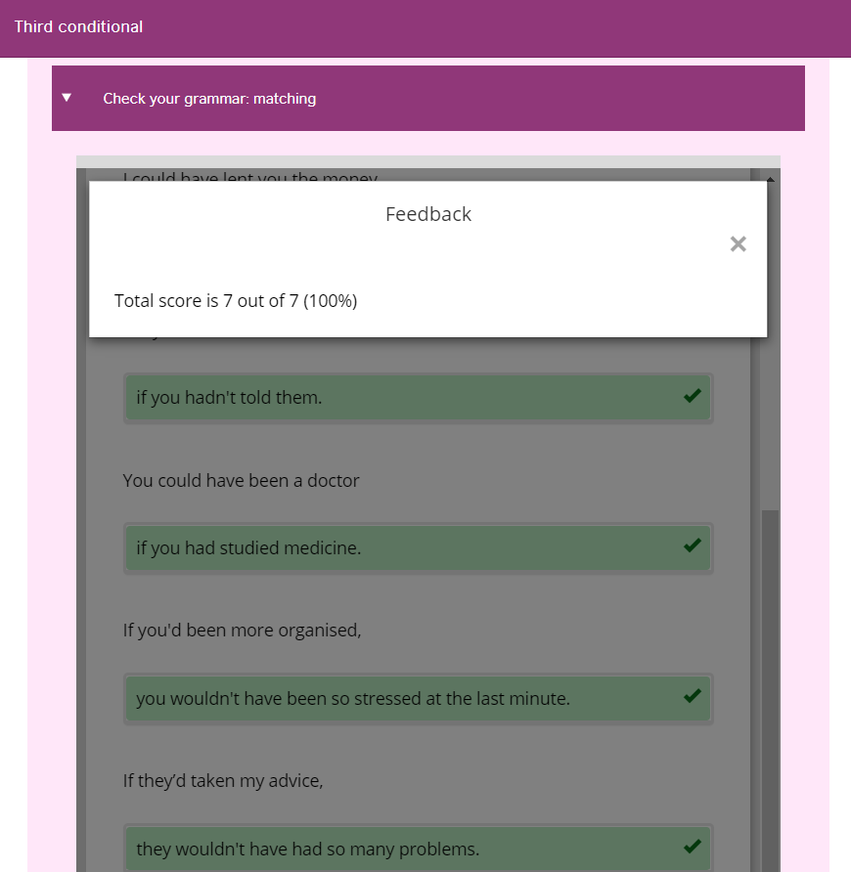***ELL UNIT 8 LESSONS 1-6 THIRD CONDITIONAL REVIEW EVIDENCE***

