Yenifer Cortez Olguín #3

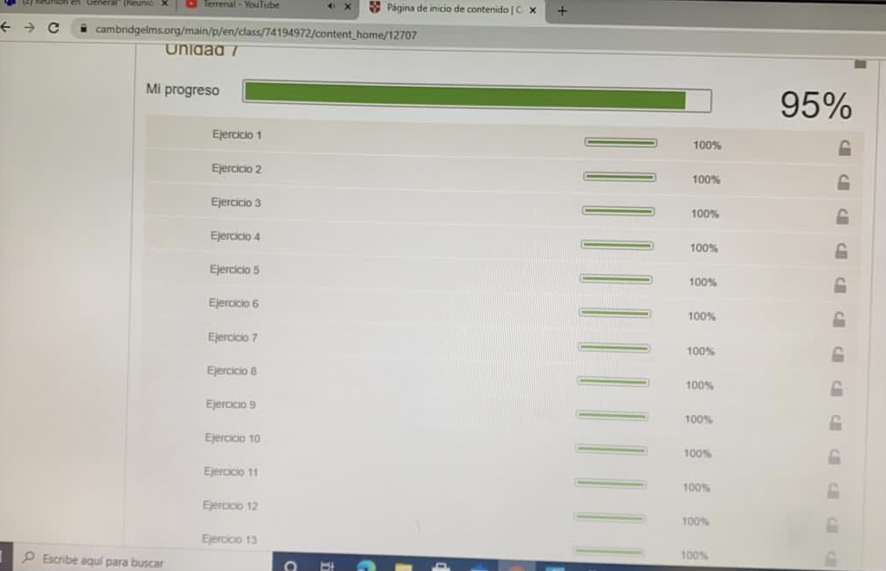

25-03-21