**ESCUELA NORMAL DE EDUCACIÓN PREESCOLAR**

**ENGLISH A2.2**

**WEEK 2 ACTIVITIES - “REVIEW”**

**SIMPLE PRESENT VS. PRESENT CONTINUOUS**

Dear students, during the week we will review the **PRESENT SIMPLE**. Complete your activities and upload your products to Escuela en Red and Padlet.

**ACTIVITY 1 – VOCABULARY REVIEW – 20 PTS**

Go to <https://learnenglishteens.britishcouncil.org/vocabulary/beginner-vocabulary/daily-routine> and do the activities to practice vocabulary about daily routines, LISTEN TO THE PRONUNCIATION OF EACH WORD AND REPEAT. Paste a screenshot with your results of each section here as in the example.

**Example:**

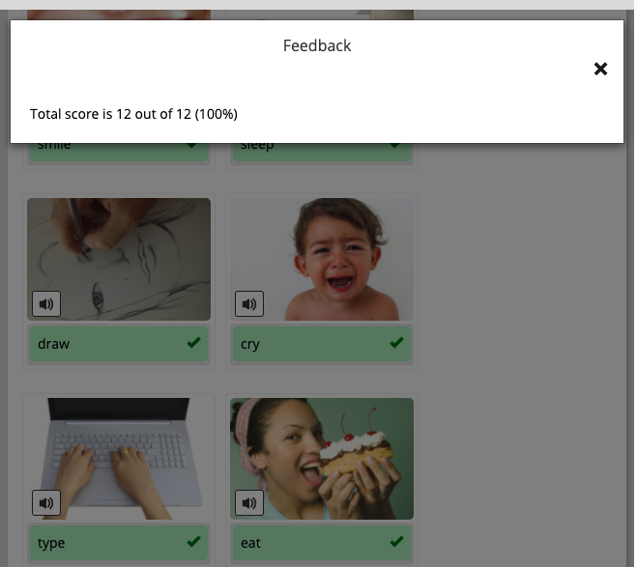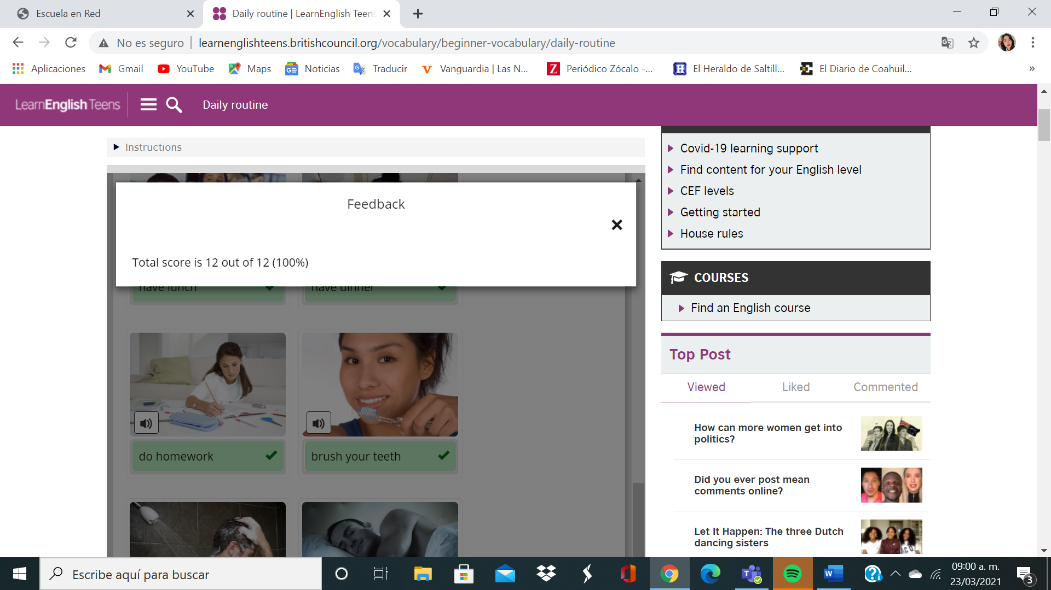

Go to <https://learnenglishteens.britishcouncil.org/vocabulary/beginner-vocabulary/actions> and do the activities to practice vocabulary about actions, LISTEN TO THE PRONUNCIATION OF EACH WORD AND REPEAT. Paste a screenshot with your results of each section here as in the example.



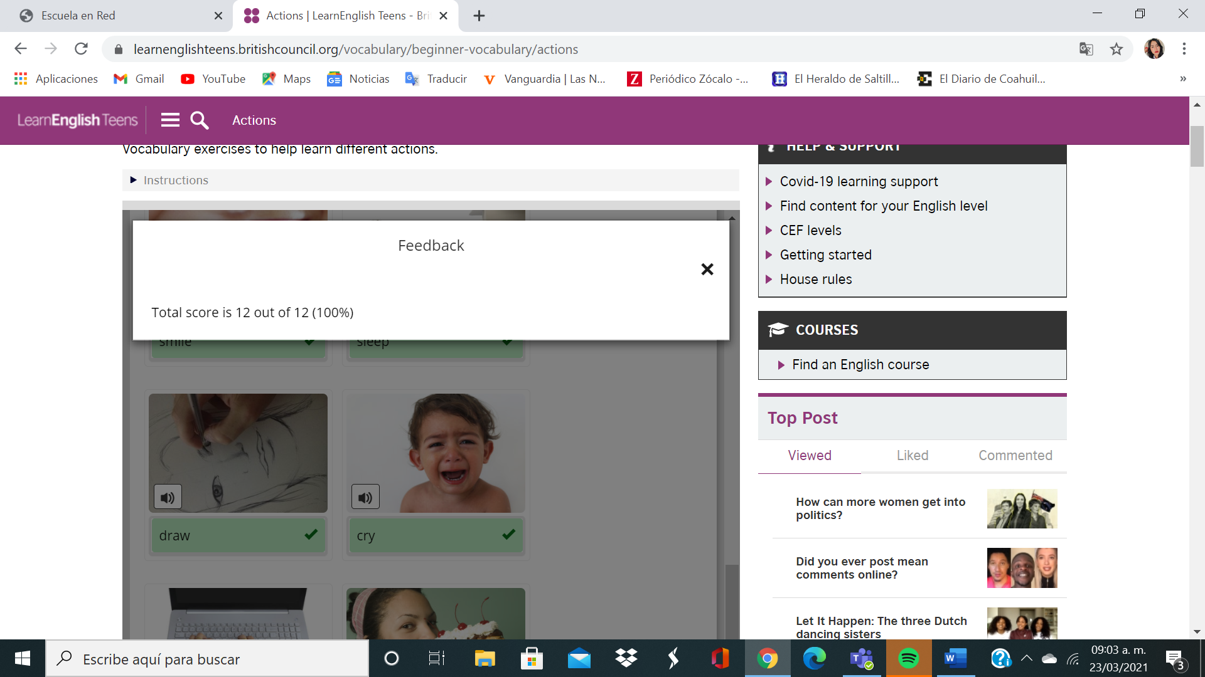

**ACTIVITY 2 – SIMPLE PRESENT – 40 PTS**

As we learned in class, the present simple is used to talk about facts, permanent situations, and habits or routines. Look at the following pictures and analyze the examples.

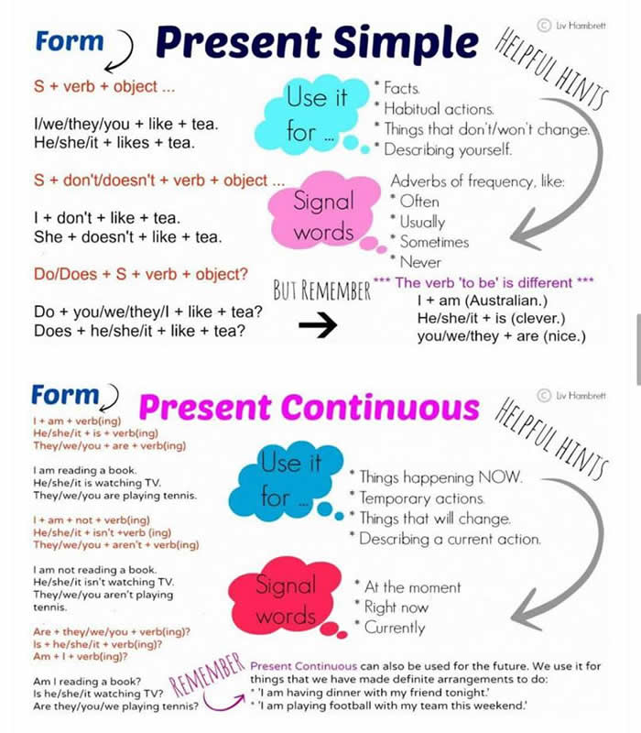

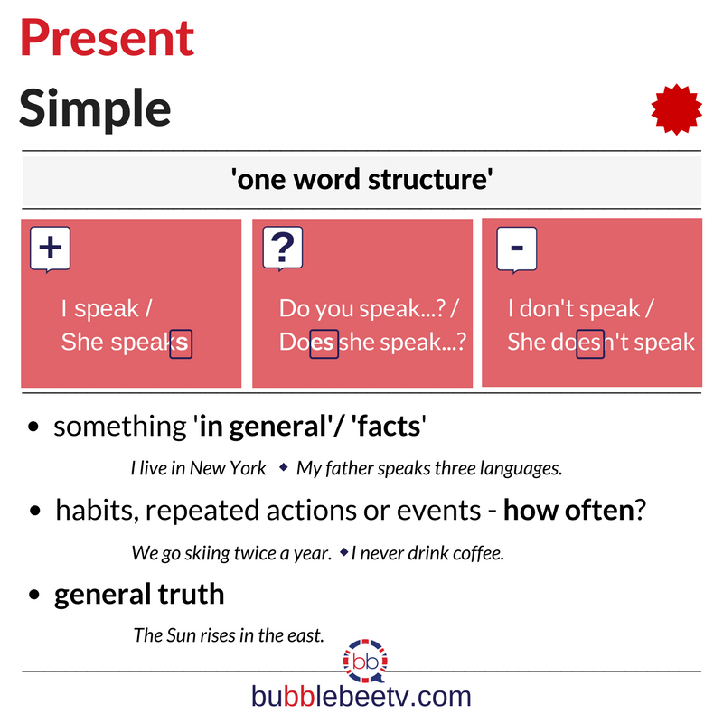

**AFFIRMATIVE STATEMENTS**

Complete the sentences with the correct form of the verb in parenthesis. Remember that in affirmative statements for the pronouns HE, SHE AND IT you must add -s or -es at the end of the verb. Look at the examples.

1. I *wake up* (wake up) at 7:00 a.m. every day.
2. My mother *visits* (visit) my grandma twice a week.
3. My father __watches________ (watch) television in the afternoon.
4. You __lives________ (live) in Saltillo.
5. Cecilia ____does______ (do) her homework at 5:00 p.m. every day.
6. We ___going_______ (go) to the gym three times a week.
7. They usually __does________ (do) the laundry on Saturdays.
8. The ice-cream ____melting______ (melt) if the weather is hot.

**NEGATIVE STATEMENTS**

Complete the sentences with the correct form of the verb in parenthesis. Remember that in negative statements for the pronouns **I, YOU, WE AND THEY** you must use the auxiliar DON’T, and for the pronouns **HE, SHE AND IT** you must use the auxiliar DOESN’T. Look at the examples.

1. I *don’t go* to the gym.
2. She *doesn’t go* out with her friends on weekends.
3. Dogs __don´t live________ (live) in the water.
4. We __don´t travel________ (travel) to USA every year.
5. My brother __doesn´t eat________ (eat) meat.
6. My parents __don´t like________ (like) big cities.
7. You __don´t know________ (know) the name of the teacher.
8. We __don´t need________ (need) help with our homework.

**YES / NO QUESTIONS**

Complete the sentences with the correct auxiliar. Remember that in questions we use DO for the pronouns **I, YOU, WE and THEY**. For the pronouns **HE, SHE and IT** we use the pronoun DOES. Look at the examples.

1. *Do* you *have* a pet at home? Yes, I *do*.
2. *Does* she *like* hamburguers? No, she *doesn’t*.
3. Does__ your friend *live* in Monterrey? Yes, she does.
4. Do___ you *brush* your teeth aftear each meal? Yes, I do.
5. Do___ they *dance* at parties? No, they don’t.
6. Do____ you *drink* soda for breakfast? No, I don´t.

**INFORMATION QUESTIONS**

Complete the questions with the correct auxiliar (DO or DOES).

1. What color *do* you *like*?
2. Where *does* your uncle *live*?
3. What do you usually *have* for lunch?
4. Where does your mother *work?*
5. What time does Pablo *start* work?
6. How do you *go* home after school?
7. When do you *do* the laundry?

**ACTIVITY 3 – READING - DAILY ROUTINE – 10 PTS**

Read Sergei’s daily routine, circle the **verbs in red** and the **time expressions and frequency adverbs in green**.

****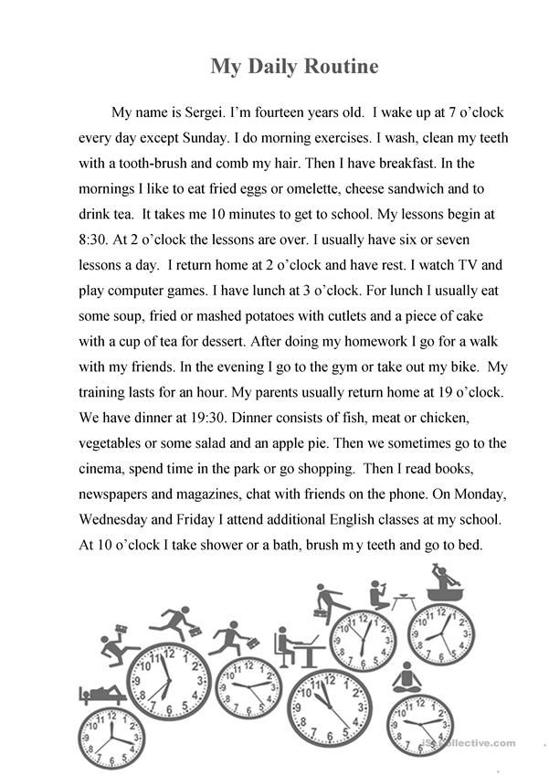

**ACTIVITY 4 – WRITING AND SPEAKING – 30 PTS**

Write your own daily routine as the one in the example. It must have at least 120 words and use the vocabulary and grammar structures revised in this document.

**Write your daily routine here**

**My Daily Routine**

My day starts when I wake up at 7:00 a.m., I shower at 7:30 a.m. and then at 7:45 a.m. I take my classes online, I have breakfast at 9:00 a.m. and lunch at 10:00 a.m. am, my favorite breakfast is fruit with yoghurt, I finish my classes at 2:00 pm and start cooking, I cook food for my grandparents and myself, I have food at 3:00 pm, I wash the dishes at 4 : 30 pm, I do my homework at 5:00 pm, I start cleaning my house at 7:30 pm, i have dinner at 9:30 pm, brush my teeth at 9:50 pm, and I go to bed at 11:00 pm and then sleep at 11:30 pm, i´m preparing for the next day.

Once you have your daily routine ready, go to https://padlet.com/alvaradocris87/cdyptcca6vtz95by or scan the QR code and record yourself reading the paragraph you wrote. **REMEMBER TO WRITE YOUR NAME IN YOUR RECORDING.**



You can check the pronunciation of the words in the Cambridge Dictionary https://dictionary.cambridge.org/us/dictionary/learner-english/.