**ESCUELA NORMAL DE EDUCACIÓN PREESCOLAR**

**ENGLISH A2.2**

**WEEK 2 ACTIVITIES - “REVIEW”**

**SIMPLE PRESENT VS. PRESENT CONTINUOUS**

Dear students, during the week we will review the **PRESENT SIMPLE**. Complete your activities and upload your products to Escuela en Red and Padlet.

**ACTIVITY 1 – VOCABULARY REVIEW – 20 PTS**

Go to <https://learnenglishteens.britishcouncil.org/vocabulary/beginner-vocabulary/daily-routine> and do the activities to practice vocabulary about daily routines, LISTEN TO THE PRONUNCIATION OF EACH WORD AND REPEAT. Paste a screenshot with your results of each section here as in the example.

**Example:**

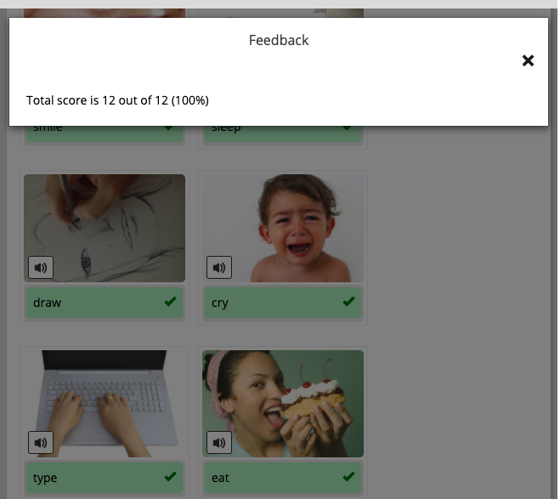

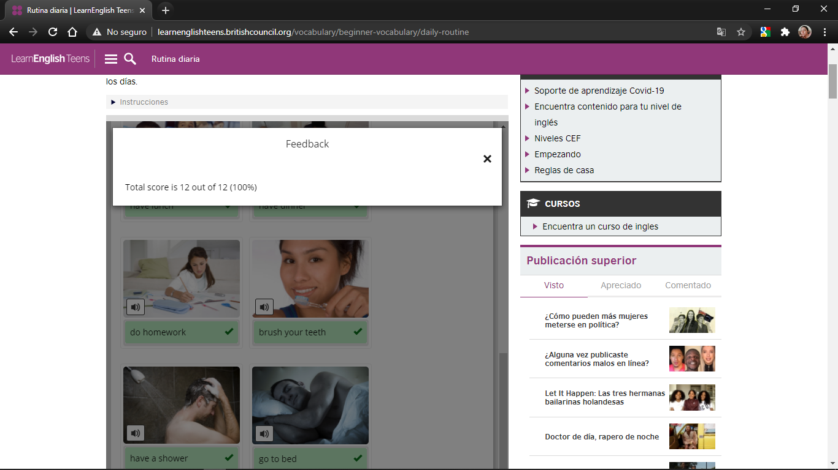

**ACTIVITY 2 – SIMPLE PRESENT – 40 PTS**

As we learned in class, the present simple is used to talk about facts, permanent situations, and habits or routines. Look at the following pictures and analyze the examples.

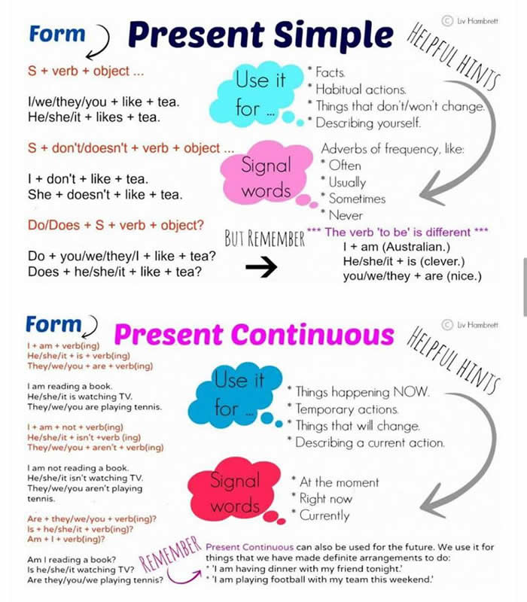

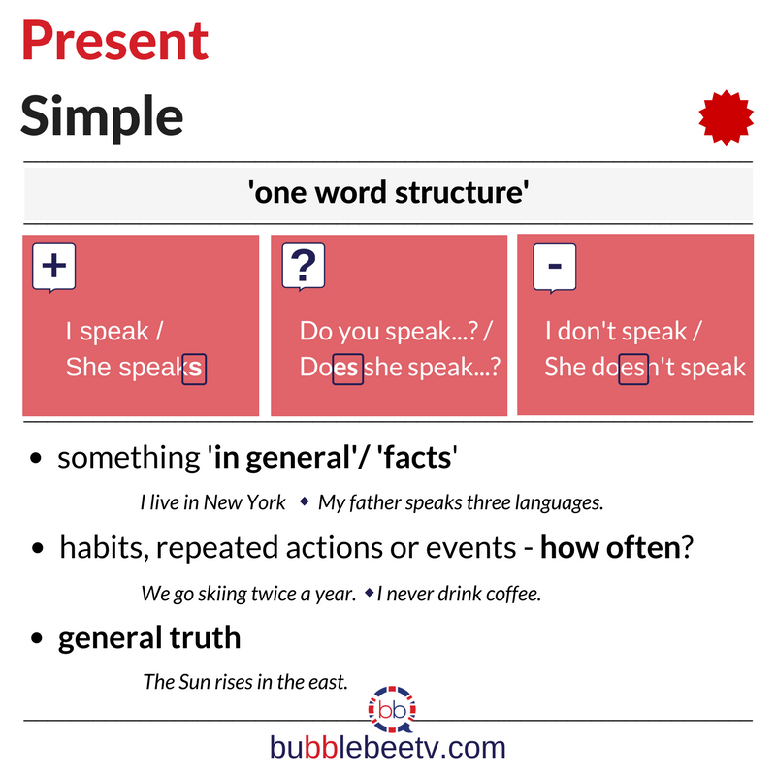

**AFFIRMATIVE STATEMENTS**

Complete the sentences with the correct form of the verb in parenthesis. Remember that in affirmative statements for the pronouns HE, SHE AND IT you must add -s or -es at the end of the verb. Look at the examples.

1. I *wake up* (wake up) at 7:00 a.m. every day.
2. My mother *visits* (visit) my grandma twice a week.
3. My father watches (watch) television in the afternoon.
4. You live (live) in Saltillo.
5. Cecilia does (do) her homework at 5:00 p.m. every day.
6. We go (go) to the gym three times a week.
7. They usually do (do) the laundry on Saturdays.
8. The ice-cream melts (melt) if the weather is hot.

**NEGATIVE STATEMENTS**

Complete the sentences with the correct form of the verb in parenthesis. Remember that in negative statements for the pronouns **I, YOU, WE AND THEY** you must use the auxiliar DON’T, and for the pronouns **HE, SHE AND IT** you must use the auxiliar DOESN’T. Look at the examples.

1. I *don’t go* to the gym.
2. She *doesn’t go* out with her friends on weekends.
3. Dogs doesn’t live (live) in the water.
4. We don’t travel (travel) to USA every year.
5. My brother doesn’t eat (eat) meat.
6. My parents don’t like (like) big cities.
7. You don´t know (know) the name of the teacher.
8. We don´t need (need) help with our homework.

**YES / NO QUESTIONS**

Complete the sentences with the correct auxiliar. Remember that in questions we use DO for the pronouns **I, YOU, WE and THEY**. For the pronouns **HE, SHE and IT** we use the pronoun DOES. Look at the examples.

1. *Do* you *have* a pet at home? Yes, I *do*.
2. *Does* she *like* hamburguers? No, she *doesn’t*.
3. Do your friend *live* in Monterrey? Yes, she does.
4. Do you *brush* your teeth aftear each meal? Yes, I do.
5. Does they *dance* at parties? No, they do.
6. Do you *drink* soda for breakfast? No, I do.

**INFORMATION QUESTIONS**

Complete the questions with the correct auxiliar (DO or DOES).

1. What color *do* you *like*?
2. Where *does* your uncle *live*?
3. What do you usually *have* for lunch?
4. Where does your mother *work?*
5. What time _does_ Pablo *start* work?
6. How __do___ you *go* home after school?
7. When ___do___ you *do* the laundry?

**ACTIVITY 3 – READING - DAILY ROUTINE – 10 PTS**

Read Sergei’s daily routine, circle the **verbs in red** and the **time expressions and frequency adverbs in green**.

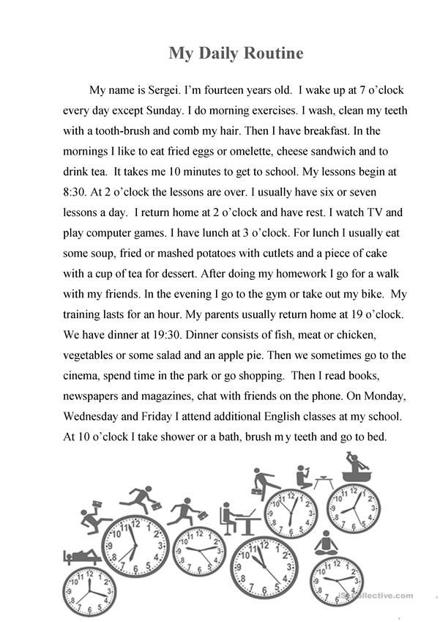

**ACTIVITY 4 – WRITING AND SPEAKING – 30 PTS**

Write your own daily routine as the one in the example. It must have at least 120 words and use the vocabulary and grammar structures revised in this document.

**Write your daily routine here**

**My Daily Routine**

My day usually starts quite early. I always get up at 7:00 on weekdays, but at the weekends I sleep an hour a half longer. When I get up, I go to the bathroom first. I wash my face to wake me up, brush my teeth and then have a shower. After that I comb my hair and get dressed. I always have breakfast. Before I attend my clases online.

Once you have your daily routine ready, go to https://padlet.com/alvaradocris87/cdyptcca6vtz95by or scan the QR code and record yourself reading the paragraph you wrote. **REMEMBER TO WRITE YOUR NAME IN YOUR RECORDING.**



You can check the pronunciation of the words in the Cambridge Dictionary https://dictionary.cambridge.org/us/dictionary/learner-english/.